**Private and confidential**

Company name

Address

Postal Code

**Subject: Canadian and US Customs Brokerage Services**

Dear __________,

We are very pleased to present our proposal to provide complete Canadian and US Customs Brokerage Services for [insert company name].

Frontier Supply Chain Solutions Inc. (Frontier) is a North American Supply Chain Solutions Company. We are able to create solutions and introduce programs that will benefit our client’s needs because we take the time to understand their business. Our priority is to:

* Provide professional and knowledgeable Canadian and US Customs Brokerage Services
* Ensure [insert company name] is compliant by taking a proactive approach to trade compliance with Frontier’s monthly Trade Management Services
* Lower your overall freight customs brokerage spend by at least 25%
* Offer educational courses to [insert company name] and its employees on how to facilitate a proper customs release
* Provide additional support through our local & international logistics services (Courier, Ocean Forwarding, etc.)

As Frontier engages new partnerships, we will work for continuous improvement. This is to ensure [insert company name] is always up-to-date on the most effective programs available by CBSA and

USCBP.

Please do not hesitate to contact me at (204) 784-4800 Ext. ____ if you have any questions. On behalf of Frontier, we look forward to working with you.

Sincerely,

[Your name here]  
Business Development Manager  
Frontier Supply Chain Solutions Inc.

Insert Company Name

**Canadian and US Customs Brokerage and Trade Management Services** 

EXAMPLE of what to include in this section: Old Dutch Foods has been producing delicious potato chips for 80+ years.  Much of what goes into the manufacturing process, gets imported from the United States (potatoes, corn, seasoning, packaging, etc.).   With a strong customer base in the US, and headquarters and a plant in Minnesota, there are also regular exports moving through US Customs.  Due to consistent activity of food products moving through the border, a timely customs release is very important to Old Dutch Foods. This is especially important with Winnipeg being less than 2 hours from the Emerson and Pembina border crossings.  This proposal will introduce Frontier’s Trade Management Services which will help prevent hold ups at the border.  In addition to other deliverables, this will manage your vendor and tariff databases, while keeping HS Code Classifications up to date.

In addition to a timely release, an accurate release is just as important.   Old Dutch recently received a C28/C29 from US-CBP.  This was due to a certain seasoning being incorrectly classified for 10+ years.  This corrective change could result in thousands of dollars’ worth of duty and interest being paid out by Old Dutch.  It is very important that your customs broker is doing post-entry audits, and ensuring each tariff is classified properly.  Through Frontier’s Trade Management Services, each shipment/entry is audited by our trade compliance team.  Any new product imported is scrutinized and looked at for its end use, country of origin, etc. to be certain it is classified correctly from the beginning.   Also, your vendor NAFTAs, and own Certificates of Origin will be maintained on a weekly basis by Frontier.  Vendor information is kept up to date as well to ensure all points of the supply chain are compliant.

Frontier’s Trade Management Services will also manage Old Dutch’s Accounts Receivable Ledger, which will be a mandatory requirement by CBSA, in 2018, for remitting GST and duty to the Canadian Government.

**Clearing Customs**

Because Canada Border Services Agency (CBSA) and US Customs and Border Protection (US-CBP) prefer that customs releases be transmitted electronically, there is no longer a need for customs brokers to be at every border crossing/port. This allows Frontier to centralize our customs release department in Winnipeg, thereby eliminating the need for multiple offices and additional overhead.  

The reduction in additional overhead permits Frontier to be very competitive with our customs brokerage pricing.  Our customs release system and software allow your brokerage team to submit your information the quickest way possible, ensuring there are no delays at the border.

Our centralized customs release teams have dedicated employees that oversee specific accounts. This enables us to have consistent communication with you and your carriers and we gain an intimate knowledge of your products, needs and expectations.

Before flowing through our Trade Consulting team, your Account Manager will manage the day-to-day review of your customs releases for all imports and exports. They will gain a comprehensive knowledge of your product and the specific needs of your shipments. They manage a team of 3-5 Integrated Service Representatives (ISR) of which one of these people will be you direct contact for all orders and processing. Your ISR will create and manage a relationship to ensure they get to know all the ins and outs of your business.

**Why is Frontier a good fit for [insert company name]?** 

* Consistent review of your HS Code/Tariff Classifications to prevent costly audits and border hold ups
* [insert company name] is guaranteed accuracy against audits through our Trade Management Services
* Frontier will collect, review, and audit all NAFTAs from vendors and [insert company name] production
* Corrections for overages and shortages on bulk commodity imports are included under TMS
* Multiple invoicing options to keep accounting practices consistent
* Annual collection and review of your NAFTA certificates to ensure accuracy and free up your clerical resources
* 24/7 service and coverage at all border crossings across the Canada-US Border
* Dedicated Senior Business Development Manager, who always services the account, making sure you are up to date with customs/logistics programs and happy with all of Frontier’s services

**Benefits of Frontier’s Customs Brokerage Services**

* One Team - One client approach to give [insert company name] one point of contact and personalized service
* 24/7 service and coverage at all border crossings across the Canada-US Border
* Working in parallel with TMS, [insert company name] stays compliant and fees are reduced
* Multiple invoicing options to keep accounting practices consistent
* Your dedicated sales rep will always service the account, to ensure you are always up to date with customs/logistics programs and happy with all of Frontier’s services

Customs rules and regulations are always being updated. That's part of what makes them complicated and why products will be misclassified if not constantly audited and updated. A proactive approach to customs compliance will help your Frontier Team be more efficient and help you avoid future problems at the border. Trade management services was developed to ensure [insert company name] stays compliant with both CBSA and USCBP. Instead of waiting for a desk review or audit, then scrambling to make changes or collect paperwork and records, Frontier offers a year round compliance service. Signing up for Trade Management Services will result in reduced Customs Brokerage fees as it increases efficiency.

This service takes the guess work out of your monthly bills as client will be billed a flat rate every month regardless of the hours worked.

Frontier's team of Trade Compliance Specialists offer three service packages with three levels of help.

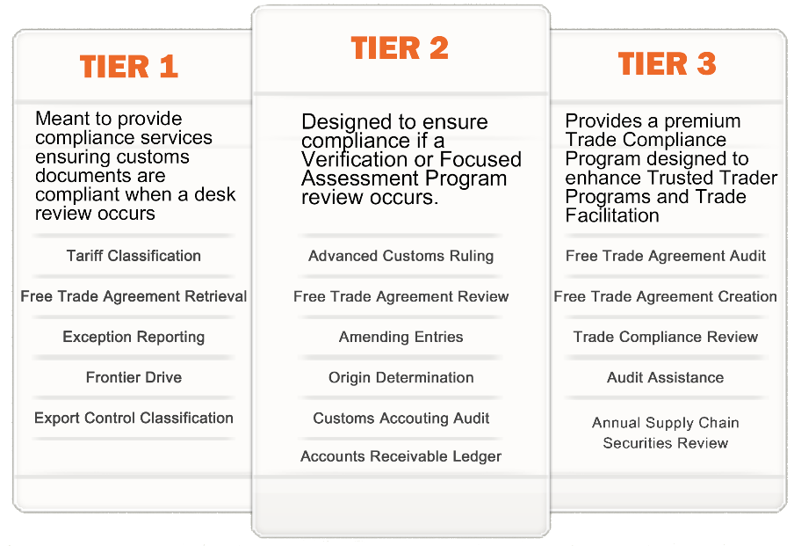

**Trade Management Services  
Tier 1**

The first package “Tier 1” was developed to ensure our clients could pass a desk review. This package includes:

* Tariff Classification:
  + All new parts being imported will be classified and reviewed prior to their first importation.
* Free Trade Agreement Retrieval:
  + We will retrieve Free Trade Agreement Certificates from your suppliers throughout the year.
* Exception Reporting:
  + Frontier will handle reporting to government agencies any overages received on an import transaction.
* FrontierDrive:
  + You will have full access to our new storage system technology FrontierDrive.
* Export Control Classification:
  + Frontier will create and provide the Export Control Classification Number on products you intend to export.

**Tier 2**

The second package “Tier 2” was developed to ensure our clients could pass a Verification or Focused Assessment Program review. This package includes:

* Advanced Customs Ruling:
  + When needed Frontier will secure an Advanced Customs Ruling for new products to ensure the tariff classification
* Free Trade Agreement Review:
  + Frontier will review and summarize all Free Trade Agreements
* Amending Entries for Free Trade Agreements:
  + Frontier will amend customs entries for overpaid duty on FTA
* Country of Origin Determination
  + Frontier will store and manage countries of origin on imported and exported material
* Customs Accounting Documents Audit:
  + Frontier will ensure your organization is paying the lowest possible duty by reviewing customs accounting documents for overpaid duty, tax, tariff and origin errors. This function is primarily for auditing purposes
* Accounts Receivable Ledger Management:
  + Frontier will manage your daily notices from customs

**Tier 3**

The third package “Tier 3” was developed to provide a premium Trade Compliance Program designed to enhance and maintain Trusted Trader Programs. This package includes:

* Free Trade Agreement Audit:
  + Frontier will audit all Free Trade Agreements ensure accuracy of the tariff classification.
* Free Trade Agreement Creation:
  + Frontier will create Free Trade Agreements for new goods being added to your database
* Audit Assistance:
  + In the case of an audit or desk review Frontier will assist in ensuring your organization will pass the review or audit
* Supply Chain Securities Review:
  + If your organization is on a Trusted Traders Program Frontier will review your security procedures to ensure they are compliant with that programs

**Benefits of Trade Management Services**

* [insert company name] will receive a discount on customs brokerage fees
* Peace of mind in knowing an expert is constantly reviewing tariffs, NAFTAs, documentation, invoices, etc. on a constant basis
* If audited by USCBP or CBSA, Frontier will contact you immediately and provide our expertise and resources to make the process as easy as possible
* Consistent review of your HS Code/Tariff Classifications to prevent costly audits and border hold ups
* [insert company name] will save on resources by reducing clerical functions such as Free Trade agreement retrieval, review and audit
* [insert company name] is guaranteed accuracy against audits through our Trade Management Services
* Corrections for overages and shortages on bulk commodity imports are included under TMS
* Frontier’s Trade Management Services will also manage [insert company name] Accounts Receivable Ledger, which will be a mandatory requirement by CBSA, in 2018, for remitting GST and duty to the Canadian Government

**Other services**

Frontier has an array of other services that could eventually provide value for [insert company name]:

* Local Courier Service in Winnipeg and Rural Manitoba
* Cross-border logistics
* International Ocean and Air Freight
* National Parcel Service
* Customs Self-Assessment

4

Frontier understands the importance of causing minimal disruption to your supply chain, upon acceptance of this proposal, we develop a timeline of events to follow to ensure a smooth transition that will allow Frontier is fully educated on your imports from the US and abroad. The following is a detailed example:

**Set Up Documents**

|  |  |  |
| --- | --- | --- |
| **Document** | **Responsibility** | **Time Needed to Complete** |
| Credit Application | Old Dutch Foods | 10 minutes |
| CDN Power of Attorney | Old Dutch Foods | 1 minute |
| GST Letter | Old Dutch Foods | 1 minute |
| Cancellation Letter | Old Dutch Foods | 1 minute |
| Carrier Authority | Old Dutch Foods | 1 minute |

**Developing Operating Procedures**

|  |  |  |
| --- | --- | --- |
| **Standard Procedures** | **Responsibility** | **Time Needed to Complete** |
| Frontier assigns a team & one account service rep [insert company name] | Frontier | 1 day |
| Tariff Database   * [insert company name] obtains the HS Code/Tariff database from old broker, which they will provide | [insert company name] | 15-30 minutes |
| Frontier Reviews Tariff Database   * Frontier’s compliance team looks for any obvious errors that can be corrected immediately * If everything looks complete Frontier uploads the database into our customs brokerage system * Frontier contacts [insert company name] if errors are found | Frontier | 1 week |
| Frontier Develops Standard Operating Procedures   * Pertinent contact information is exchanged * Communication lines are set in place * Contingency plans are prepared * Expectations for both parties are made | Frontier | 1-2 days |
| Provide NAFTAs   * If [insert company name] does not have on file, your broker should be able to provide copies * Frontier will collect NAFTAs if under TMS * Frontier will review NAFTAs for accuracy | [insert company name] | 1 day |
| Internal On-boarding meeting   * Meeting with key Frontier members involving our customs operation manager, logistics operations manager, your ISR and account manager, accounts receivable, warehouse managers, and of course your sales rep * Questions are gathered which your sales rep will collect and bring forward | Frontier | 30-60 minutes |
| Final questions are prepared and brought forward to [insert company name]   * This will be the final specific questions your team will have about your expectations, products, etc. | Frontier & [insert company name] | 15-30 minutes |
| SOP updated and Finalized   * Final changes are made if any | Frontier | 15-30 minutes |
| Final SOP reviewed between Frontier & [insert company name]   * At this time you are personally introduced to your team and other key members | Frontier | 15-30 minutes |
| [insert company name] communicates to vendors and internally, the change of customs broker   * This can be done beforehand or as your send in POs * Internal communication to the rest of [insert company name] employees can be made at this time as well | [insert company name] | 30-60 minutes |

**Finalizing Transition**

|  |  |  |
| --- | --- | --- |
| **Task** | **Responsibility** | **Time Needed to Complete** |
| Send Cancellation Notice | Frontier | 1 minute |
| Send Carrier Authority | Frontier | 5 minutes |

**Canadian Customs Brokerage**

The following pricing is based on an estimate of approximately 2400 import shipments per year:

|  |  |
| --- | --- |
| **Standard Market Value Release Fee** | **Frontier’s Release fee under TMS** |
| $19.00 per Canadian Customs Release up to 10 lines | Tier 1: $16.25 (15% or $6600 annual savings) |
| $0.25 per additional line over 10 | Tier 2: $15.25 (20% or $9000 annual savings) |
| **All pricing is in Canadian Dollars** | Tier 3: $14.25 (25% or $11,400 annual savings) |

**US Customs Brokerage**

The following pricing is based on an estimate of less than 100 exports to the US per year:

|  |  |
| --- | --- |
| **US Customs Clearance (any value over $800)** | **Frontier’s Release fee under TMS** |
| $21.00 per US Customs Release up to 10 free lines | Tier 1: $20.00 |
| $.25 per additional line over 10 | Tier 2: $19.00 |
|  | Tier 2: $18.00 |
| **Continuous Bond Fee** |
| $425 US |
| To be renewed annually |

*US Dollars

**Trade Management Services**

|  |  |
| --- | --- |
| **Level of Service** | **Monthly Fee** |
| Tier 1: Review | $600.00 |
| Tier 2: Assessment | $800.00 |
| Tier 3: Audit | $985.00 |

Frontier provides the same payment terms to our customers that Canada Border Services Agency (CBSA) extends to us as a Customs Broker. 

The release date of the shipment triggers the payment due date.  All shipments released from the 18th of the previous month to the 17th of the current month are due to Frontier on the 3rd last business day of the current month.  The 18th to the 17th cycle may vary by a day during some months depending on how the days in the month fall.  See our Production Schedule showing the cycle and due dates for each CBSA accounting month. 

[insert company name] has the opportunity to be set up through ARL to pay the receiver general directly online which would allow for a final business day of month payment.

Frontier will issue and send a monthly statement of account via email on approximately the 22nd of each month.   This statement amount must be paid in full at month end.  

Frontier reserves the following as part of our credit policy. 

Frontier can, at its discretion, opt not to pay a client’s taxes at the month end due date if payment from the client has not been received at month end. Penalties to the client from CBSA will occur as a result of this.  

Frontier can, at its discretion, opt to suspend services to the client if payment is not by the due date each month. 

Frontier may request payment in advance of the due date if a client exceeds their established credit limit.  

Payments are accepted by cheque, wire, or electronic funds transfer (preferred). Any bank wire charges incurred are the responsibility of the client and will be charged back to them.