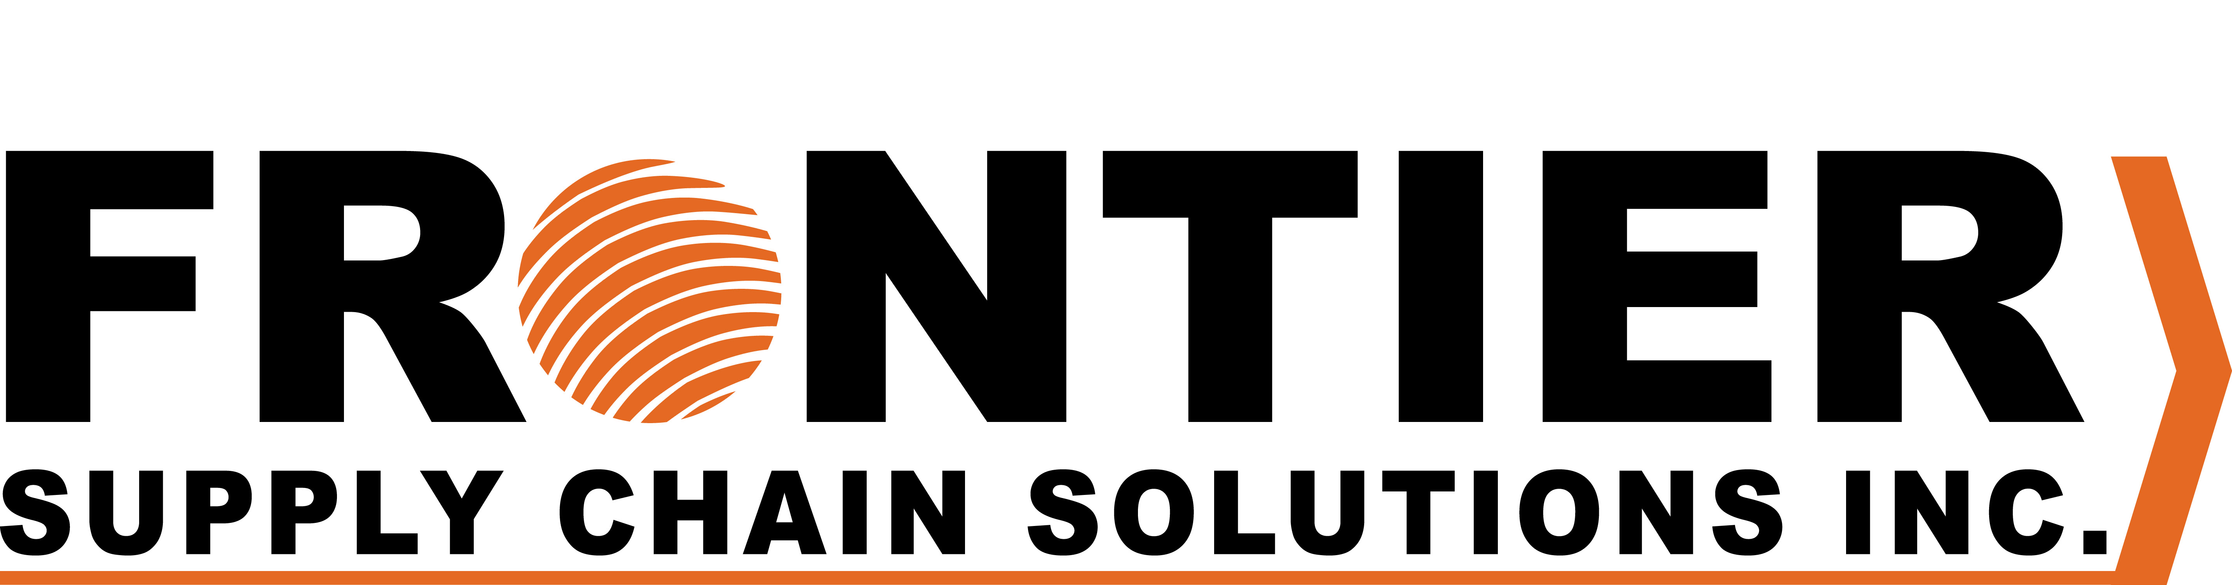

CARRIER AUTHORITY

Effective as of ____________________ this is your authority to forward all advice, Arrival Notices and other documentation covering shipments entering Canada consigned to ourselves directly to our customs broker. This cancels all previous instructions.

Frontier Supply Chain Solutions Inc.
310-555 Hervo Street
Winnipeg, Manitoba
R3T 3L6
T: 1-877-704-3727 F: 1-204-784-4803

Company:

Address: ____________________________________
____________________________________
____________________________________

Name:

Title:

Signature: ____________________________________

