**Vtiger Instruction**

**How to Login**

The welcome Screen in Vtiger is your login screen. Enter your Frontier email and create your password to sign in.

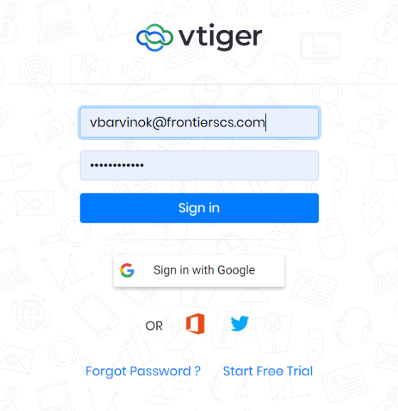

In Vtiger, there is option of “Quick Create” which allow to open any form in any open window.

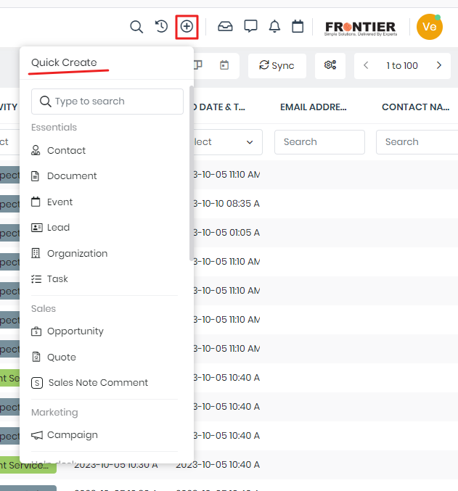

# Organization

**Organization**

You can find “Organization” in “Essentials” Apps under “Lead & Contact Management”

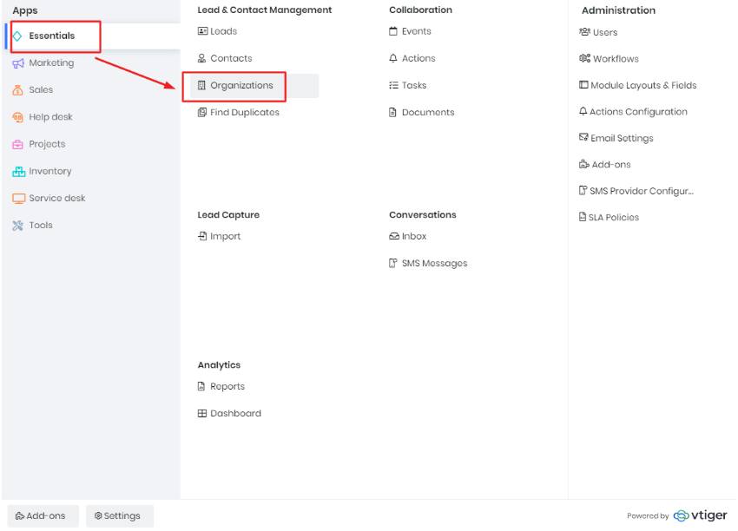

## Create an Organization

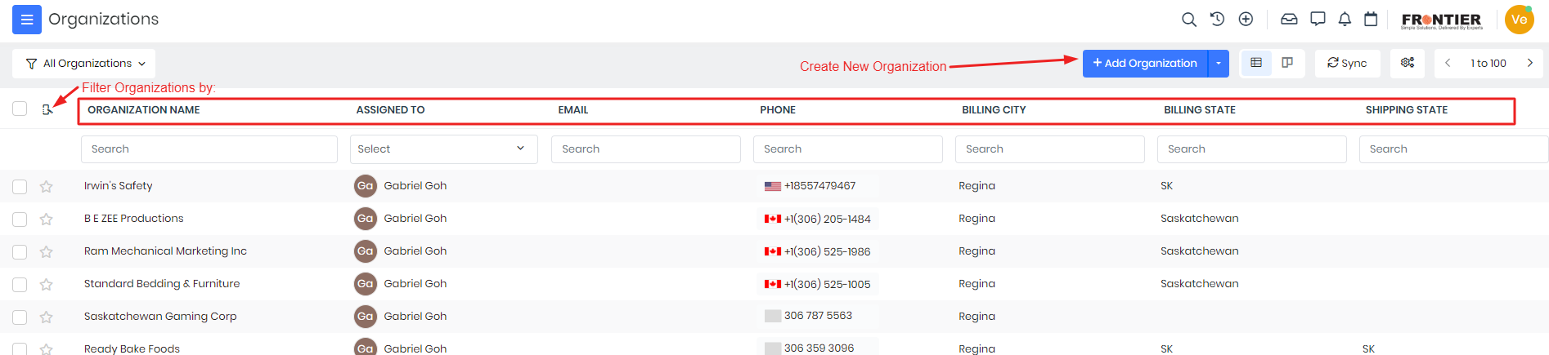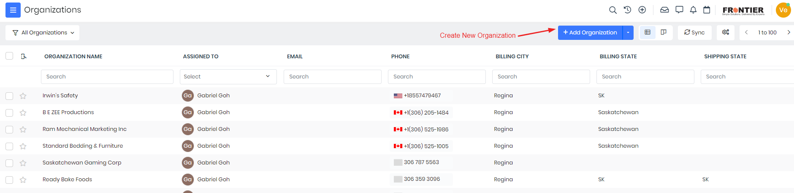

View the Opportunity Form below:

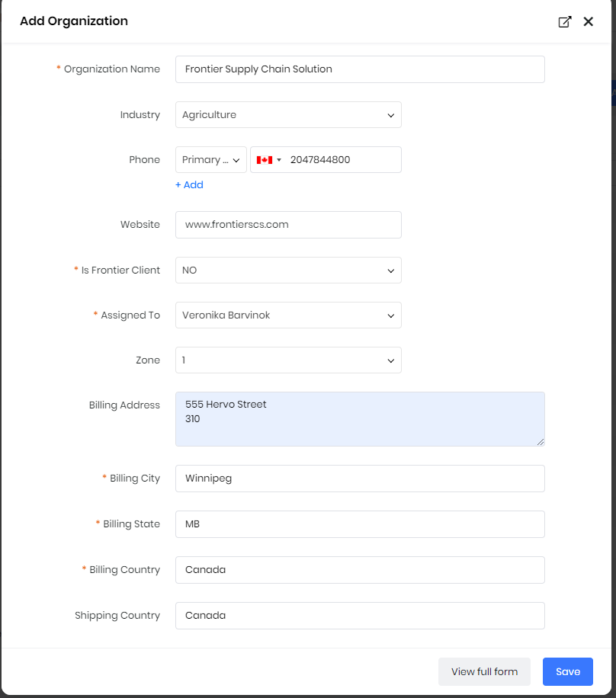

To create a new Opportunity, click button “Add Organization”. The short “Add Opportunity” Form includes:

1. Enter Organization Name (obligatory)
2. Select an “Industry” from list by clicking to the icon
3. Enter Phone number
4. Enter Website of the Organization
5. Answer “Is Frontier Client”
6. Choose assigned sales person to the Organization
7. Select Zone (0,1,2,3,4)
8. Enter “Billing Address / City / State / Country” (obligatory)
9. Enter “Shipping Country”
10. Click “Save”

# Contact

You can find “Contacts” in “Essentials” Apps under “Lead & Contact Management”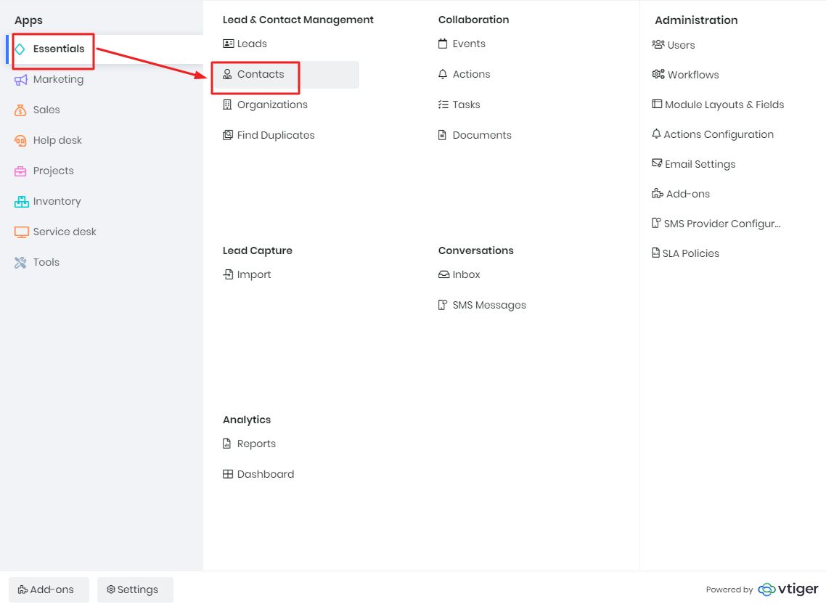

## Create an Contact

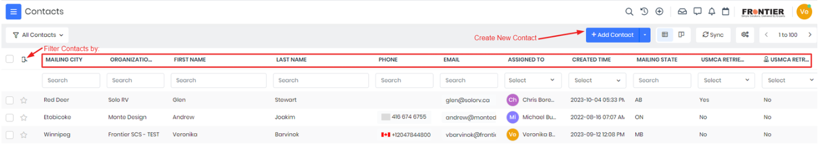

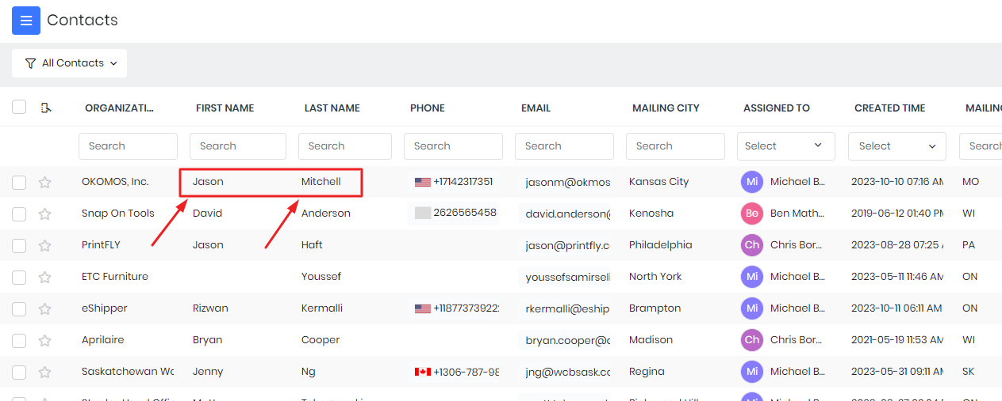

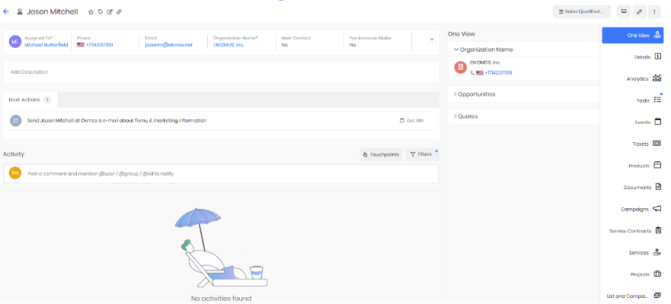

# Opportunity

**Opportunity** is a potential sales deal or business opportunity. It is a record that represents a potential sale of a product or service to a customer or prospect. It uses to track and manage the sales pipeline.

**Important:** *“When do you enter an opportunity?” - When salesperson identifies a potential sales opportunity.*

You can find “Opportunities” in “Sales” Apps under “Pipeline Management”

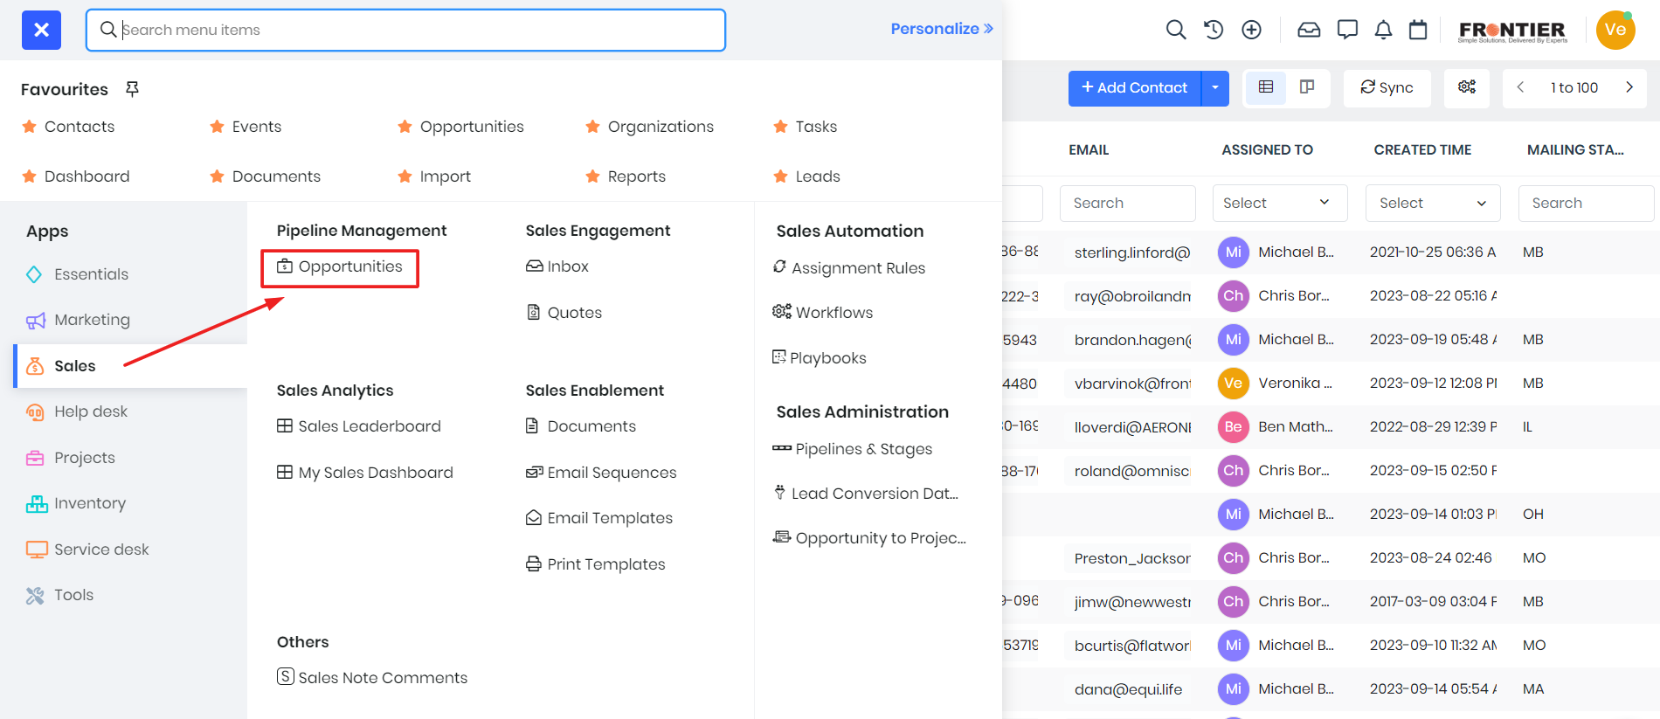

The Opportunity can be presented in List View or Kanban View. While the List View displays your Opportunities in a list form, the Kanban View shows by Sales Stage.

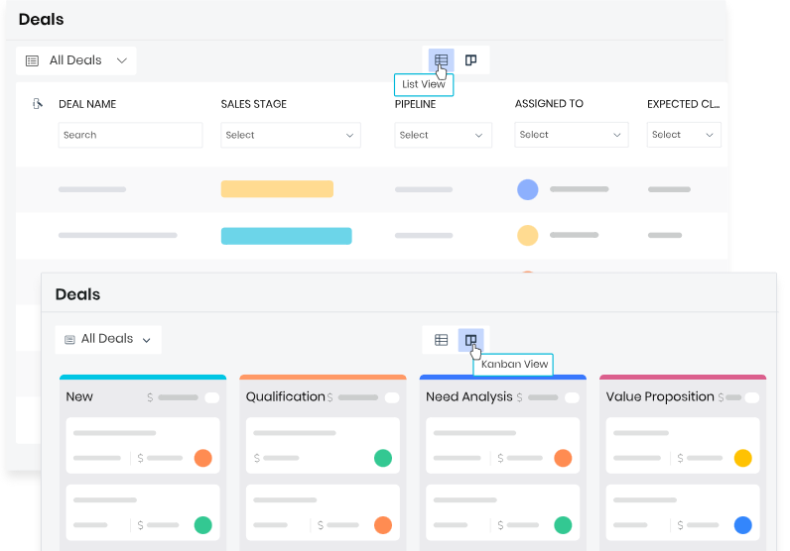

## Create an Opportunity

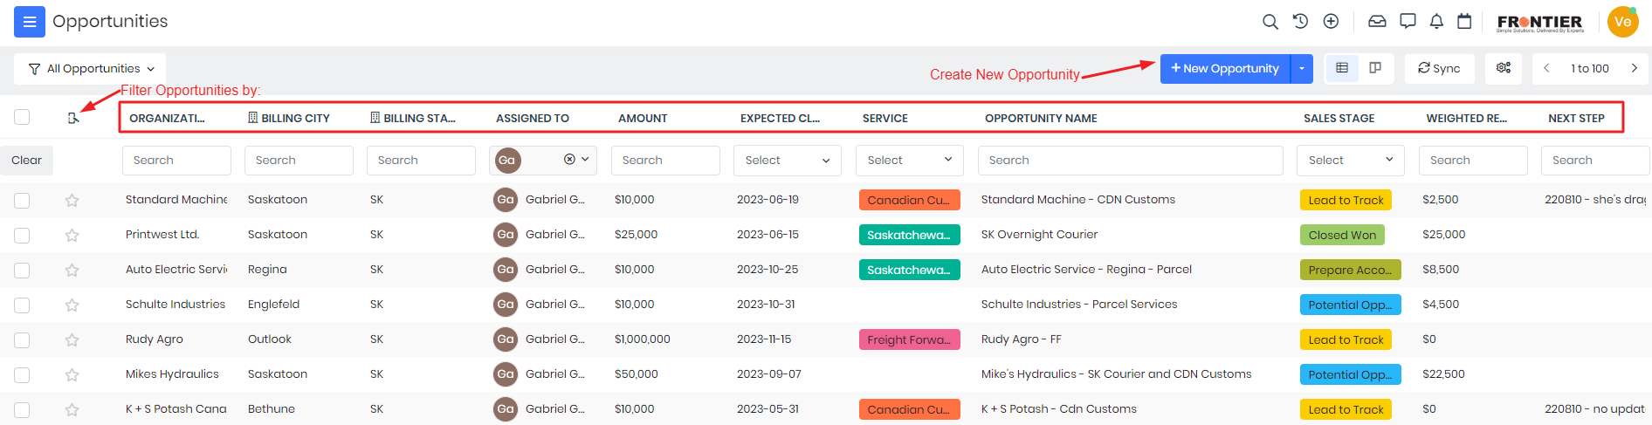

View the Opportunity Form below:

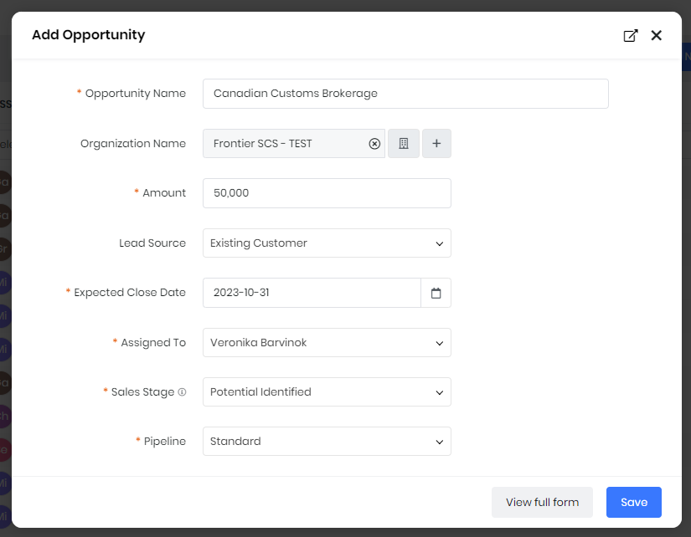

To create a new opportunity, click button “Add Opportunity”. In the appeared short “Add Opportunity” Form:

1. Enter Specific Opportunity Name (obligatory)
2. Select a Company from “Contacts” list by clicking to the icon
3. Enter expected Earrings (obligatory)
4. Choose where did you receive this Lead from the list
   1. Existing Customer
   2. Web Site
   3. Trade Show
   4. Conference
   5. Direct Mail
   6. Public Relations
   7. Partner
   8. Employee
   9. Self Generated
   10. Cold Call
   11. Facebook
   12. Mailroom
   13. Referral
   14. Twitter
   15. Mail Manager
   16. Mail Converter
   17. Other
5. Select Expected Close Date in the Calendar (obligatory)
6. Choose assigned sales person to the Opportunity (obligatory)
7. Select Sales Stage (obligatory):
   1. Lead to Track
   2. Lead Qualified
   3. Potential Identified
   4. Sales Assisted Opportunity
   5. Opportunity Qualified
   6. Potential Opportunity Relationship
   7. Proposal Stage
   8. Proposal Negotiation
   9. Prepare Account Implementation
   10. Start Date Chosen
   11. Closed Won
   12. Closed Lost
8. Click “Save”

1.a Sales Stages in Opportunties

**"Sales Stage"** is a step in sales process where it moves from a potential relationship to a paid deal.

You have to clarify Sales Stage in Opportunities accurate. To do this, we will explain it:

1. **Lead to Track:** The initial stage where potential leads are identified and entered into the system for tracking and further evaluation.
2. **Lead Qualified:** Leads that were assessed and determined to have potential for conversion into customers.
3. **Potential Identified:** The stage where specific opportunities within the qualified leads are identified, signaling potential sales.
4. **Sales Assisted Opportunity:** Opportunities that have been assigned to sales representatives for further engagement and conversion.
5. **Opportunity Qualified:** Opportunities that have been evaluated and meet the criteria for potential conversion into actual sales.
6. **Potential Opportunity Relationship:** Building and nurturing relationships with potential customers and further developing the opportunity.
7. **Proposal Stage:** The point at which a proposal or offer is presented to the potential customer.
8. **Proposal Negotiation:** The stage where negotiations take place between the sales team and the customer regarding the proposal.
9. **Prepare Account Implementation:** Preparations and planning for implementing the sale and setting up the customer account.
10. **Start Date Chosen:** The date has been agreed upon for the initiation of the sales process or customer engagement.
11. **Closed Won:** Successful closure of the sale, indicating that the deal has been won and the customer has committed to making a purchase.
12. **Closed Lost:** The sales opportunity that did not result in a successful deal, indicating that the potential sale has been lost.

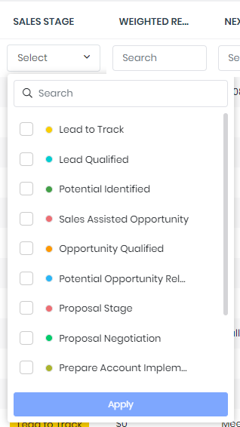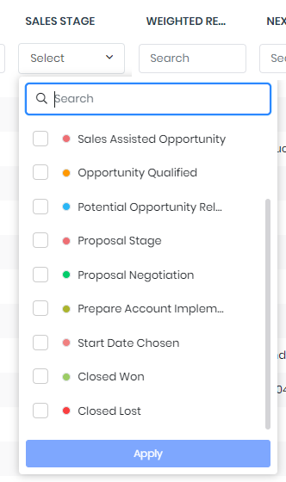

Opportunities can be presented by Sales Stage.

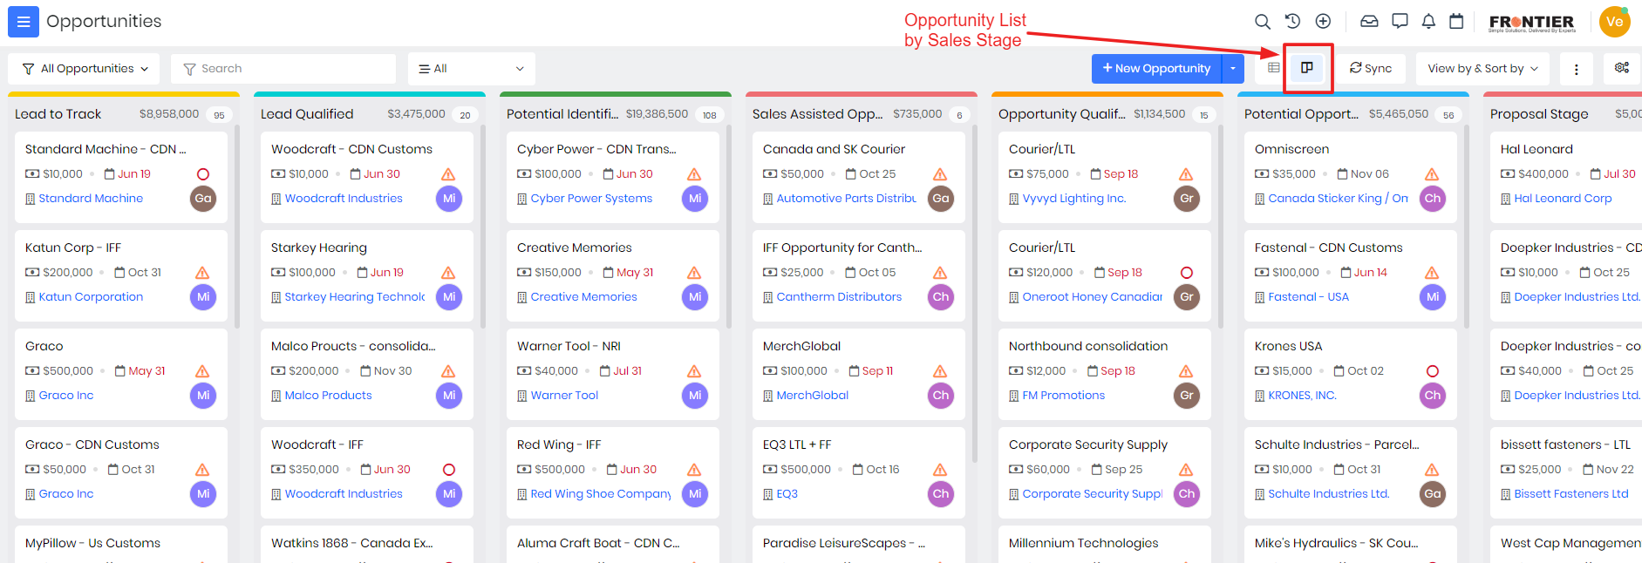

# Events

**Event** is a potential sales deal or business opportunity. It is a record that represents a potential sale of a product or service to a customer or prospect.

Events is used for

You could find “Events” in “Essentials” Apps under “Lead & Contact Management”

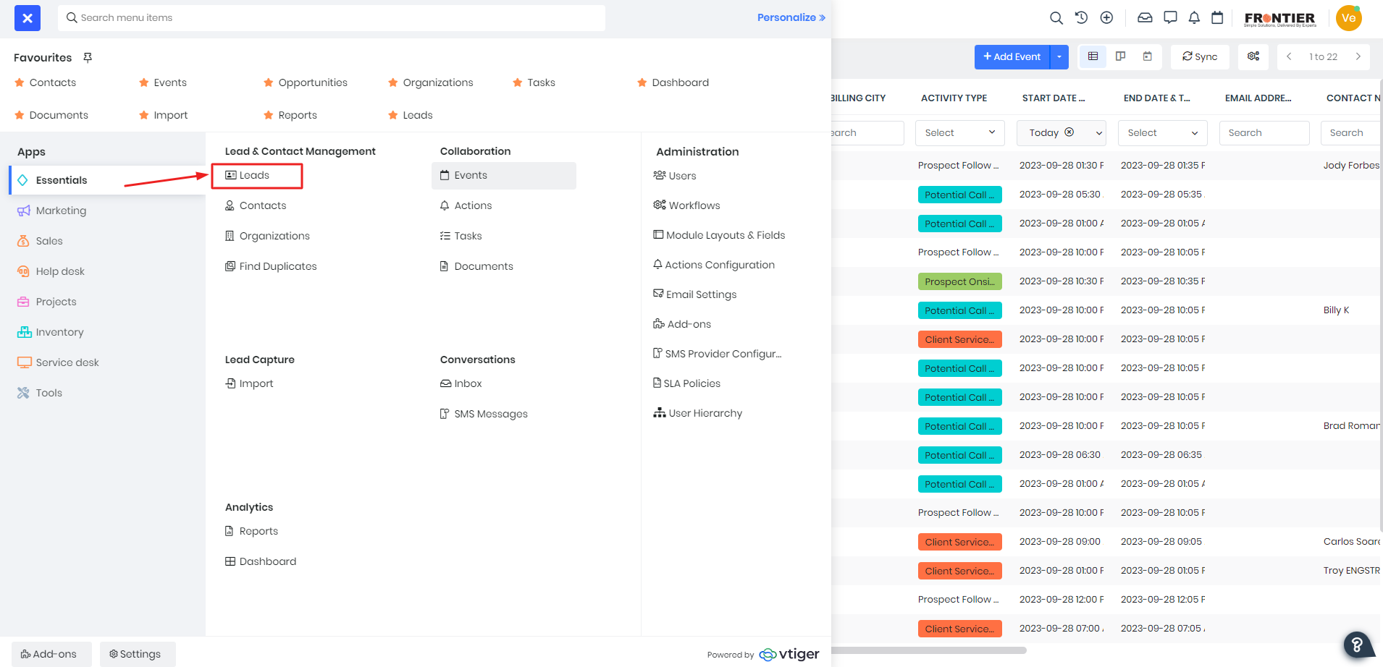

## Create an Event

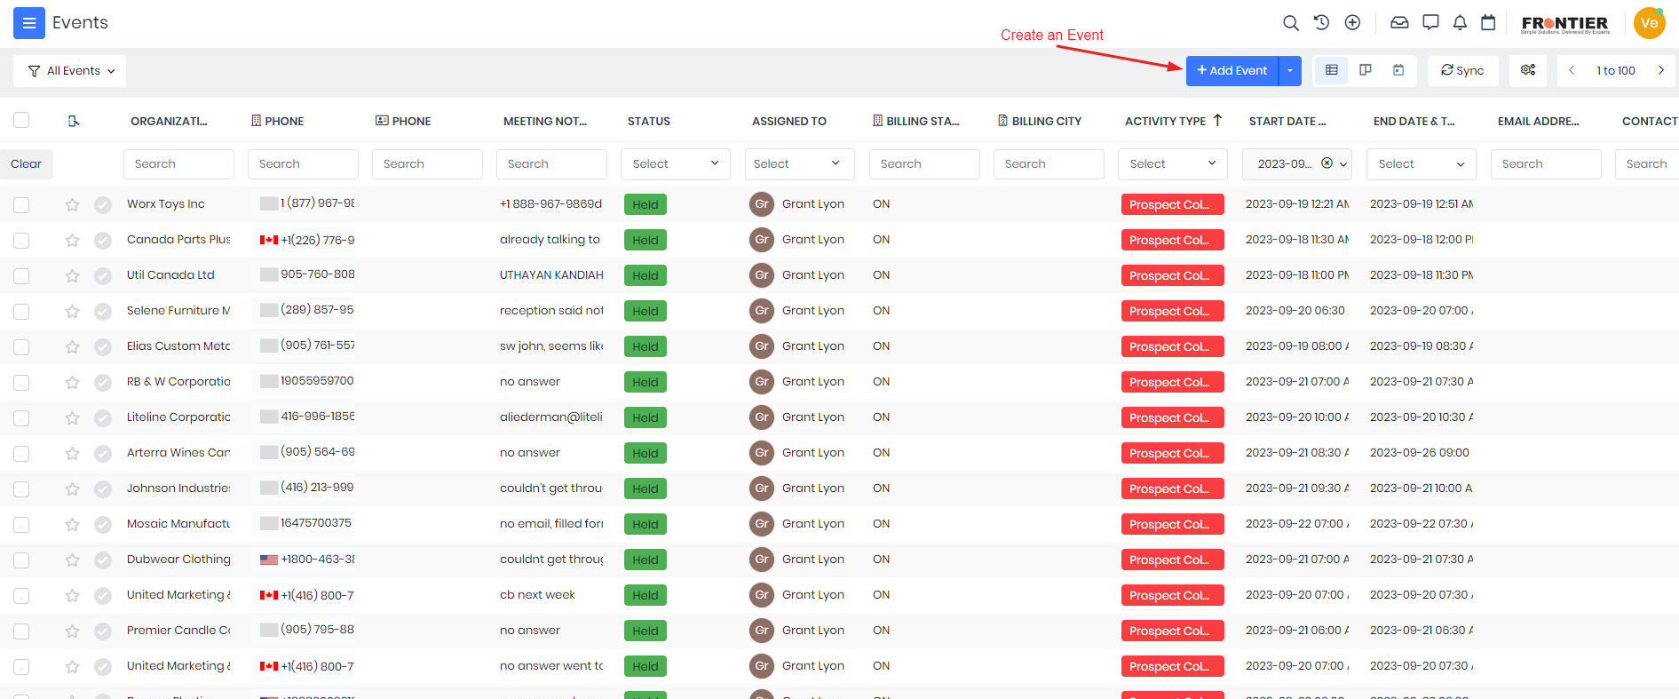

OR

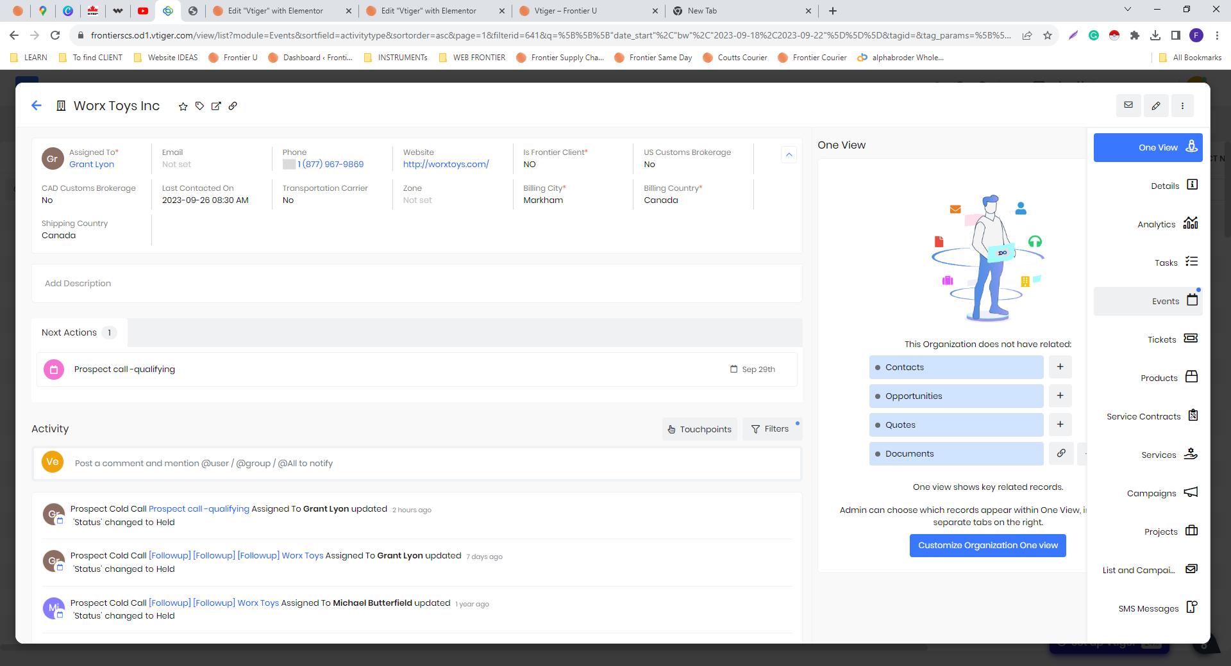

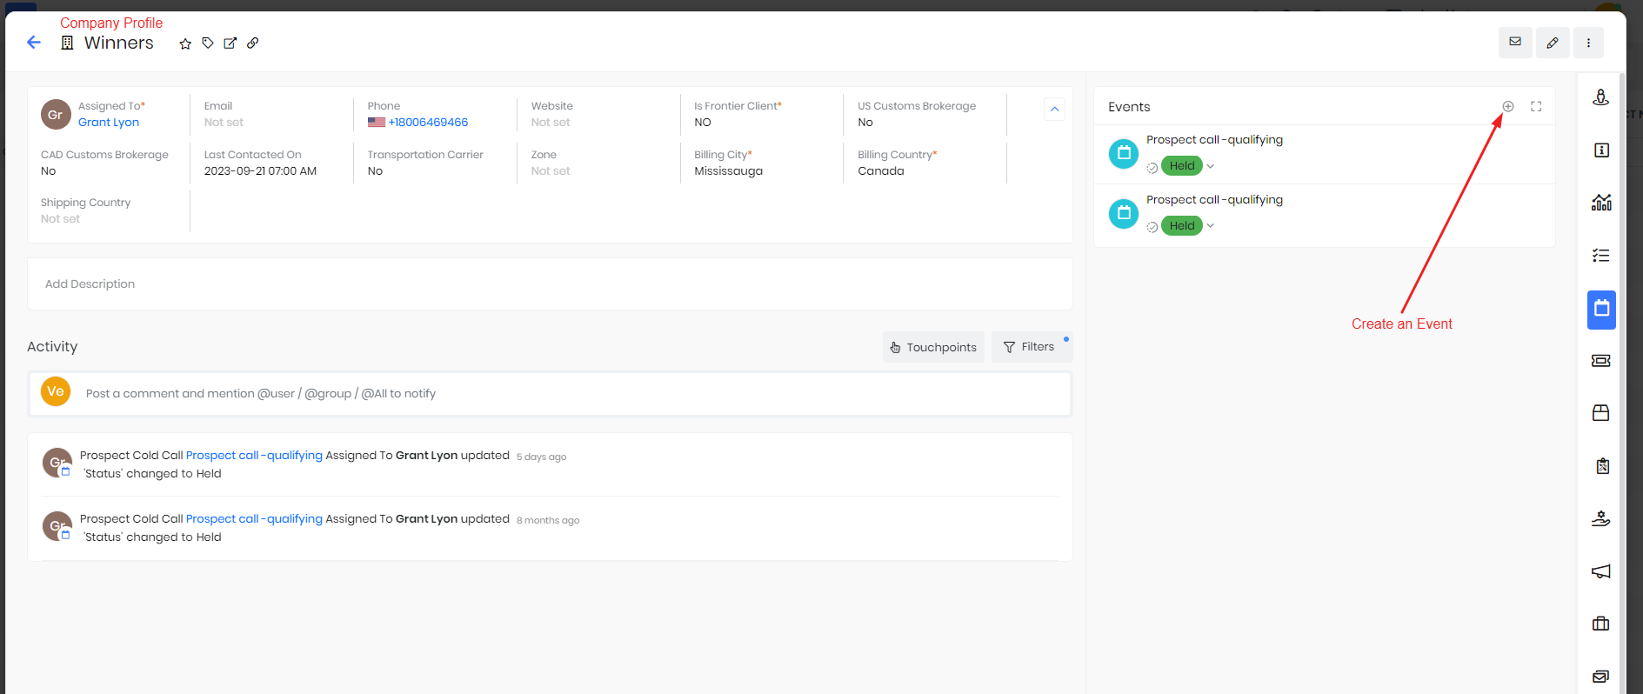

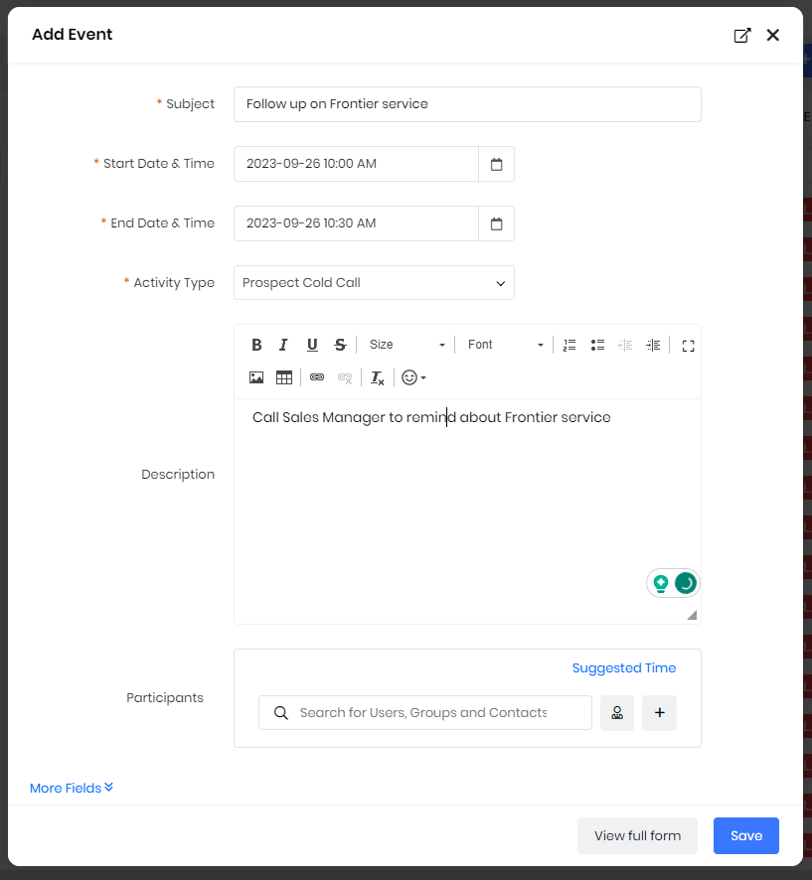

To create a new Event, click button “Add Event” in the Event section, or in the “Company Profile” choose “Events” and click “+” button. In the appeared short “Add Event” Form:

1. Enter “Subject” of Event Opportunity Name (obligatory)
2. Select “Start Date & Time” and “End Date & Time” in the Calendar (obligatory)
3. Choose assigned sales person to the Opportunity (obligatory)
4. Select “Activity Type” from the list (obligatory):
   * Prospect Cold Call
   * Prospect Follow up Call
   * Prospect Onsite Meeting
   * Potential Call or E-Mail
   * Potential Onsite Meeting
   * Client Service Onsite Meeting
   * Relationship Onsite Meeting/Lunch/Event
5. Enter “Description”
6. Choose “Participants” among Contact Person. **IMPORTANT:** DELETE the invite for client BEFORE finishing the form.
7. Click “Save”

­­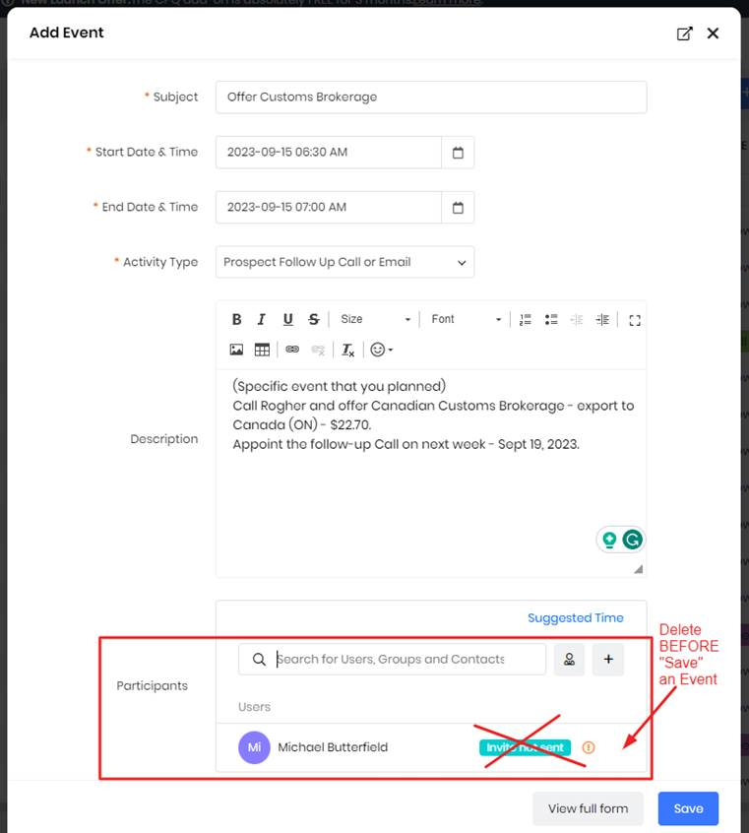

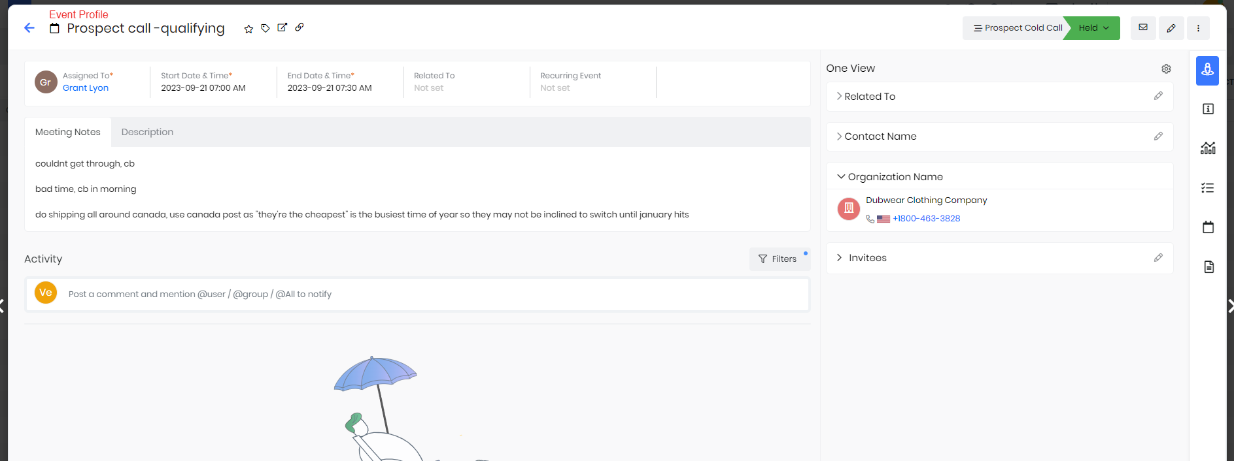

## Activity Type

**Activity Type** is name of communication type with a client.

There are following Activity Type:

－ Prospect Cold Call

－ Prospect Follow up Call

－ Prospect Onsite Meeting

－ Potential Call or E-Mail

－ Potential Onsite Meeting

－ Client Service Onsite Meeting

－ Relationship Onsite Meeting/Lunch/Event

ALWAYS **update Status** of your Events to track your progress correctly:

* Planned
* Checked In
* Held
* Not Held
* Canceled
* Rescheduled
* Skipped

