**Using Vtiger to support Your Prospecting Calls:**

1. **Helpful Tips When Calling**
2. **Checking off the Right Categories for Organizations & Contacts in Vtiger**
3. **Adding Notes to Vtiger**
4. **Helpful Tips**

Once you have your call list ready to go here are some helpful tips to prepare you and keep you organized.

**Read the notes in Vtiger**

* There may be good hints about the last time the company was contacted. Familiar subjects that you could bring up with a contact – “oh, right was that Tom?”

**Have the company’s website open in Google**

* Always look up the company prior to calling, it’ll give you a better understanding of what they do and probably specific discussion points – i.e. “oh, so you probably have shipping needs into this area”

**Zoom Info on the company name**

* Zoom info can give you a little more info on a specific contact you could make
* For mid to large sized companies it’ll give you a list of employees and their roles (smaller companies generally won’t have detailed info)
* When you’re asking for a person in a specific role i.e “The person who handles your exporting” it *May* be beneficial to have that list open to be able to say “oh, would that be Tom maybe?” (makes it look like you kind of *Know the company)*

**Recalling a company; when is it okay?**

* You want to be persistent, but not annoying
* If you think you spoke to the wrong person, it's fine to call the company again - if you have another contacts name that you think would be better
* Chris doesn’t like leaving voicemails/emails to potential contacts *before* he actually speaks to anyone. Unless he’s called multiple times and hasn’t been able to reach anyone on the other end
  + That is kind of a judgement call though

1. **Checking off the Right Categories for Organizations & Contacts in Vtiger**

**Why It’s Important:**

This is super important for us to create direct mailing lists. We want to make sure that we’re contacting the correct organizations or contacts for the services we’re promoting or message that we’re sending our mailings to. For example, we want to make sure that a company we know uses us for courier services in Saskatchewan – they’d probably be interested in learning about our ability to offer an “overnight delivery from Regina” however a contact on our list who uses us purely for getting freight into the U.S wouldn’t care and shouldn’t be receiving this email.

**Why Not Send to Everyone?**

You may think, well, why not just send to everyone? What’s the harm in that? It’ll just make sure that we’re not missing anyone. This method can be okay for *some things* but it’s not good to do a lot. People get annoyed when they’re continually getting emails that don’t pertain to them. Also, often companies will set up their internet servers to filter out certain content. It will begin to recognize your content a “spamy” when its receivers continually do not open content sent by you. So, when you’re sending them something that actually applies to them (or another contact you have within that organization) it may not go through properly.

**Who Needs to be Checked Off?**

We export our lists based on Organizations or Contacts. We mostly use contact lists because the contact will have a direct email address associated with them that will appear on the exported list. So It’s very import to make sure your Contacts are checked off in the categories that you want them to receive mailings for.

**Our Categories (under Contact):**

You can find these checkboxes under “Details” for a particular contact (click on Organization name):

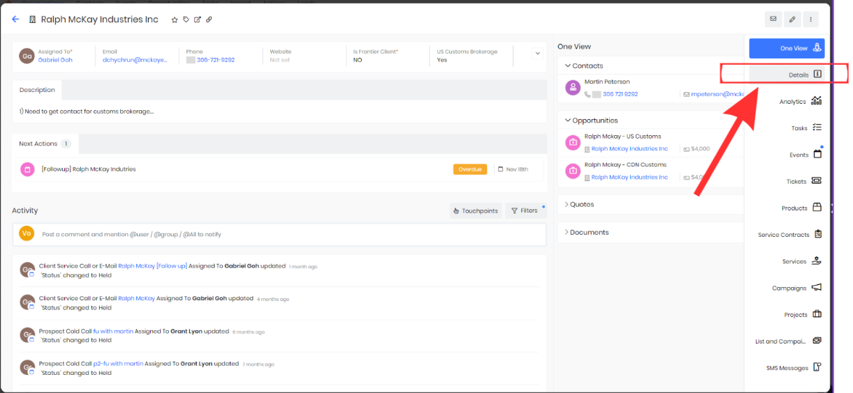

The Contact Detail & Service Categories:

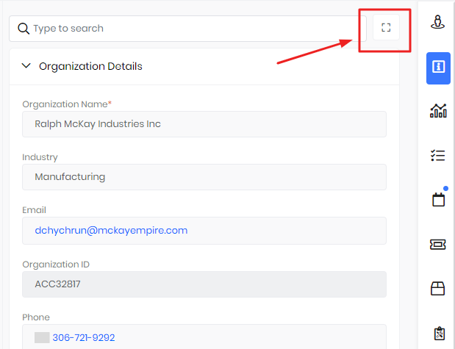

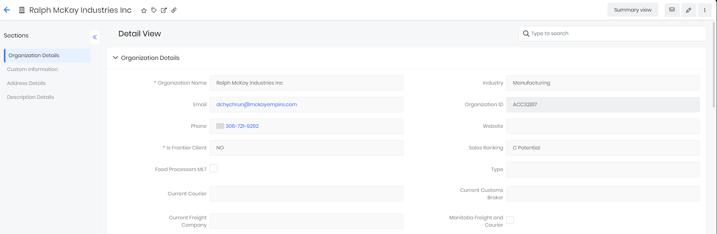

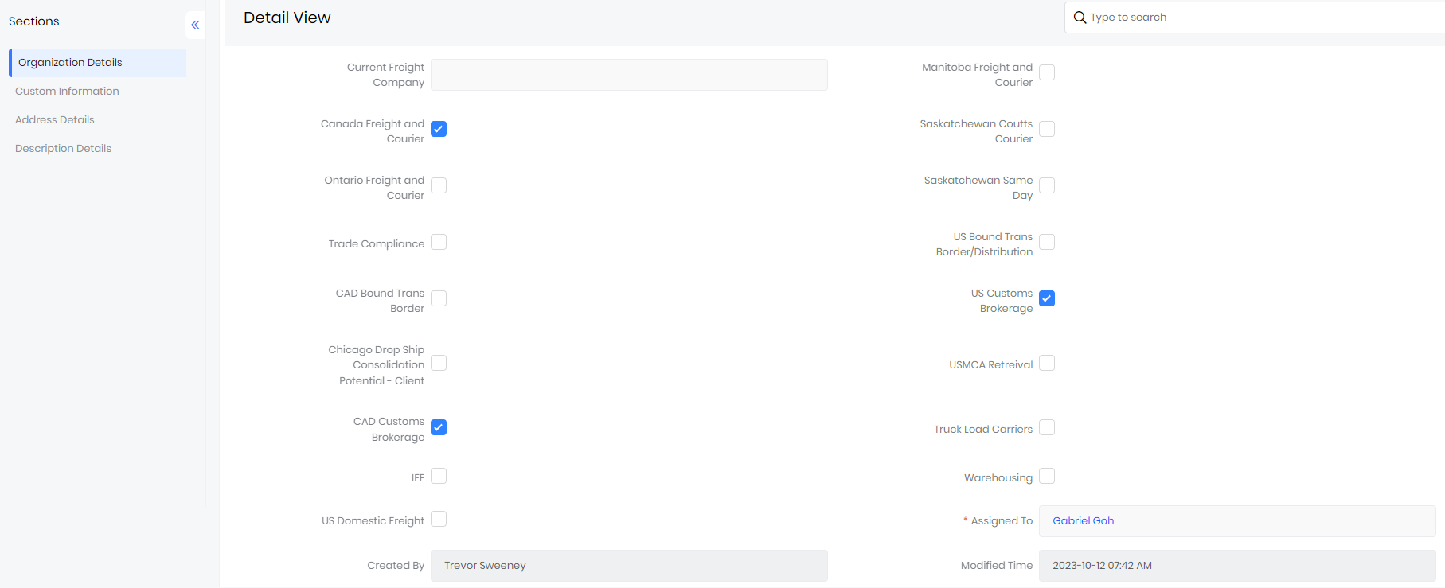

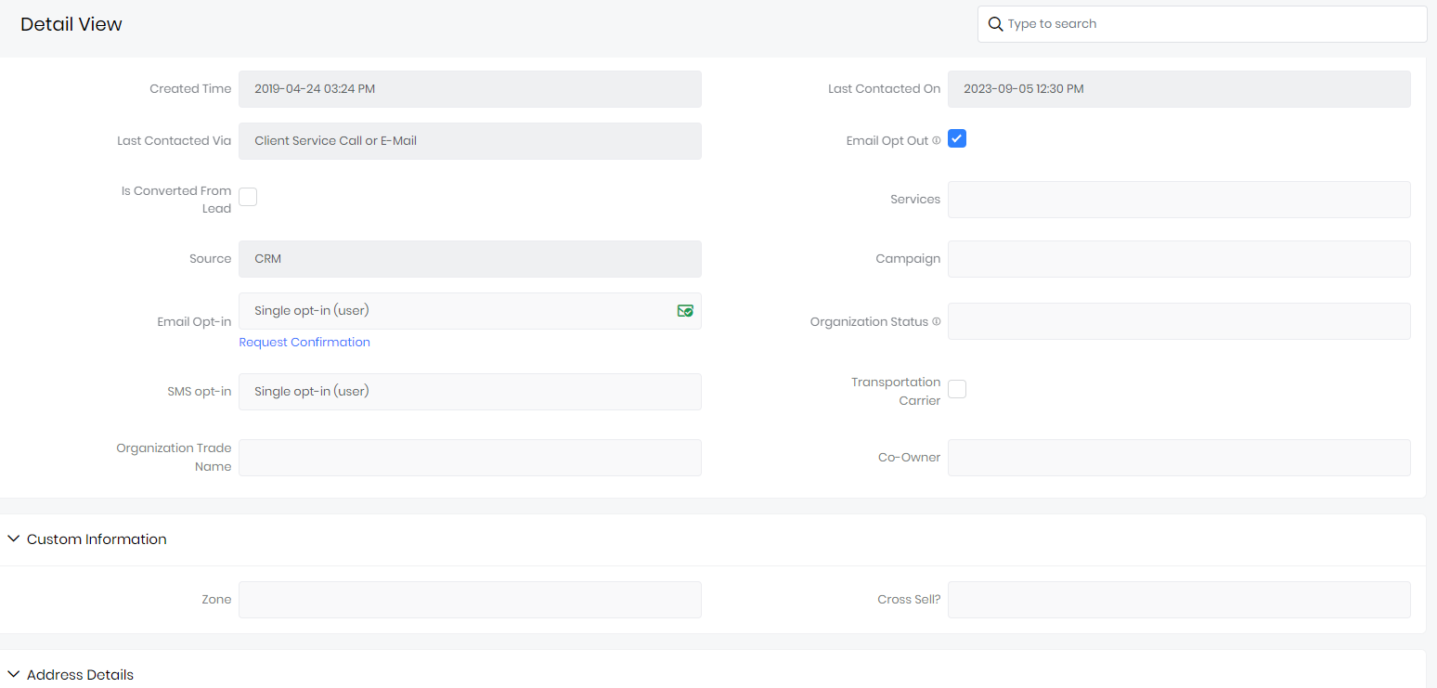

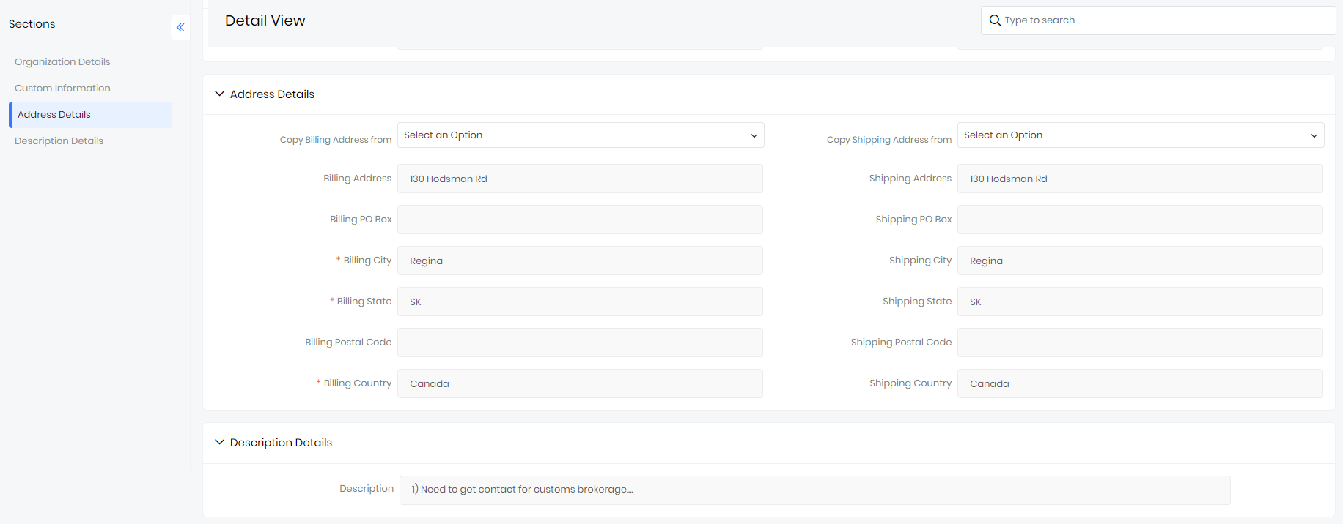

When you make your contacts, you need to check off which categories you think they’d be interested in receiving corresponding emails about. For example, if you’re phoning companies in Regina, SK to promote our courier service in Saskatchewan it makes sense to check them off in those categories to ensure they receive updates.

I’ve highlighted the Food Processors MLT box for this example. When you get the email/contact name of someone you think is interested in this event, check them off to ensure they get all of our emails about the event!

**Shortcuts:**

When we’re promoting a certain event/service or directing a message towards a category, I will add the detail checkbox to the “key fields” which will appear on the first page once you click in the contact. It makes your life a little easier for when we create a new mailing and you have a bunch of contacts in mind that you’d like to add to the mailing list.

In the example below, it shows that I have put the “Food Processors MLT” in the key fields for you.

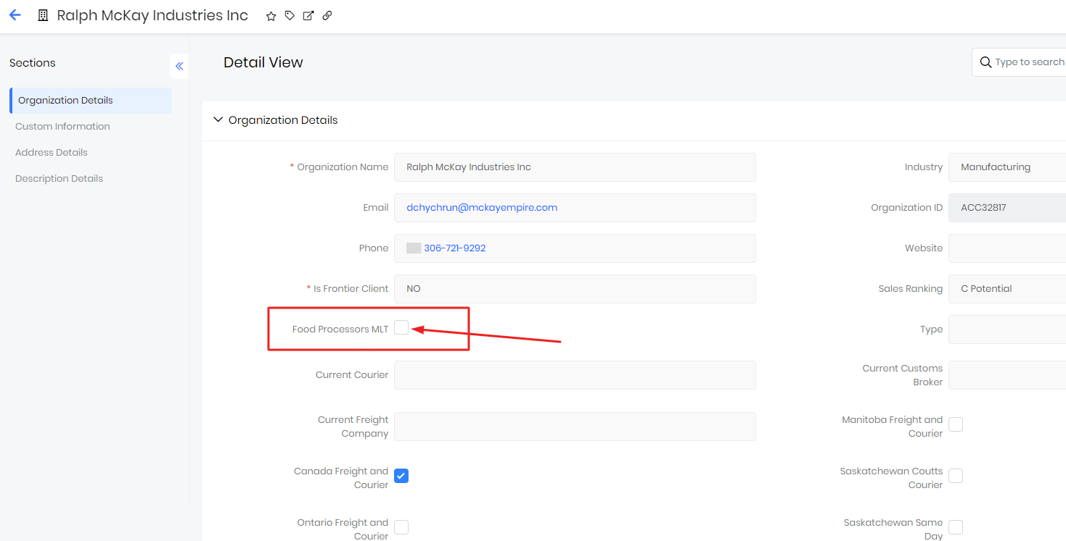

**Location Details:**

It’s super important that you fill this part out as well, in the right lines. It ensures that we will reach the contacts that reside in certain places when we are directing a mailing to a specific region.

1. **Adding Sales Notes to Vtiger (Events)**

When you call a company, you will want to create notes about the interaction and where you are in the process. You will also want to set up reminders for yourself, that will show up in your calendar reminding you to reach out to contacts at a later date.

Under the contact, select “Events”

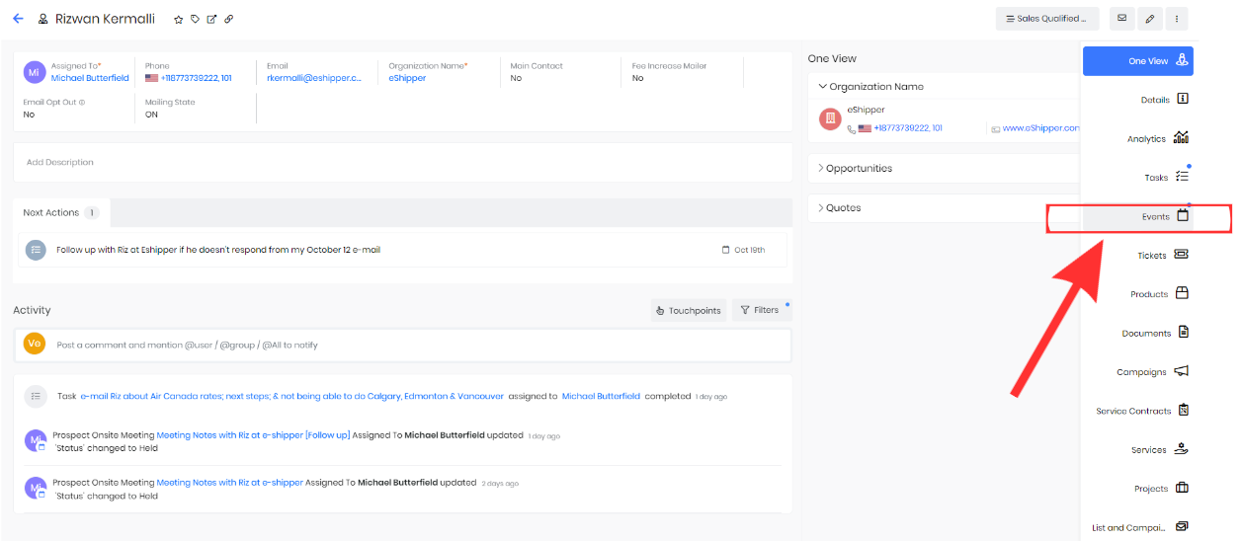

If they’re a new contact, that you’re calling for the first time, select an icon “Add Event”

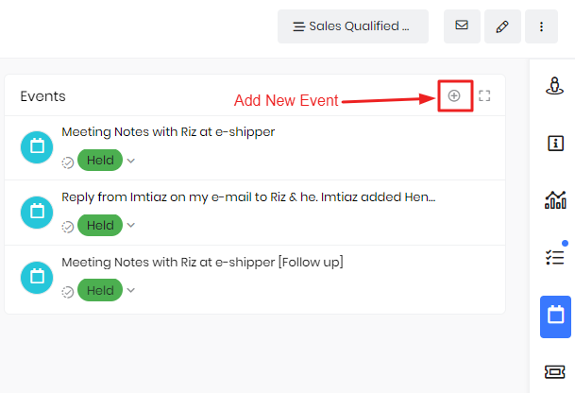

For contacts that you’ve had multiple interactions with, the events thread will appear with the dates and times for the last time they were contacted and when your next event is planned to take place.

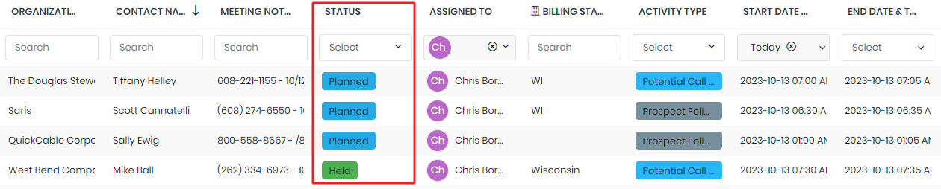

If you have a thread going, click into the latest one to add your new notes in, if you’re creating a new event, start the thread from scratch. Select “Details” under “Events”. The below page will appear. Once on the details page, select the edit button in the top, right-hand corner.

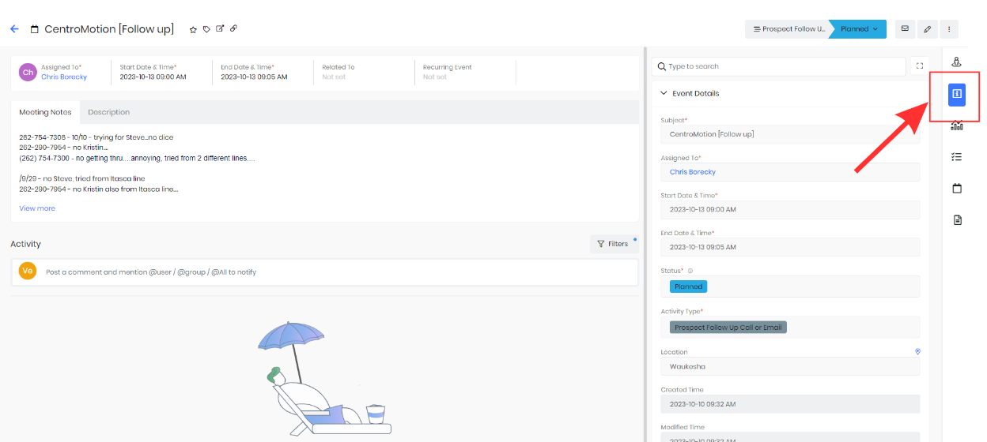

Once in edit mode, you can record the details of your interaction.

**Subject:** Title it something that makes sense to you

**Status:** Was it held or is it something that will happen in the future

**Activity type**: What kind of an interaction was it (where are you in the process of this potential client)

**Assigned to:** Assign it to yourself* (if the contact was assigned to someone else prior, and you’re now taking over) – if it’s not assigned to you and you create a “follow-up” it will not show up in your Calendar.

scroll down to the “Description Details”. This is where you will make all of your sales notes about your interaction with the contact:

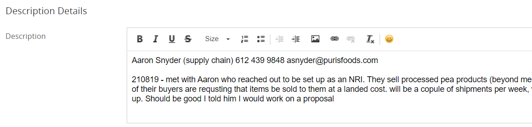

**\*\* Hints,**

* Because this is a place that you visit often, it’s a good idea to put the contacts Name/Phone number/Email at the top of the conversation – creates an easy shortcut for you in the future
* You can write your dates and style in a way that makes most sense to you
* Be detailed, and record – this is something that we (Michael) directly monitor

**Hold “Follow-up”**

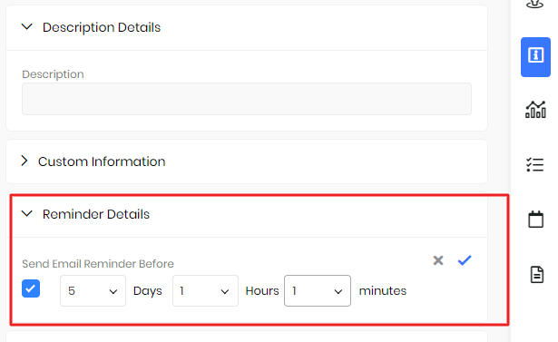

Check-off “Reminder Details” and select a days and hours that you want to reach out to them next i.e

* Whether that’s need to send a brochure/rates sheets

**The Calendar:**

You can find your Vtiger calendar here where all of your reminders will pop up for you.

