**Using the revenue report to find potential courier clients in rural Saskatchewan:**

**Overview of what we’re doing:**

There are a lot of companies that use our courier services in Saskatchewan – but we’re not *really* interacting with them. These are companies that are infrequently using our service for whatever reason (i.e. because their usual courier wasn’t available/possibly or they may have been a client in the past and are not anymore..). These companies are often a missed opportunity because *we could* be getting more buisness from them. (You’re more likely to use a service when you have a relationship with someone – and this likelihood increases the more interactions you have (to a point..)). There is also an opportunity to cross-sell another service to these guys i.e helping them import into Canada.

**Your goal:**

1. Look over the revenue report to familiarize yourself with the *types of companies* that use our services.
2. Create a call list for yourself to start calling in the upcoming weeks. You want to begin developing a relationship with them to hopefully increase their involvement with us!

**Where to Find the Report:**

Shared folder🡪Everyone🡪Power BI reports🡪Power Query 🡪 Sales reports with yoy mom (year-over-year, month-over-month).

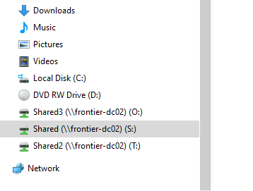

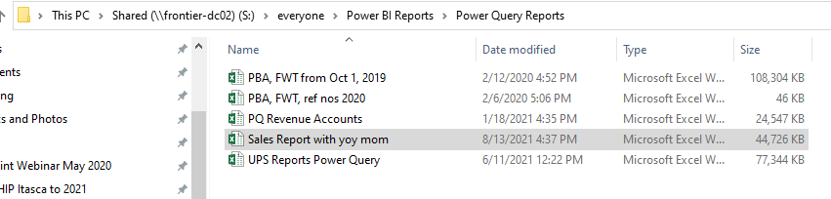

**Your steps:**

When you open the report, it will look like this:

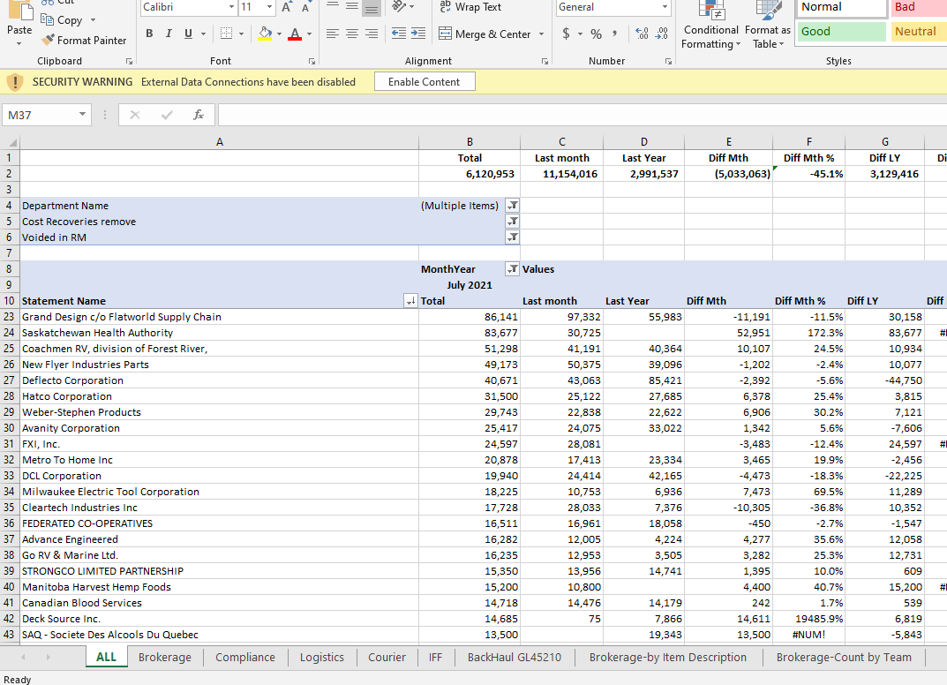

Go to the Courier tab at the bottom



Then select the “SK-Coutts” tab

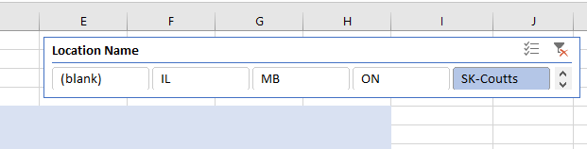

This will display all the companies that used our courier service in Saskatchewan in the last month. Your goal is to find the companies in the revenue **rage of 0 – 500ish** because they represent the types of companies that we could potentially get more revenue from.

Example Hillberg & Berk:

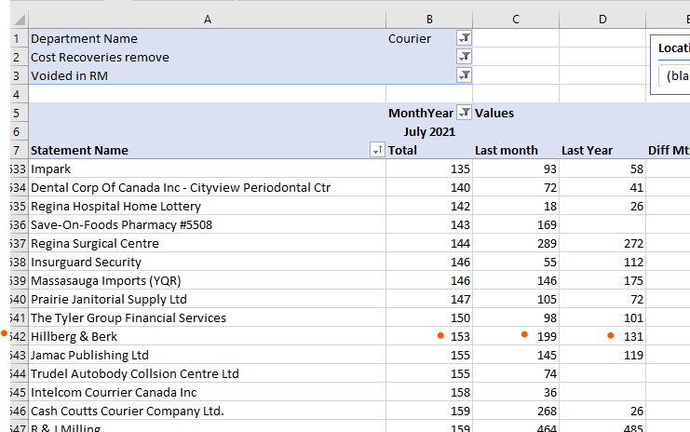

Your next step is to see if they exist in Vtiger. Search under “All Organizations”.

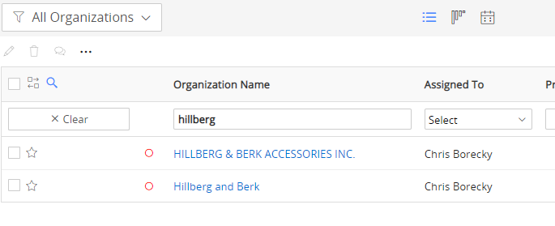

So this company exists, but if you hover over the red circle it tells you that they’ve been “idle” fo r7 years

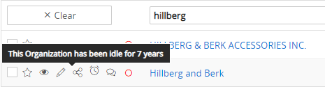

So clearly no one has interacted with them for a very long time. They would probably be worth calling.

* Always look under the “Activities” to read old notes (events) about the contact or company. This will give you a bit of a heads up about the past (maybe there’s a reason we stopped calling them)

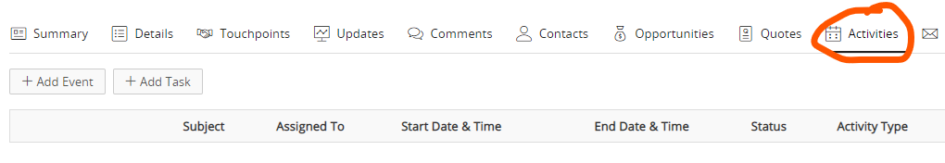

Then search these companies on Google for a phone number and address that can be added to your call list (or updated for existing contacts when applicable).