**Categories for mailing lists:**

**Checking off the Right Categories for Organizations & Contacts in Vtiger**

**Why It’s Important:**

This is super important for us to create direct mailing lists. We want to make sure that we’re contacting the correct organizations or contacts for the services we’re promoting or message that we’re sending our mailings to. For example, we want to make sure that a company we know uses us for courier services in Saskatchewan – they’d probably be interested in learning about our ability to offer an “overnight delivery from Regina” however a contact on our list who uses us purely for getting freight into the U.S wouldn’t care and shouldn’t be receiving this email.

**Why Not Send to Everyone?**

You may think, well, why not just send to everyone? What’s the harm in that? It will just make sure that we’re not missing anyone. This method can be okay for *some things* but it’s not good to do a lot. People get annoyed when they’re continually getting emails that don’t pertain to them. Also, often companies will set up their internet servers to filter out certain content. It will begin to recognize your content a “spamy” when its receivers continually do not open content sent by you. So, when you’re sending them something that actually applies to them (or another contact you have within that organization) it may not go through properly.

**Who Needs to be Checked Off?**

We export our lists based on Organizations or Contacts. We mostly use contact lists because the contact will have a direct email address associated with them that will appear on the exported list. So It’s very import to make sure your Contacts are checked off in the categories that you want them to receive mailings for.

**Our Categories (under Contact):**

You can find these checkboxes under “Details” for a particular contact:

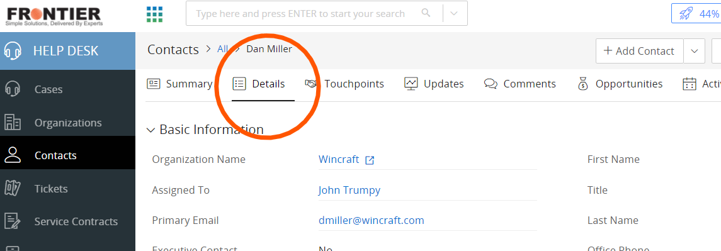

The Contact Detail & Service Categories:

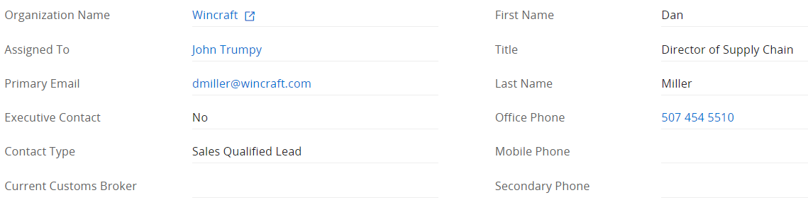

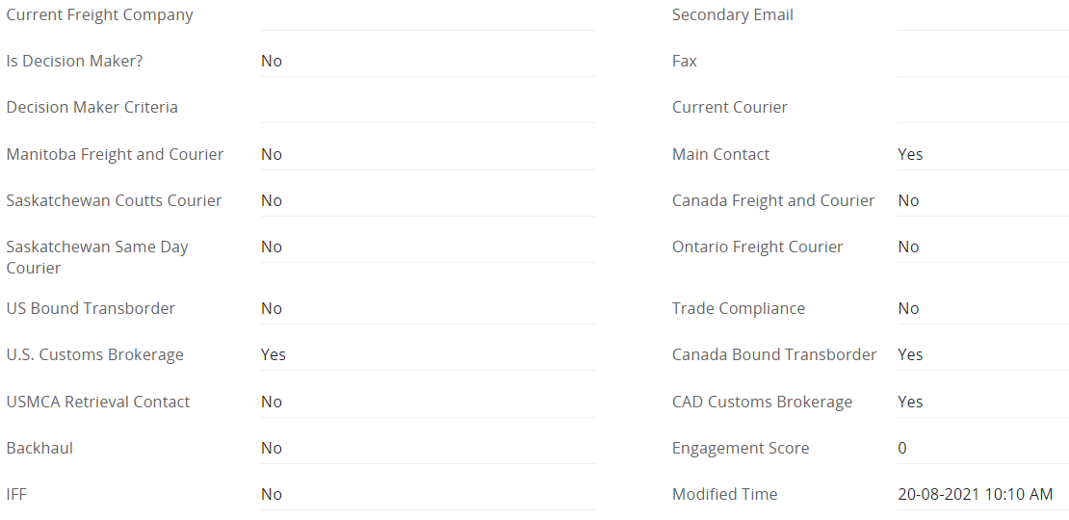

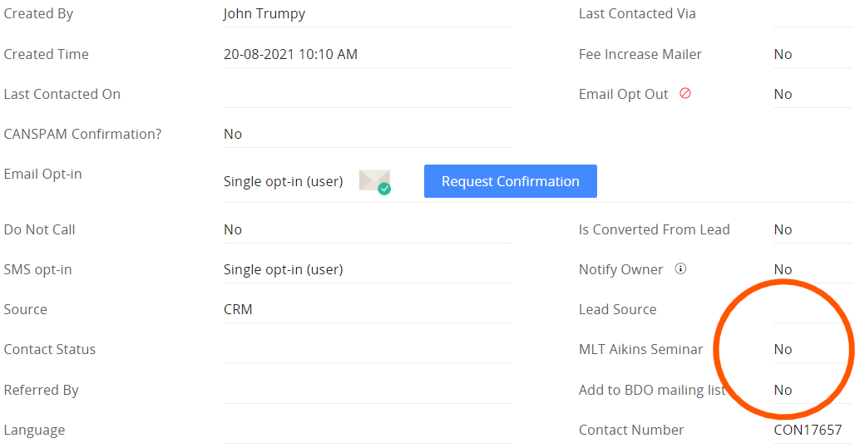

When you make your contacts, you need to check off which categories you think they’d be interested in receiving corresponding emails about. For example, if you’re phoning companies in Davidson, Sk to promote our courier service in Saskatchewan it makes sense to check them off in those categories to ensure they receive updates.

I’ve highlighted the MLT Aikins box for this example. When you get the email/contact name of someone you think is interested in this event, check them off to ensure they get all of our emails about the event!

**Shortcuts:**

When we’re promoting a certain event/service or directing a message towards a category, I will add the detail checkbox to the “key fields” which will appear on the first page once you click in the contact. It makes your life a little easier for when we create a new mailing and you have a bunch of contacts in mind that you’d like to add to the mailing list.

In the example below, it shows that I have put the “MLT seminar” in the key fields for you.

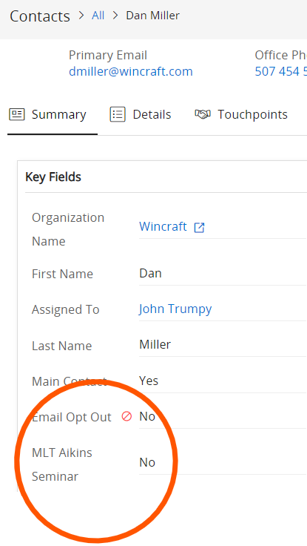

**Location Details:**

It’s super important that you fill this part out as well, in the right lines. It ensures that we will reach the contacts that reside in certain places when we are directing a mailing to a specific region.