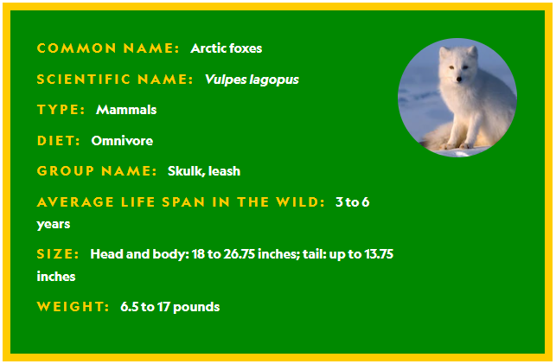
Not far from the North Pole, the world is frozen for thousands of miles. Suddenly a snowy mound wiggles and reveals two dark eyes. The lump is transformed into the furry white body of a lone arctic fox. The canine casually shakes the blanket of snow off her thick coat—the key to her survival. But warm fur alone might not keep this fox alive during the polar winter, when temperatures rarely get above zero degrees Fahrenheit. Until spring arrives, this arctic fox will rely on some freeze-defying strategies, making it a champion of the cold.

BUILT FOR THE ARCTIC
Arctic foxes live on the land and sea ice within the Arctic Circle. Winter in the Arctic is unlike winter in most parts of the world. From October to February, the sun never rises to shine warmth and light.
Luckily, these small foxes have some useful adaptations for living in the icy Arctic. Their thick fur coat keeps the fox’s body at a toasty 104°F. Their long, fluffy tails act like a blanket, keeping the fox warm when it wraps the tail around its body to sleep.
Their feet also have a layer of thick fur, like built-in snow boots. This helps muffle an arctic fox’s footsteps, making it harder for prey to hear them. And their white coats make it difficult for predators such as wolves, polar bears, and golden eagles to spot them among the ice and snow.

FINDING FOOD
When it’s not trying to keep warm or avoid predators, an arctic fox is on the hunt for food. They prefer to eat small rodents called lemmings, but when times are tough they’ll eat whatever they can find: insects, berries, and even the droppings of other animals. Sometimes an arctic fox will follow a polar bear on a hunting trip and eat the bear’s leftovers.
If a fox can’t find food, or if the weather gets really bad, it can dig a snow den and hunker down for up to two weeks. As long as a fox is warm, it can slow down its heart rate and metabolism, which helps the animal save energy so it doesn’t have to eat as much. It’s sort of like how bears hibernate, but for a shorter period of time.
Once the animal emerges from its den, it’ll try to hunt again. With food in its belly, the arctic fox has a better chance of making it through another long, dark winter.
