**Fee Increase mailing directions:**

**What it is and why we do it:**

Every year we send out a fee increase letter to our clients to account for inflation and other general price increases to our services.

**Process:**

1. Create a contact list (not organization) in Vtiger with the following conditions:

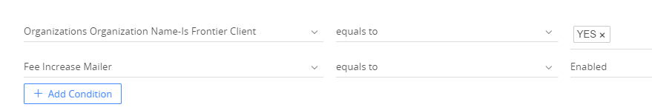

* Note*
  + Yes, Frontier client (under the organization)
  + Fee increase (under the designated contact)
  + We want a contact list because when we export it, it will allow us to see individual contact details (name, email etc)

1. Export the excel file and save as an excel workbook
2. Make pivot tables that for all of the different service categories we have (courier, customs brokerage, transborder, IFF). *Each in their own sheet
3. Get a “Revenue report” from a recent month and cross reference it to the exported fee increase mailing list.

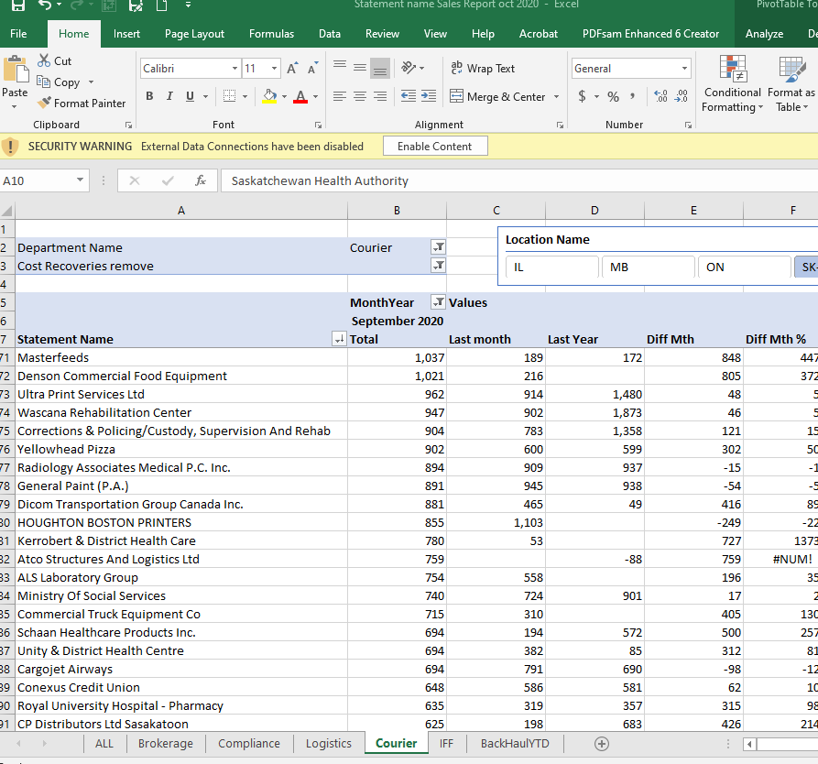

* + Cross reference each service category separately (Courier, IFF, Customs brokerage)

1. Make a new workbook and call it something like “November Revenue report vs Vtiger fee increase list”
   * Make all of the tabs on the bottom to be associated with a service category
2. Cross reference the two lists:

* Copy the first two columns from “Revenue report” and paste it into a new workbook

**Vtiger**

* Organization needs to be checked off in the following “categories”
  + Frontier client
* Contacts need to be checked off in the following categories
  + Fee increase (*note that this person needs to be designated as the person to receive this letter
* We need to

**Common Problems Each Year**

* The statement name (given on the revenue report
* Sometimes a contact is checked off as a fee increase when they shouldn’t be
* An organization may not always get an increase each year for whatever reason but still appear on the list
  + They have a different way of designing the contract that year, they’re a new account, they set their own rates..etc.
  + The organization may however still have a contact checked off in the “fee increase category” because *next year* they will be included on the list or they were included the previous year
  + we still
* There may be an organization on the
* Vtiger doesn’t include all of the organizations that we have on our revenue report – so we know that we do business with them, but have no contact for them in Vtiger, and therefore won’t appear in our list
* Sometimes you think something is checked off but you checked it off in the wrong section (Contact vs. Organization) so it doesn’t get met in the conditions when we make the list
* Statement names from GP/Cargowise don’t always match – Big problem*
  + The best way to deal with this is by refencing the recent revenue report, taking that name and making sure the Vtiger organization name matches it (change the Vtiger “organization name” to match the statement names
  + This takes a long time to do, very tedious

**Solutions**

* We have contacts/emails on GP that Maureen can send to us, for the companies that we don’t have in Vtiger
  + The problem with this: they’re generally accounts of people who wouldn’t make decisions regarding fee increase – (the good thing about Vtiger is that the sales team can determine who should get the letter)
  + Good for when there isn’t another option though, because at least we know that someone in the organization is receiving the letter and can forward it to the right person

**Suggestions for next year**

* First, make sure the sales team goes into Vtiger and matches the organization names to the statement names from GP. This is essential to getting the Vlookup to work. checks off the right things for the companies they know they want included in the letter.
* Export the list and compare it to our revenue report right away
* I really think a shared excel file that everyone can edit at the same time would be very beneficial
  + I ended up with so many different excel files (all looking very similar) from everyone who had their edits/suggestions
  + Trying to keep one file was difficult
  + This “mastersheet”