**Pull a Shipment Management Report – Vitran**

1. Having an Account on Vitran’s website is required. Sign up information below if needed.

**For  Vitrac Registration Please use the link below-**

<http://www.vitran.com/canadian_ltl/cgi/webreg.htm>

Please enter-

WEB Account-FRO8443723

WEB Password-9QNC86CFRO

User needs to enter his/her email address.

1. Once you have an account/log in, from their main page, select VITRAC

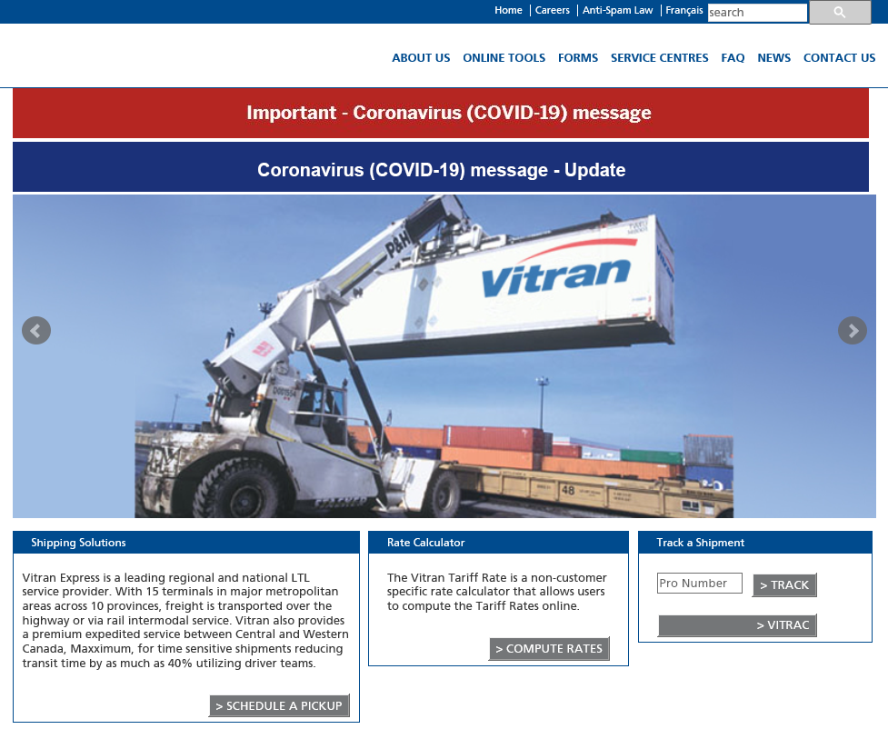

1. On the next page, you will have to select the Vitrac drop down arrow that will bring you to another page.

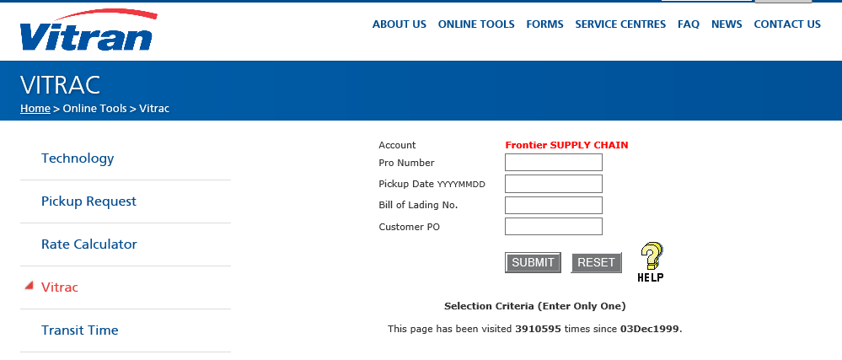

1. Select Web Reporting

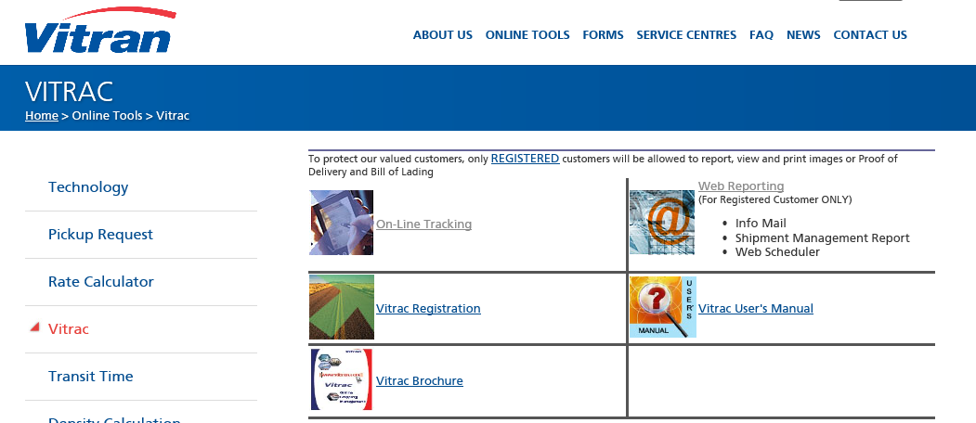

1. In Web Reporting, select Shipment Management Report

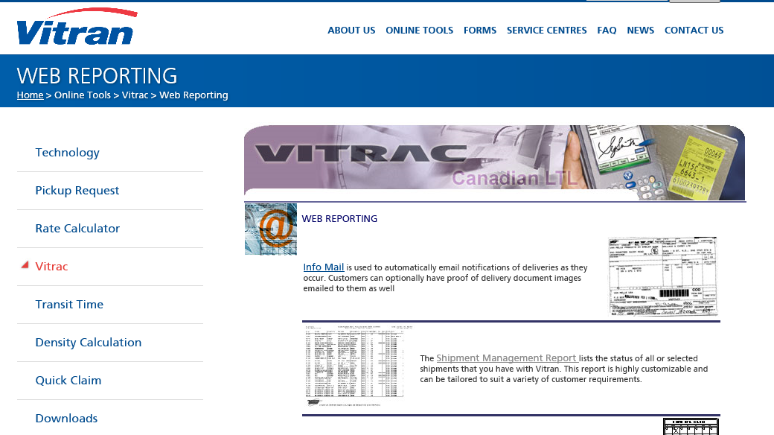

1. On this next page, this is where you can select exactly what you want to see on the report. (Example: Date Range, From Province, Vitran PRO#, etc.)
2. Ensure you change the File Format to Excel, not PDF, and the Email Report To is your email.
3. The best thing to do is to select all the options available to see on your report, then you can delete anything once you have the excel report if you need.

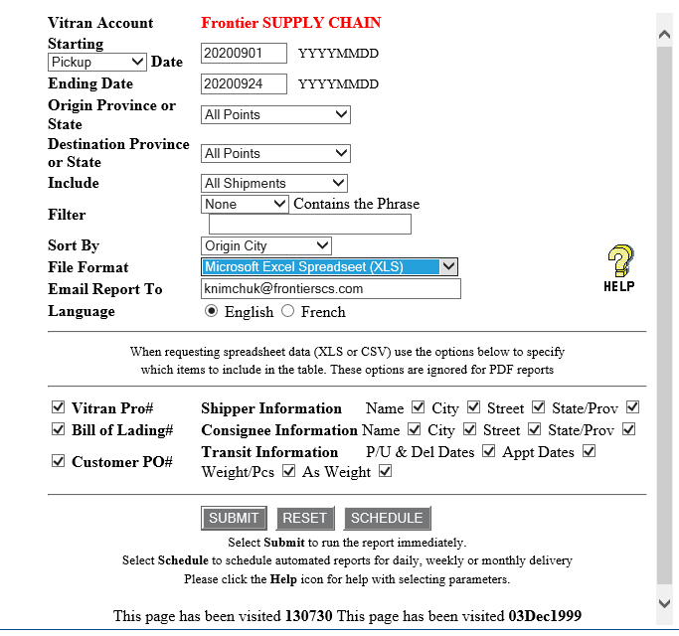

1. Once you have defined on the page what you would like to see on the report, click on SUBMIT.
2. Once submitted, you will have to wait for an email from Vitran that will include the report.
3. When you have received your email from Vitran with your report, open it and follow the below instructions on how to make this sheet more user friendly.
4. Scroll to the top of the Spreadsheet, freeze the top row and put a filter on the top row.
5. To freeze the top row, select entire Row 1, under “View” tab, select Freeze Panes, then on the little drop down, select Freeze Top Row.

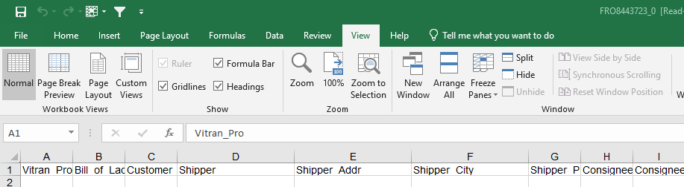

1. To put a filter on Row 1, go on the “Data” tab and select Filter.

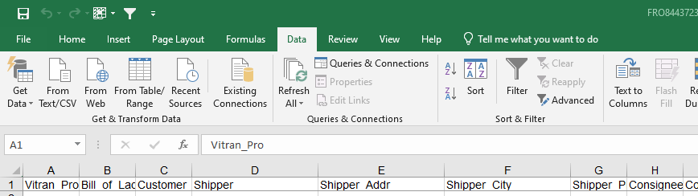

1. In order for the filters to work, you will need to delete out the entire Row 2. To do this, select Row 2 and under “Home” tab, select Delete.

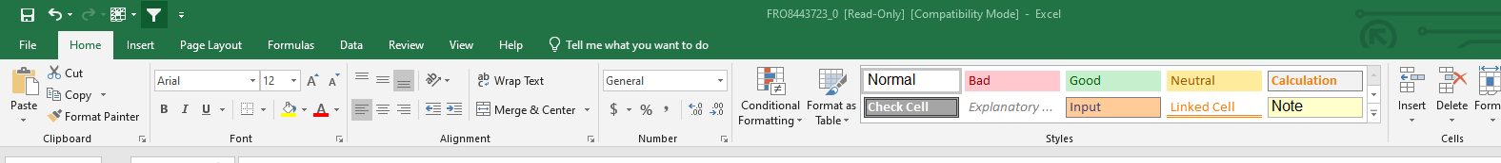

1. On this report, your PFS#’s are under the Bill of Lading column (Column B) but they will have an added/extra number at the end of the PFS#, which we will need to remove.
2. To remove the last number, insert a new column by selecting Column C, and select insert on the “Home” tab.

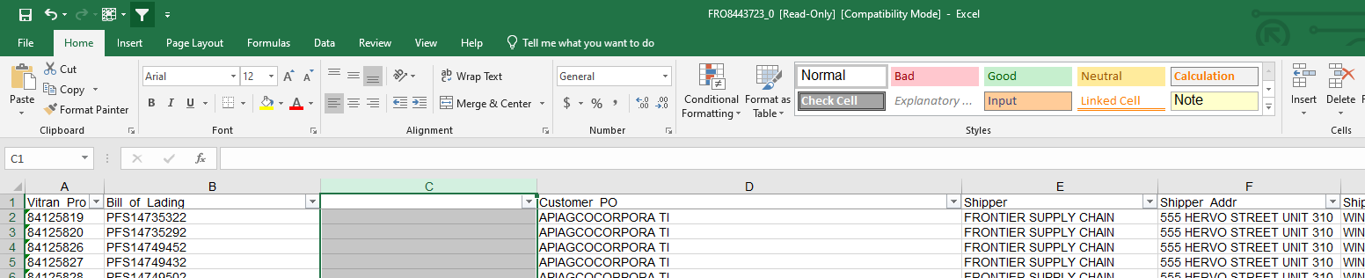

1. You will now select Column B, and select Text to Columns under the “Data” tab that will give you a pop up.

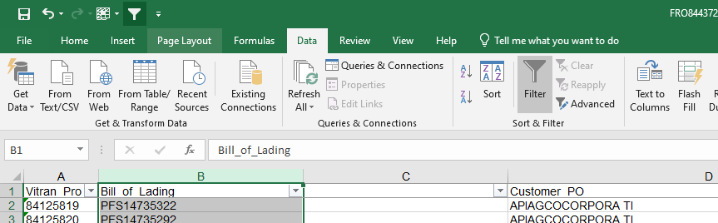

1. On the pop up, choose “Fixed width”, then click on Next.

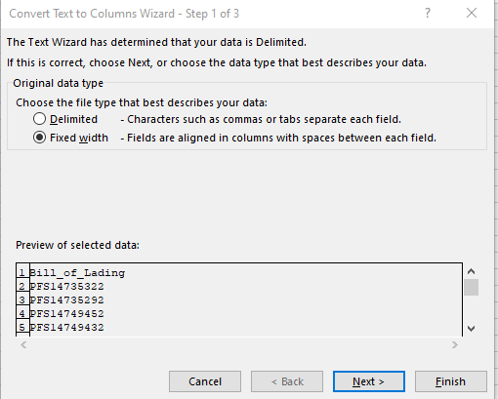

1. On the next page, you will need to click between the second last number and the last number, then click Finish.

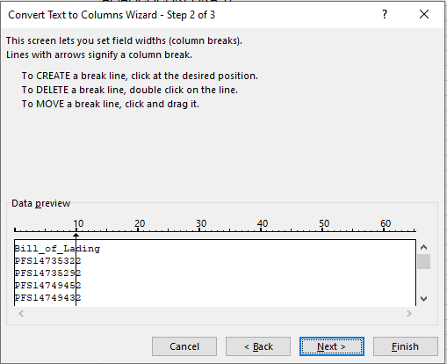

1. Once finished, you will notice Column C will now have that last number in it, leaving the rest of the PFS# in Column B.

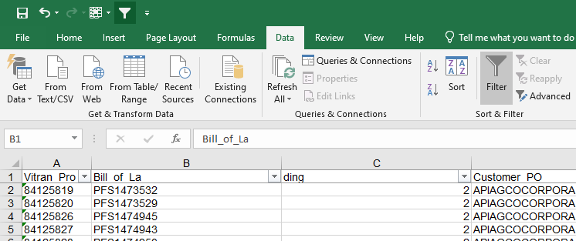

1. You can now delete Column C that has this last number as you don’t need it. Refer back to Step 15 on how to delete.
2. Now you can run a VLOOKUP formula from your tracking spreadsheet with this Vitran Report.

VLOOKUP Formula: =VLOOKUP(lookup_value, table_array, col_index_num,(range_lookup,)