LONG HAUL DRIVER’S PAY SOP
Step 1: Exporting Miles Details from KeepTruckin
- Open KeepTruckin
- Click Reports
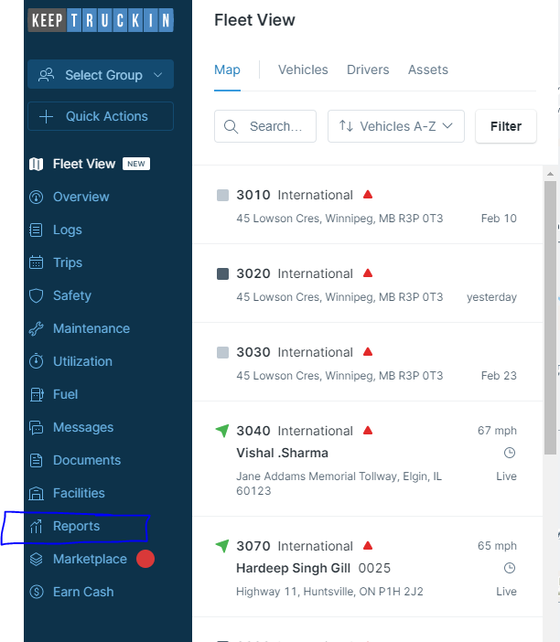

- Click Trip Details
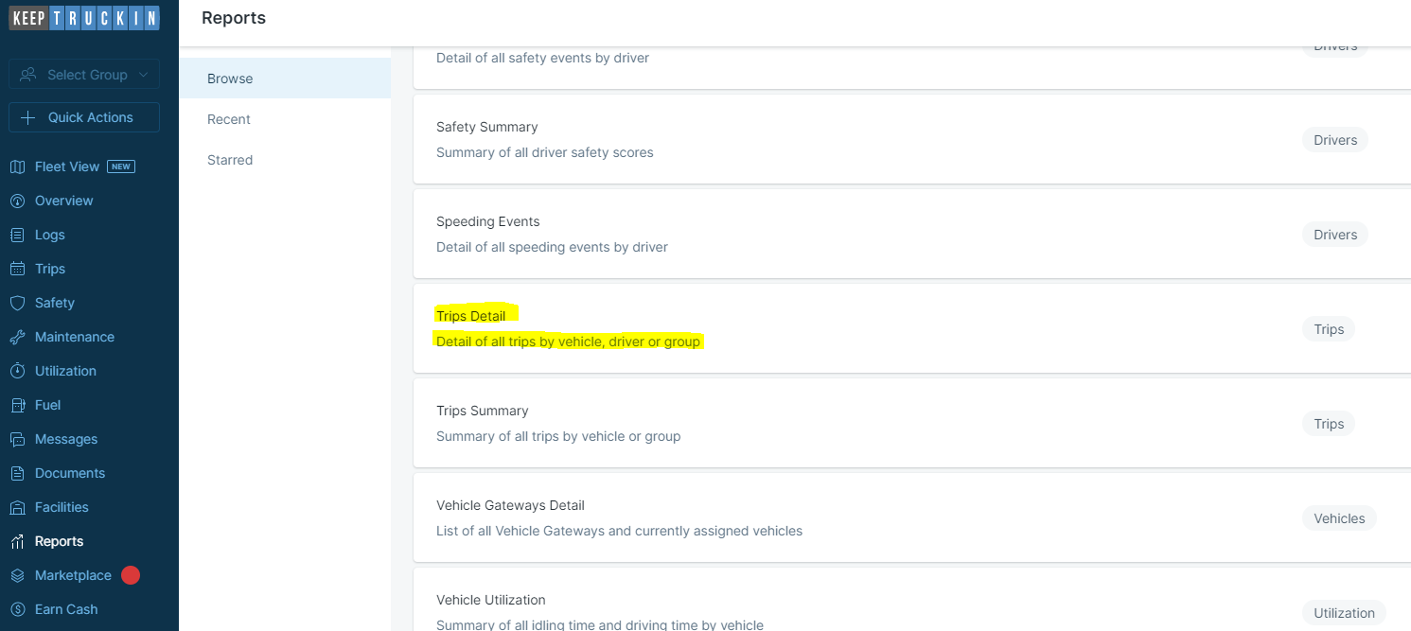

- Select Pay Period date range
- Click “Options”
- Click “Export as CSV”, it will send an email with the link to download all CSV file.
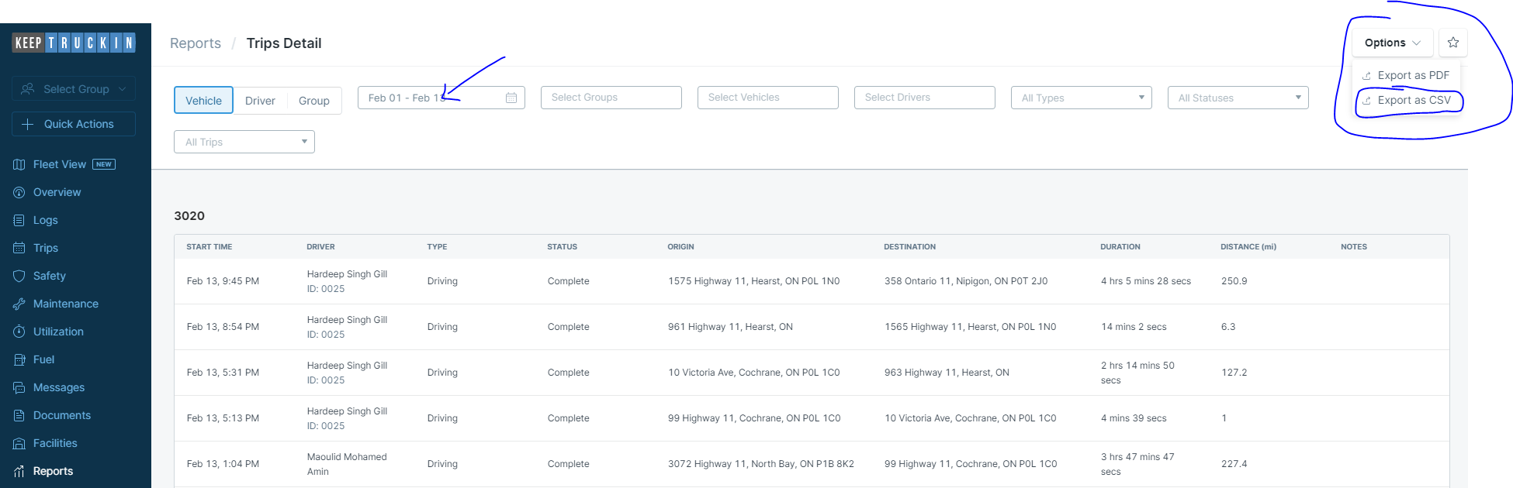

Step 2: Exporting Geofence and Speeding Details from Verizon
- Open Verizon
- Click Reports
- Click Speeding Report
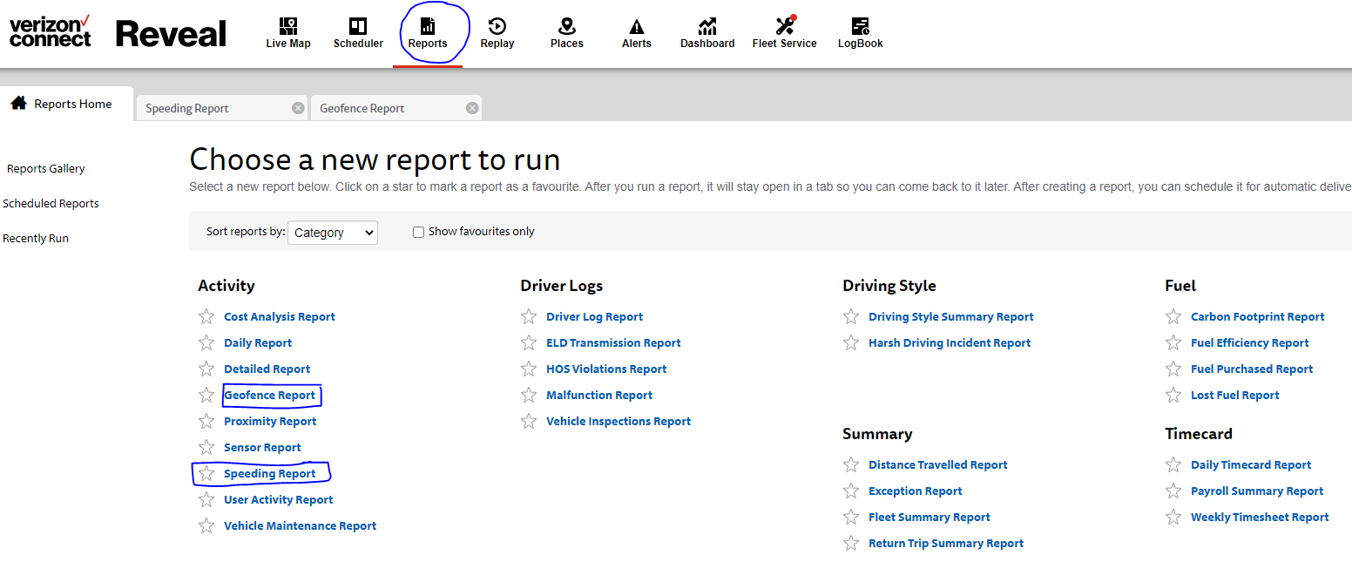
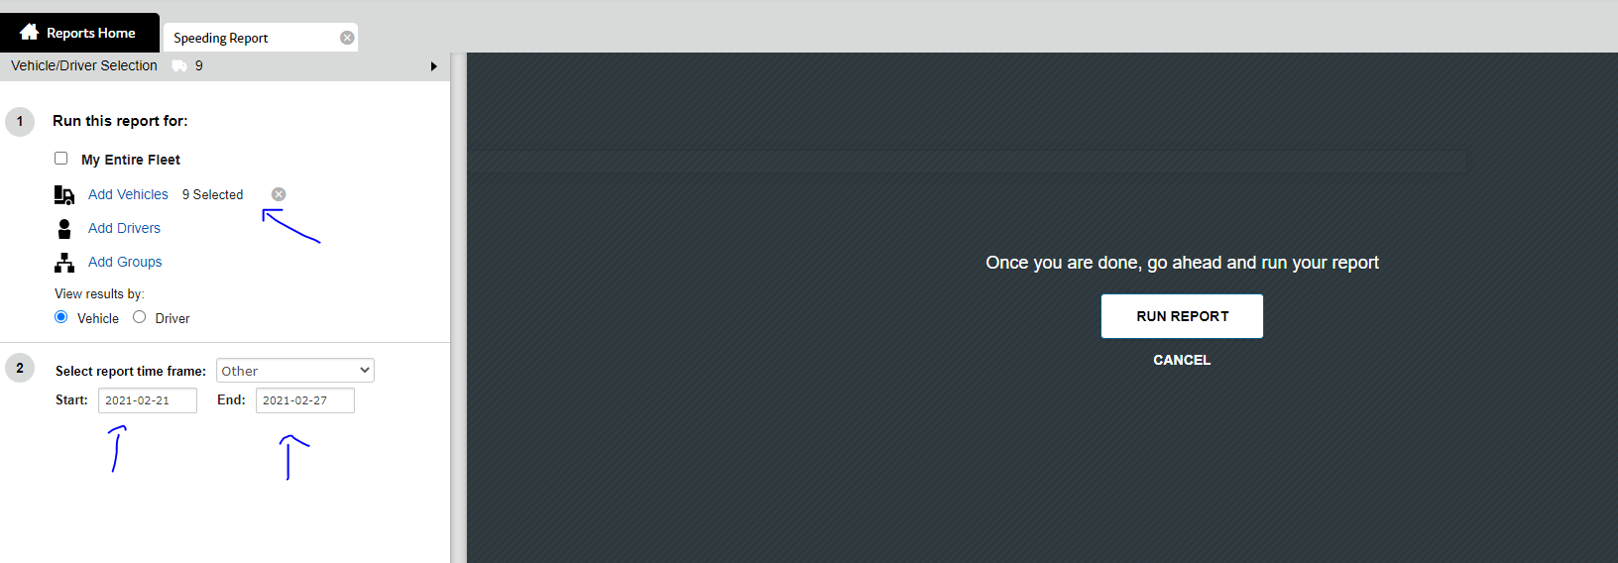

- Update date range for the specific pay period
- Make sure all the trucks are selected
- Click Run Report, and it will take open the different tab
- Click CSV on top right and it will download CSV file for Speeding Report.
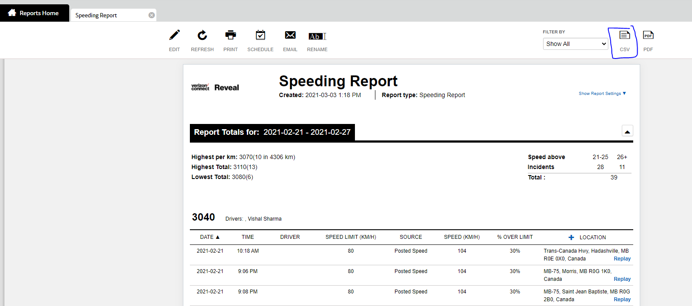
- Repeat Same process for Geofence Report
- Update date range for the specific pay period
- Make sure all the trucks are selected
- Click CSV on top right and it will download CSV file for Speeding Report.
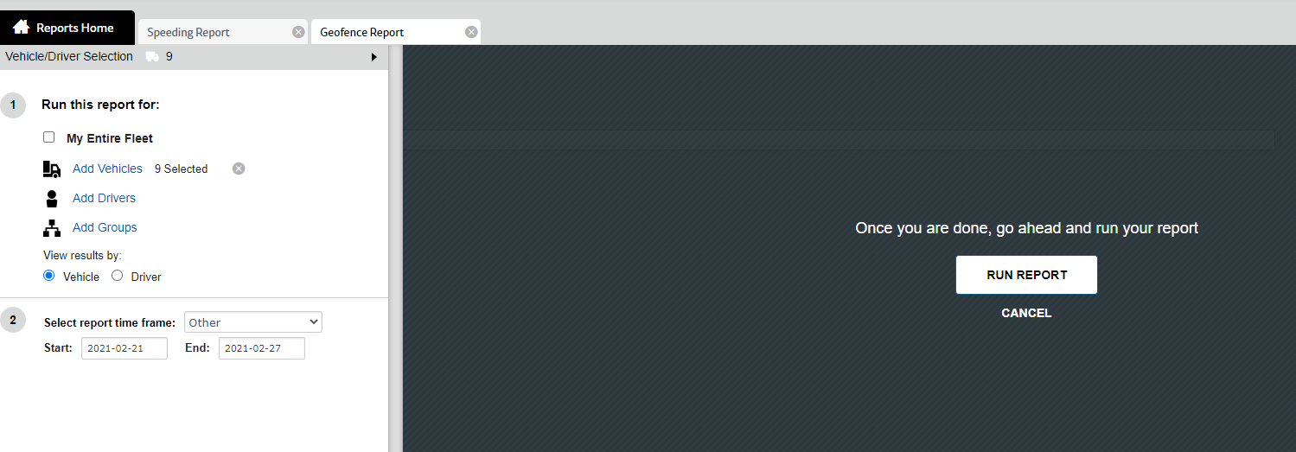
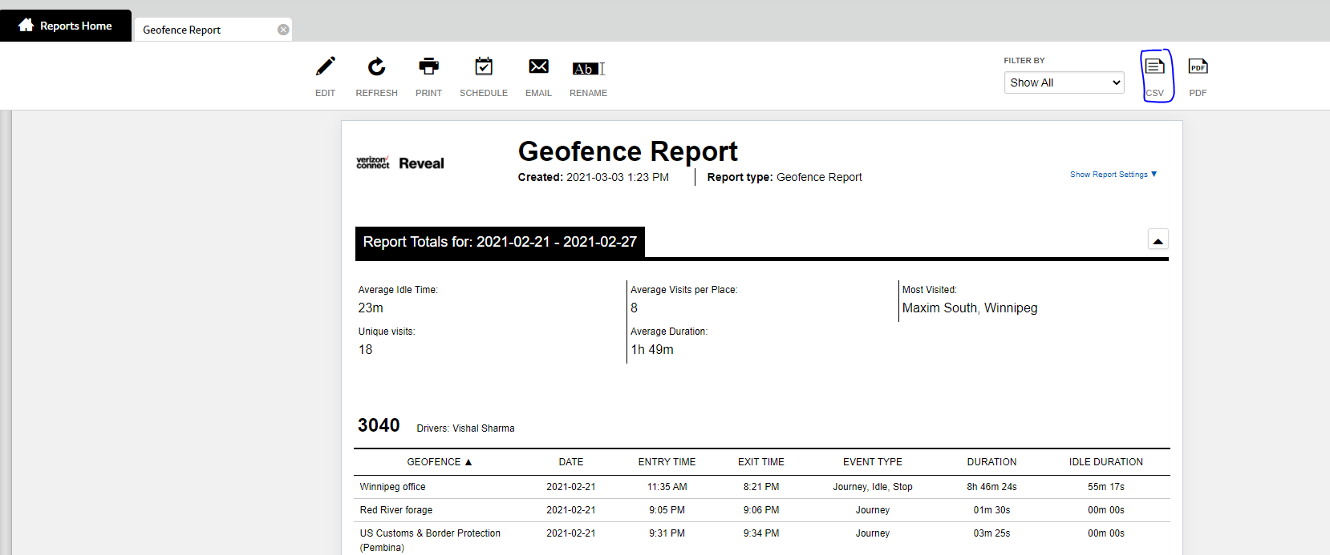

Step 3 – Filter Out Miles Details CSV (KeepTruckin)

- Open downloaded CSV (pic given below)
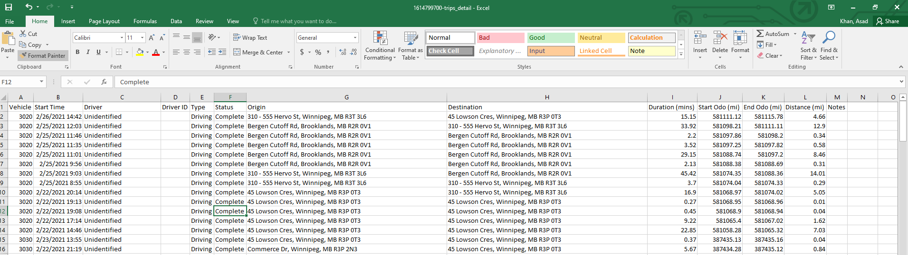
- Apply Filter on Main Headings
- Click on “Vehicle” filter
- Select “3090” – It’s a local truck in ON, we don’t need to add this in our pay details.
- Delete out all the data for “3090” (pic given below)
- Click on “Driver” filter
- Select “Unidentified” – When city driver uses long haul trucks in City then it generates “Unidentified” driver, which we don’t need in pay.
- Delete all the data for “Unidentified”.
- Save the spreadsheet.
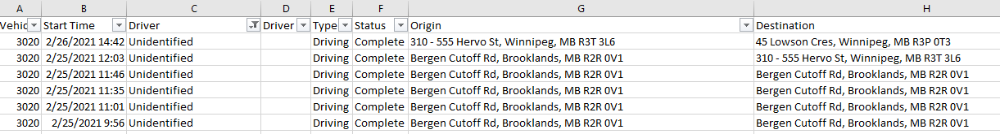
Step 4 – Filter Out Geofence Data
- Geofence data provides the waiting time for the drivers at each location
- Locations are added in Geofence tab
- Open the downloaded CSV (Step# 2 for instructions)
- Apply filter on main headings
- Click on “Geofence” heading and select following only:
- Winnipeg Office
- Red River Forage
- Rest Stop
- Rest Stop in Alexandria, MN
- Maxim South, Winnipeg
- Delete out the data after applying filter
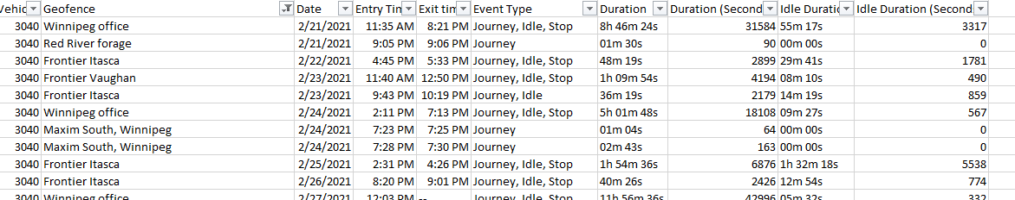
- Click on “Duration” heading and select time which is showing more than 2 hours.
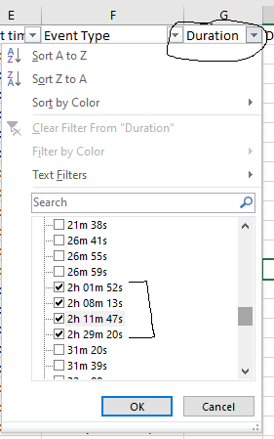
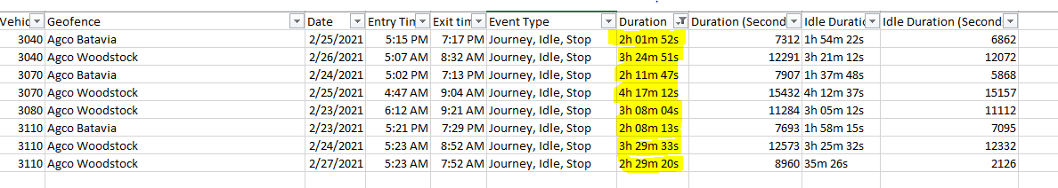
- We will deduct 2 hours from each and that will give us the waiting time that we need to pay. (Note: we pay waiting hourly after 2 hours)
- For example: for the time showing “4h 17m 12 sec”, we will deduct 2 hours, which gives us only 2h 17m sec, we will round this time as “2.25 hours”, so we will include “2.25 hours” in Drivers Pay for that specific truck according to the date.
- There are some waiting which doesn’t show up in Geofence, which is because it occurs due to truck breakdown out of Geofence locations, so we have to manually keep records for those kinds of waiting’s and them once creating pay.
- Save the spreadsheet after calculating the data.
Step 5 - Filter Out Speeding Record
- Speeding Report provides the information of the speeding events for the drivers with date, location and speed limits.
- Open the downloaded CSV (Step# 2 for instructions)
- Apply filter on main headings
- Click on “Location” heading and select all the addresses for Manitoba only.
- Delete out the data for Manitoba only locations
- Clear out the filter
- Save the spreadsheet
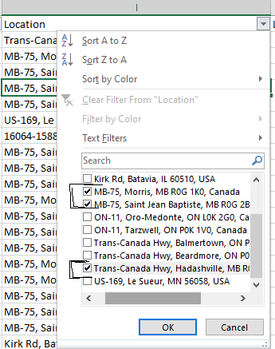
STEP 5 – MOVING DATA FROM SPEEDING, GEOFENCE, MILES DETAILS SPREADSHEET TO FRONTIER PAY SPREADSHEET TO GENERATE PAY DETAILS
- Open Pay Spreadsheet template, this is the main spreadsheet, where we paste all the data from Speeding Report, Geofence Report & Miles spreadsheets. (example given below)
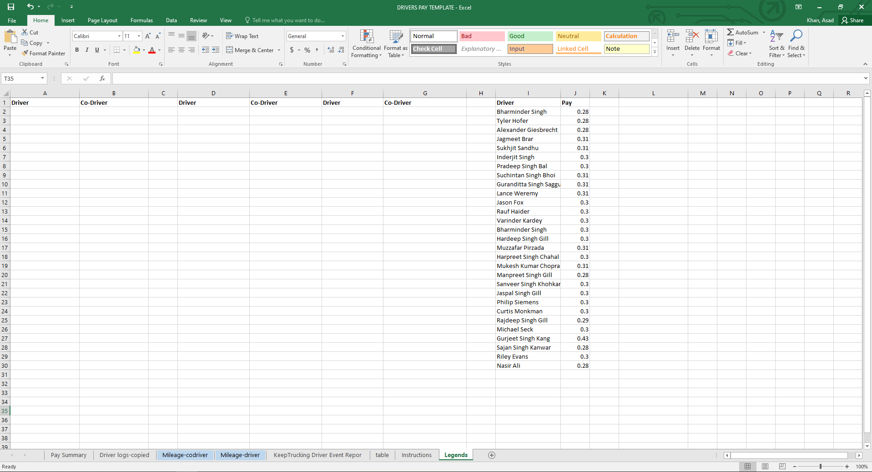
- There are 6 tabs that we need to work on every time.
-Legends
-Keeptruckin Driver Event Report
-Mileage-Driver
-Mileage-Codriver
-Driver logs-copied
-Pay Summary
LEGENDS:
- This tab includes drivers pay per mile details, we need to make sure that we are paying driver correct pay per mile.
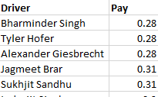
- This tab also includes Driver and Co-Driver section, so we have to add the teams accordingly.
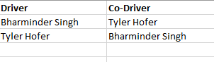
Bharminder & Tyler are team drivers, so we enter both as Driver and Co-Driver.

KEEPTRUCKIN DRIVER EVENT REPORT:
- We will copy all the data from Speeding, Geofence & Keeptruckin Miles data and we will paste in this tab.
1 - MOVING DATA FROM KEEPTRUCKIN MILES DATA
- Open KeepTruckin miles details spreadsheet. (Step# 3)
- Copy all the data
- Paste in the Keeptruckin Driver Event Report (example given below)
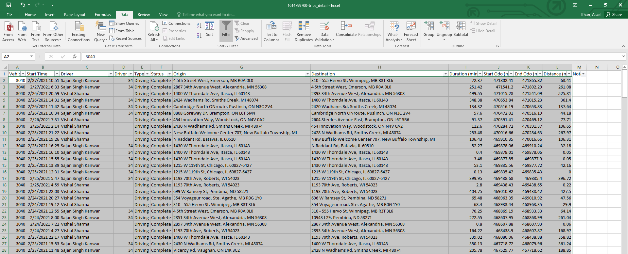

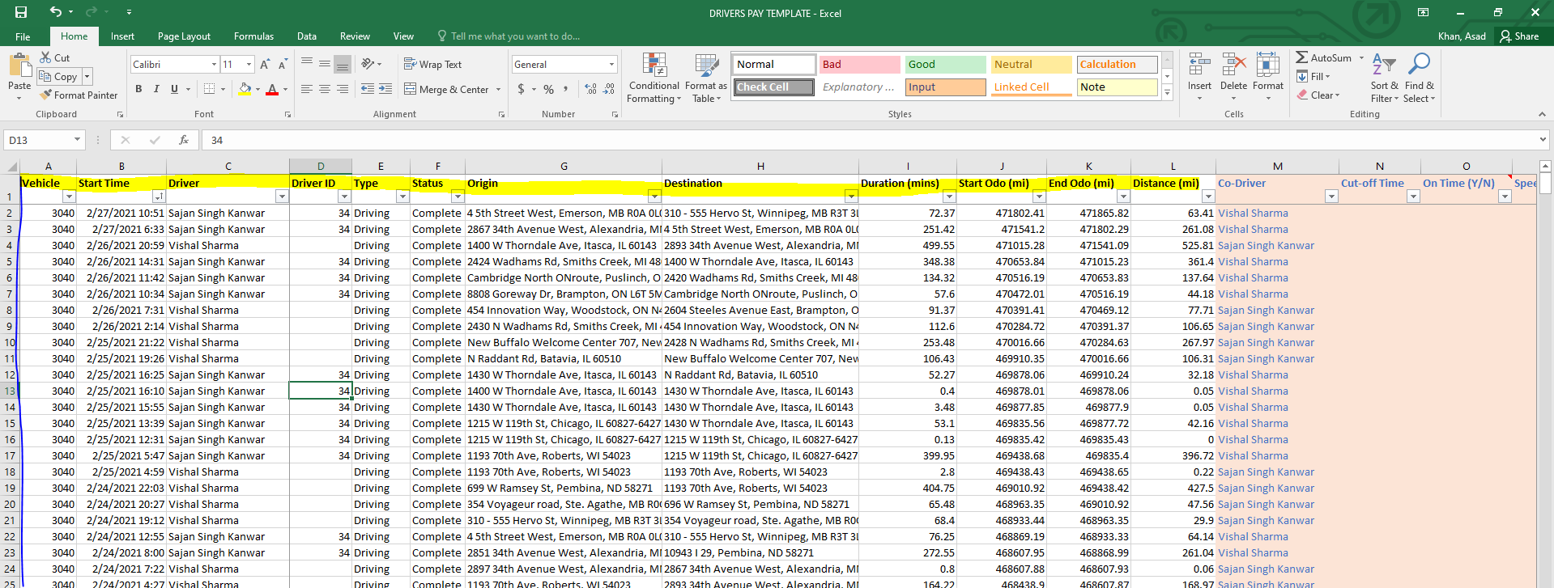
2 - ADDING SPEEDING DETAILS FROM SPEEDING REPORT
- Open Speeding Report (Step#4)
- Read the data and move it to the Keeptruckin Miles Data (Example given below)
Speeding Report Data:
- As we can see on the 1st line that 3040 is the vehicle that did speeding, this speeding occurred on 2/22/2021 – 07:20 AM – Le Suer, MN, we will go the KeepTrukin Driver Event Report in Pay Detail Template spreadsheet, and will look for 3040 for the same date and time. (Pic given below):
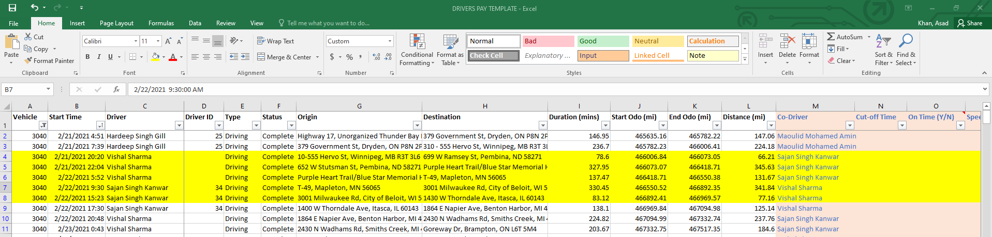
- So the 3040 was found speeding on 2/22/2021, so we have to add the speeding for their whole trip from Winnipeg to Itasca, as they were speeding in Le Suer, MN while heading towards Itasca.
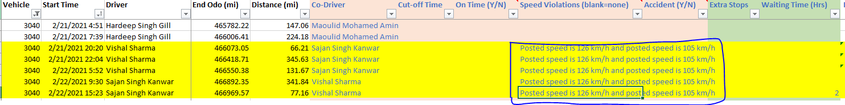
NOTE: We will put speeding for the entire leg always, the legs can be following:
- Itasca Batavia Winnipeg
- Itasca Winnipeg
- Itasca Vaughan
- Vaughan Itasca
- Winnipeg Itasca
- Itasca Batavia Woodstock Vaughan

3 - ADDING WAITING TIME FOR DRIVERS FROM GEOFENCE REPORT
- We downloaded and filtered out Geofence report earlier (Step 4)
- We will now add the waiting time in KeepTruckin Driver Event Report Tab.
This is a data from Geofence Report:
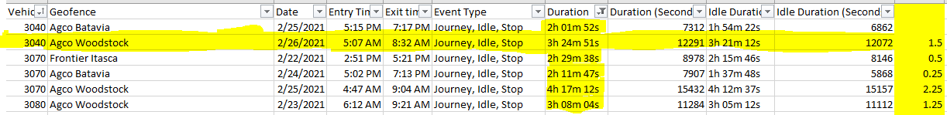
The calculations are to take out the waiting time is given below:
3h 24m 51s - 2h = 1h 24m = 1.5 hours (round it up to the closest)
NOTE: we disregard waiting for 1 minute or so, we don’t have to add waiting for 1 minute, it should be at least 10 – 15 minutes.

- We will add 1.5 hrs. of waiting for vehicle 3040 in KeepTruckin Driver Event Report Tab.
- We will apply filter for 3040 on KeepTruckin Driver Event Report Tab and will look for 2/26/2021 and then add 1.5 hours in “Waiting Time” column. (example given below)
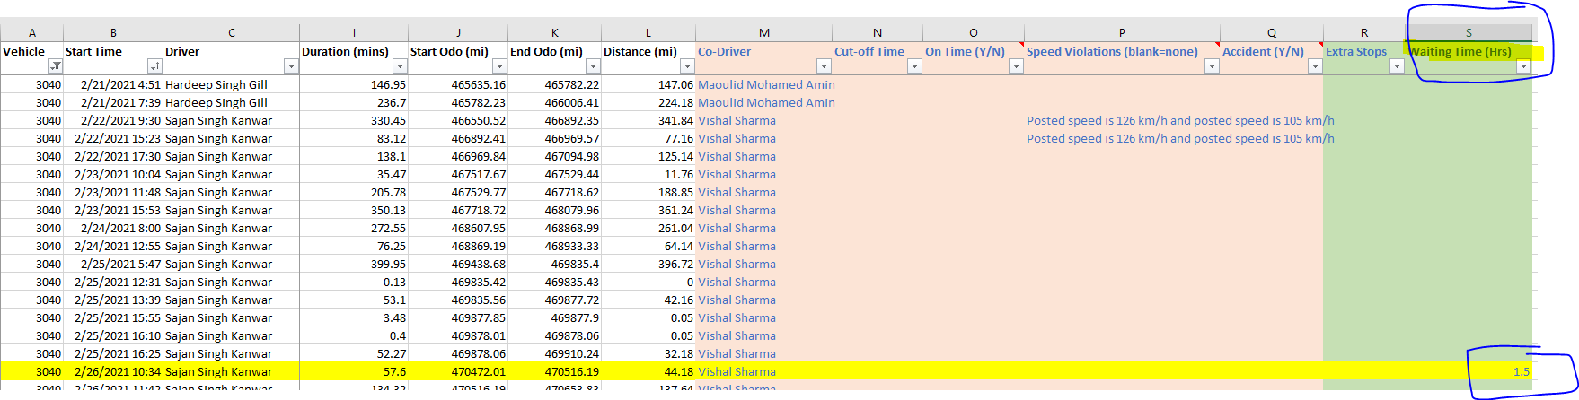
- Follow the same process to add the all waiting’s from Geofence Report to KeepTruckin Event Report Tab (Drivers Pay Spreadsheet).

4 - ADDING STOPS
- We don’t pay stops for all Frontier Warhouses
- We only pay stops for Batavia, Woodstock, Brampton & all other backhaul shipments
- We have to manually keep record for the stops every day.
For Example: Drivers did run to the Itasca, but they delivered backhaul shipment while on their way to Itasca (Wpg Mapleton Itasca), so we will add 1 stop for Mapleton in their pay.

MILEAGE-DRIVER & MILEAGE-CODRIVER TABS
- Click Mileage-Driver tab
- Click Data on Top
- Click Refresh All
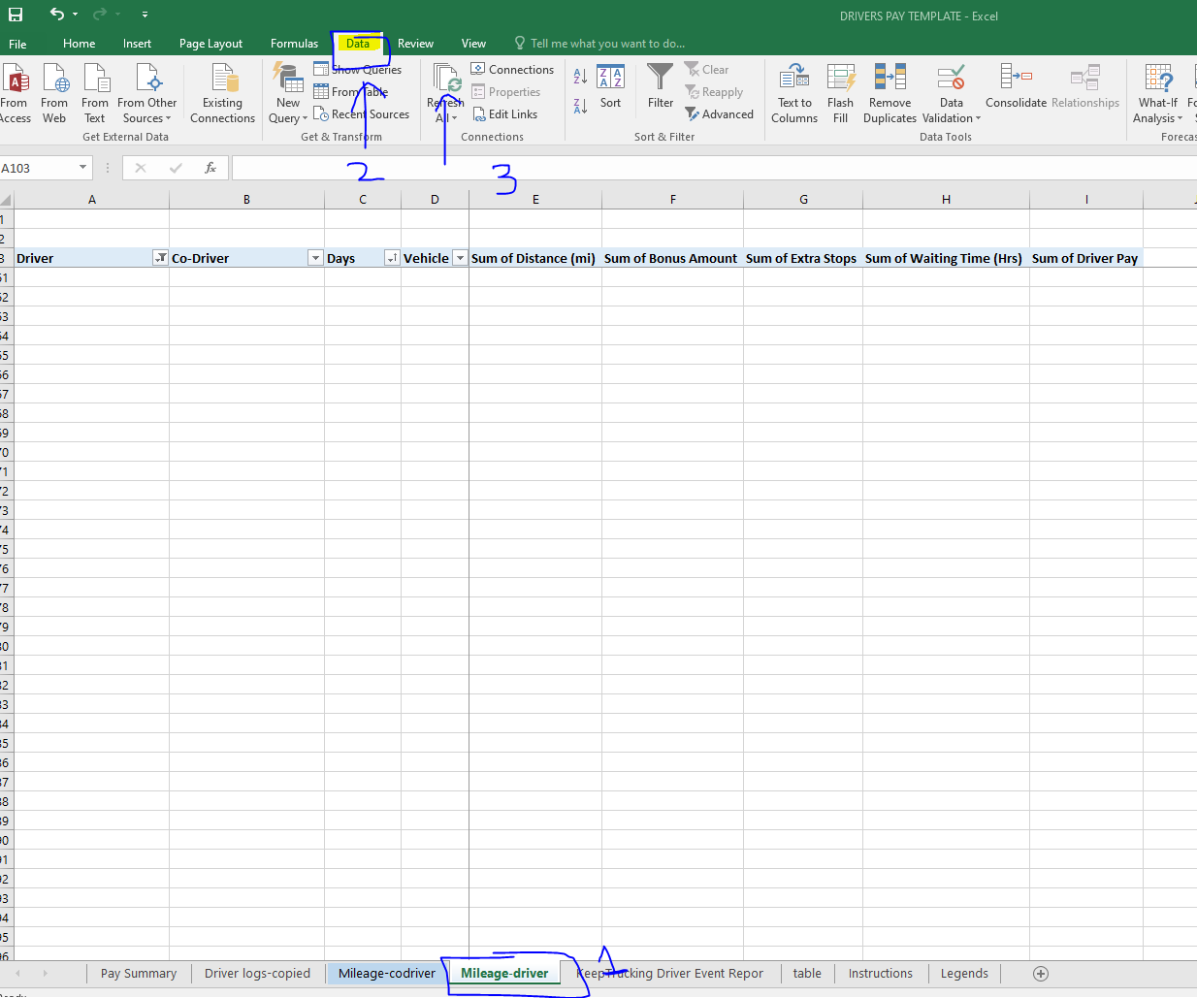
- It will show the data after clicking Refresh All (see below for an example).
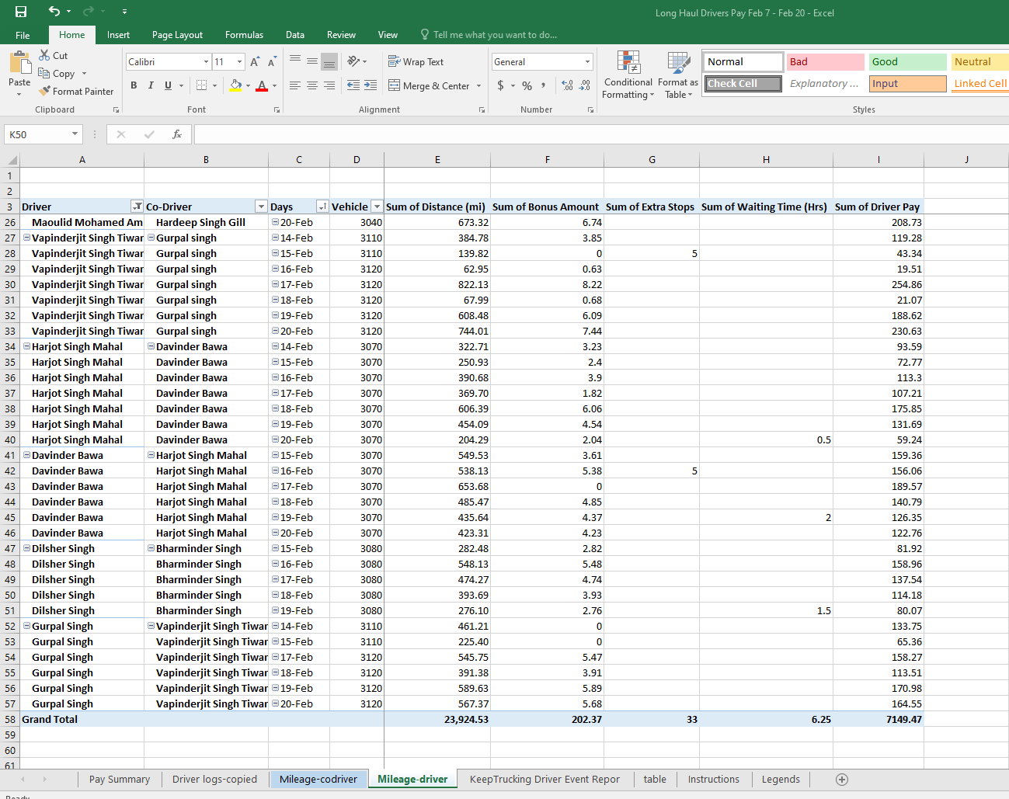

- Click Mileage-Driver tab
- Click Data on Top
- Click Refresh All
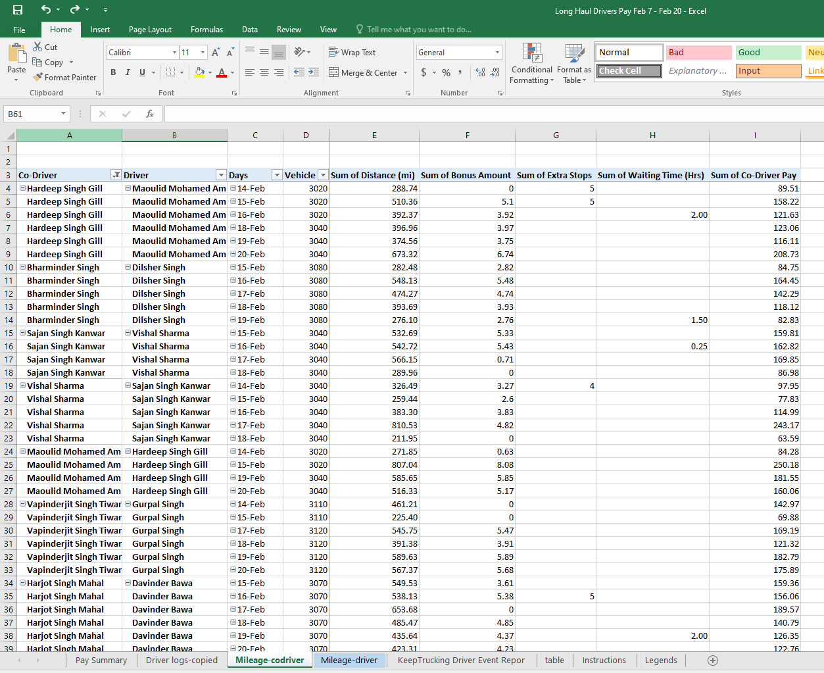
DRIVER LOGS-COPIED TAB
- Copy all the data from “Mileage-Driver” tab
- Paste it in Driver “Logs-Copied“ Tab
- Type “Driver” in “Sheet Source Column”
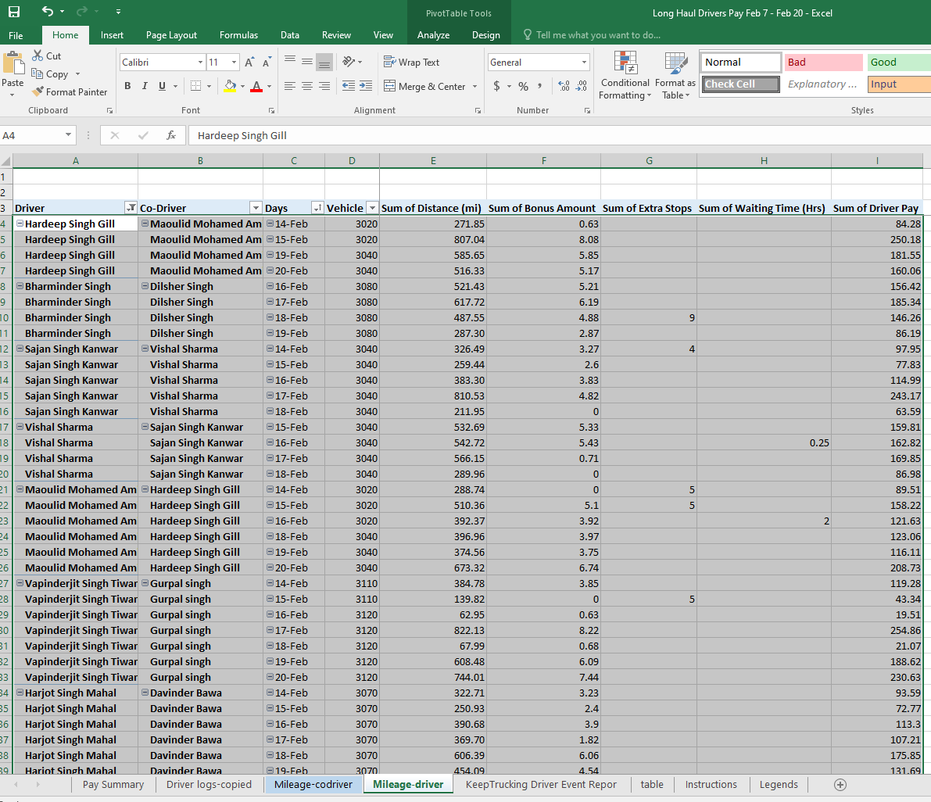
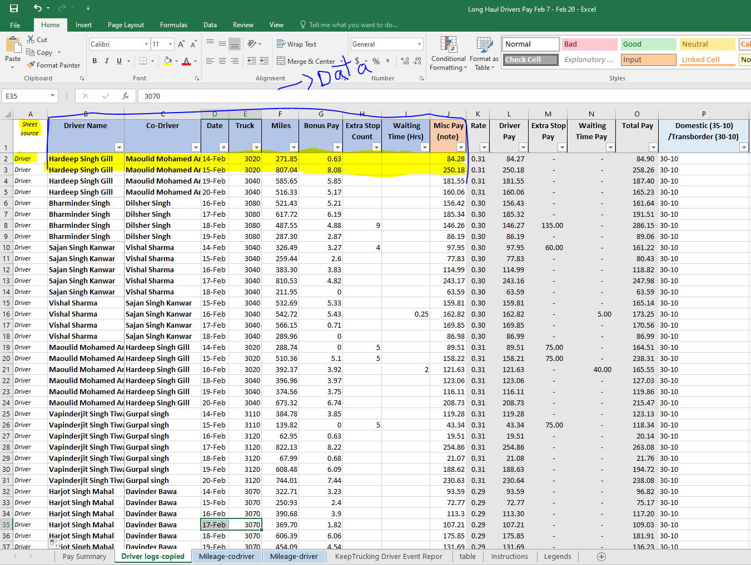
- Copy all the data from “Mileage-CoDriver” tab
- Paste it in Driver “Logs-Copied“ Tab
- Type “Co-Driver” in “Sheet Source Column”
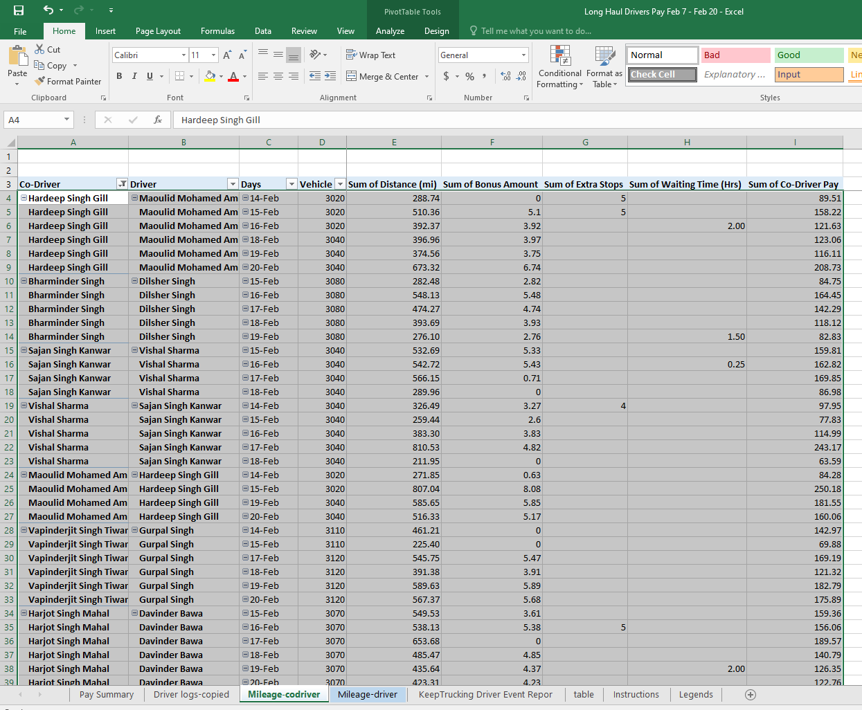
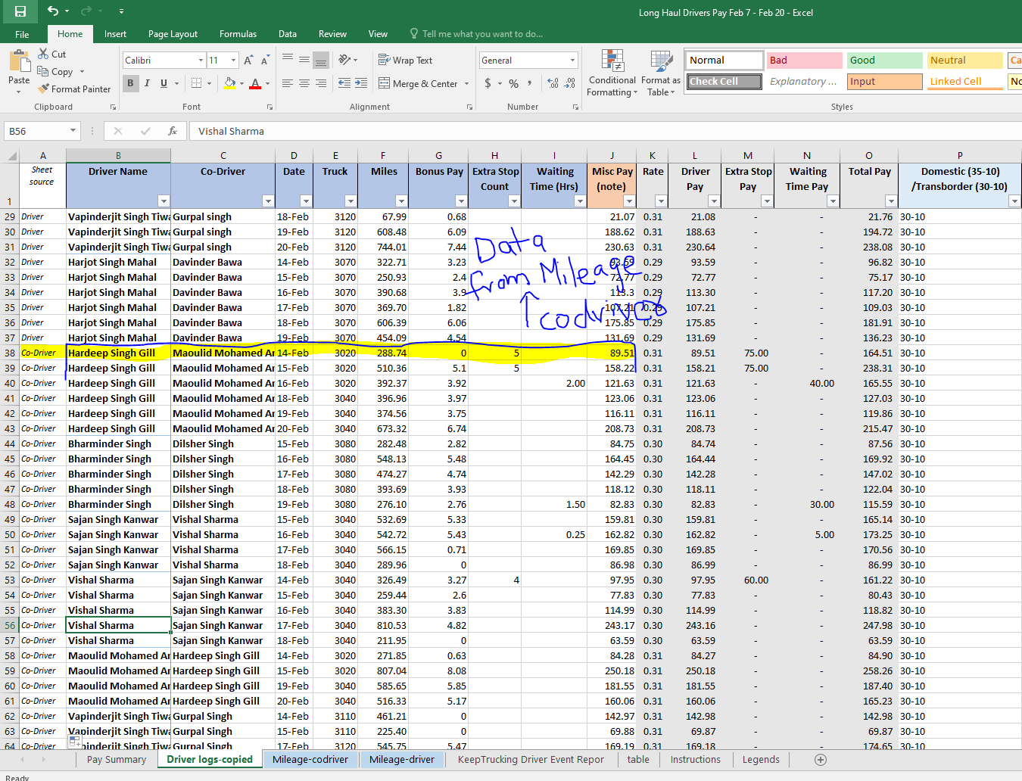
PAY SUMMARY TAB
- Open Pay Summary Tab
- Click Data on Top
- Click “Refresh All”
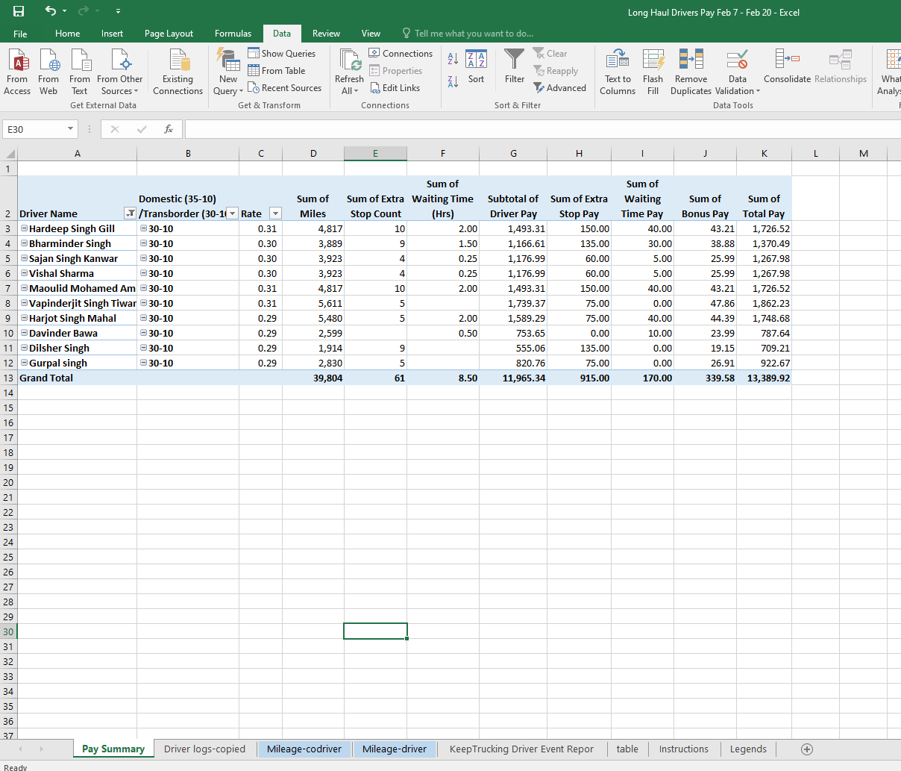

- Double check miles
- Double check pay rate
- Double check waiting’s
- Double check stops
- Save this spreadsheet in share driver.
T:\TransLineHaul\Long Haul Driver Pay for payroll\Driver Pay Sent to HR
- Send completed spreadsheet to HR.

