**Step 1 – Import media files**

Before we can begin making a video, we need to import media files into OpenShot. Most video, image and music file formats will work. Drag and drop a few videos or images and a music file from your Desktop to OpenShot. Be sure to drop the files where the arrow in the illustration is pointing to.

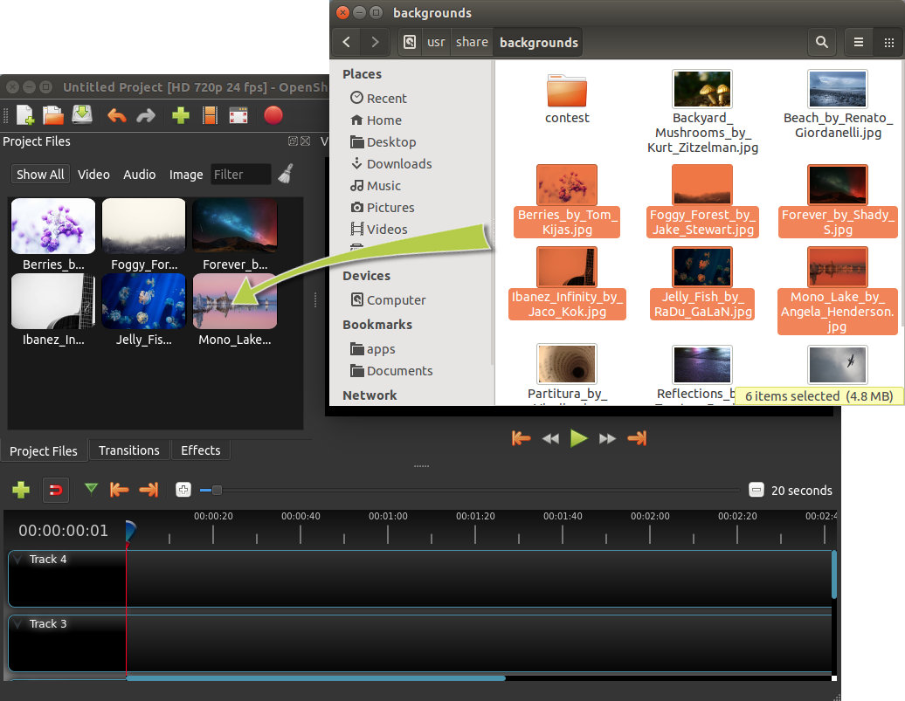

Alternative methods to add files to your projects are described in the section [Import Files](https://cdn.openshot.org/static/files/user-guide/files.html#import-files-ref). The “Show All”, “Video”, “Audio”, “Image” filters above the added files allows you to only see the file types you are interested in.

**Step 2 – Arrange Videos and Photos on Timeline**

Next, drag each video or photo onto a track in the timeline (as seen in the illustration). The timeline represents your final video, so arrange your photos in whatever sequence you want them to appear in your video. If you overlap two clips, OpenShot will automatically create a smooth fade between them, displayed by blue rounded rectangles between the clips. Remember, you can rearrange the clips as many times as needed by simply dragging and dropping them.

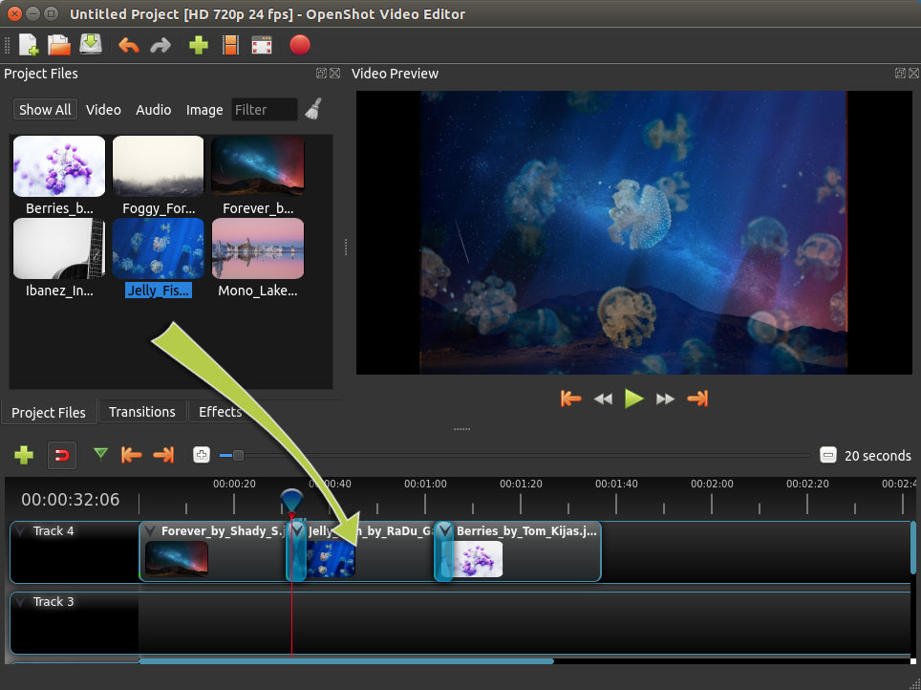

**Step 3 – Add Music to Timeline**

To make our creation more interesting, we need to add some music. Click on the music file that you imported in step 1, and drag it onto the timeline. If the song is too long, grab the right edge of your music clip, and resize it smaller (that will make it end earlier). You could also insert the same file multiple times, if your music is too short.

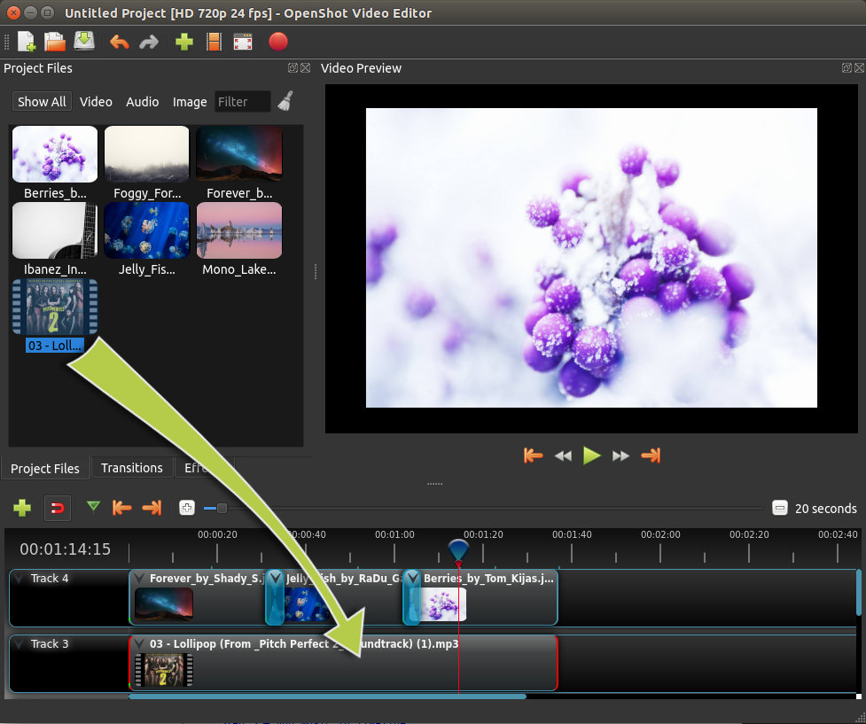

**Step 4 – Preview your Project**

To preview what our video looks & sounds like, click the Play button under the preview window. You can also pause, rewind, and fast-forward your video project by clicking the corresponding buttons.

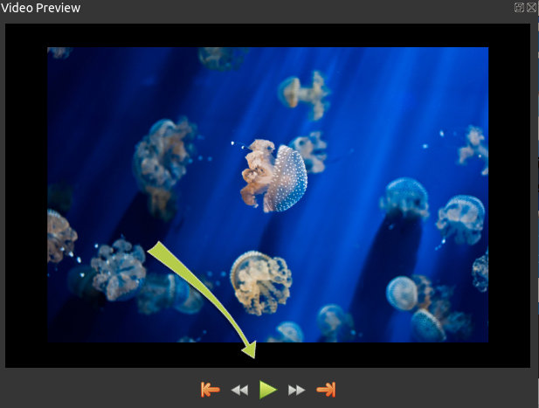

**Step 5 – Export your Video**

Once you are happy with your project, the next step is to export your video. This will convert your OpenShot project into a single video file, which will work on most media players (such as VLC) or websites (such as YouTube, Vimeo, etc…).

Click on the Export Video icon at the top of the screen (or use the **File > Export Video** menu). Choose from one of the many preset export options, and click the *Export Video* button.

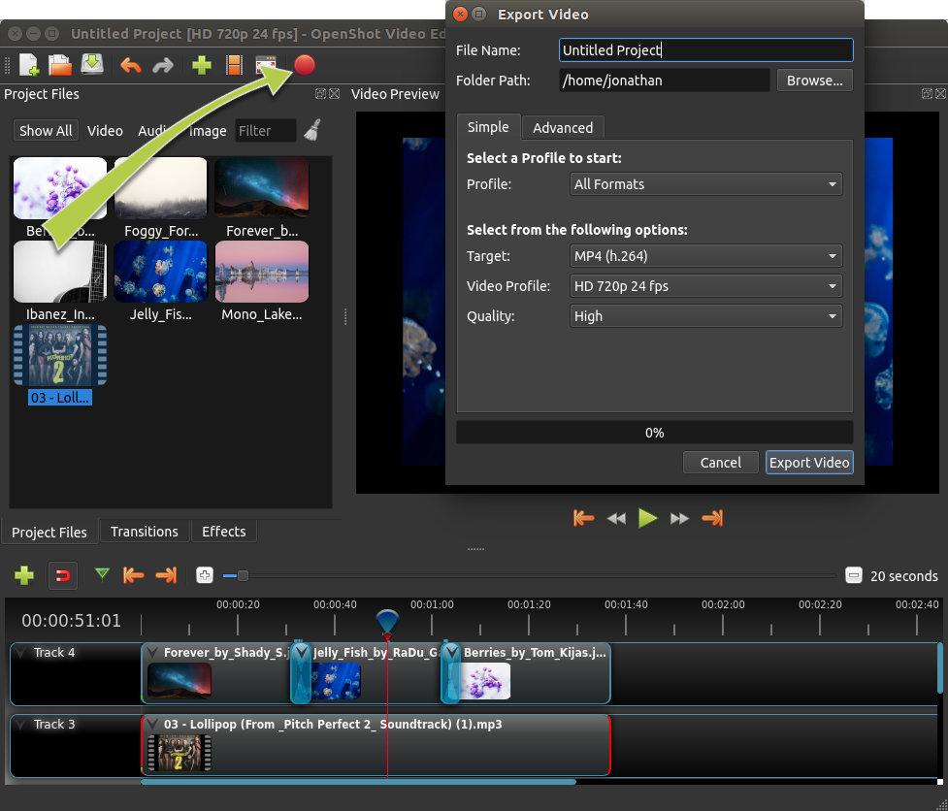

**Features**

# Clips

Each media file you add to the OpenShot timeline is called a clip, and is visualized by a dark, rounded rectangle (as seen in the screenshot below). A clip has a large number of properties, which affects how the clip is rendered and composited, such as scale, location, rotation, and alpha. These properties can also be animated over time, and when combined together, can create some amazing effects.

## Overview

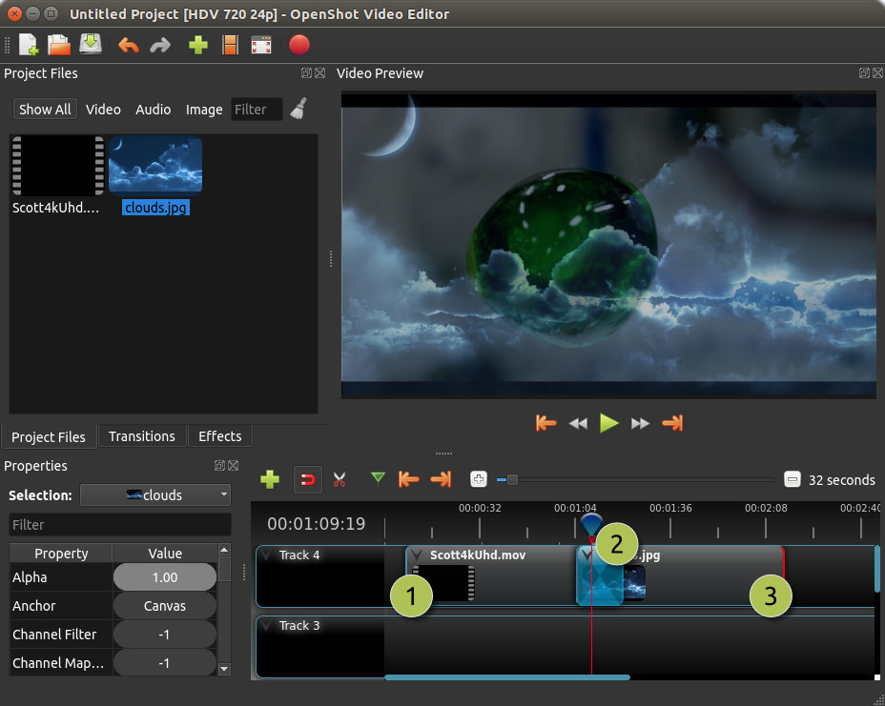

| **#** | **Name** | **Description** |
| --- | --- | --- |
| 1 | Clip 1 | A video clip |
| 2 | Transition | A gradual fade transition between the 2 clips |
| 3 | Clip 2 | An image clip |

## Cutting & Slicing

OpenShot has many easy ways to adjust the start and end positions of a clip (otherwise known as cutting). The most common method is simply grabbing the left (or right) edge of the clip and dragging. Here is a list of methods for cutting clips in OpenShot:

| **Name** | **Description** |
| --- | --- |
| **Slice** | When the play-head (i.e. vertical red playback line) is overlapping a clip, right click on the clip, and choose **Slice**. |
| **Slice All** | When the play-head is overlapping many clips, right click on the play-head, and choose **Slice All** (it will cut all intersecting clips on all tracks). |
| **Resizing Edge** | Mouse over the edge of a clip, and resize the edge. |
| **Split Dialog** | Right click on a file, and choose **Split Clip**. A dialog will appear which allows for creating lots of small cuts in a single video file. |
| **Razor Tool** | The razor tool  from the **Edit Toolbar** cuts a clip wherever you click on it. So be careful, it is easy and dangerous! |

Keep in mind that the above cutting methods also have [Keyboard Shortcuts](https://cdn.openshot.org/static/files/user-guide/main_window.html#keyboard-shortcut-ref), to save even more time.

## Preset Menu

OpenShot has tons of great preset animations and clip properties, such as fading, sliding, zooming, etc… These presets can be accessed by right clicking on a clip.

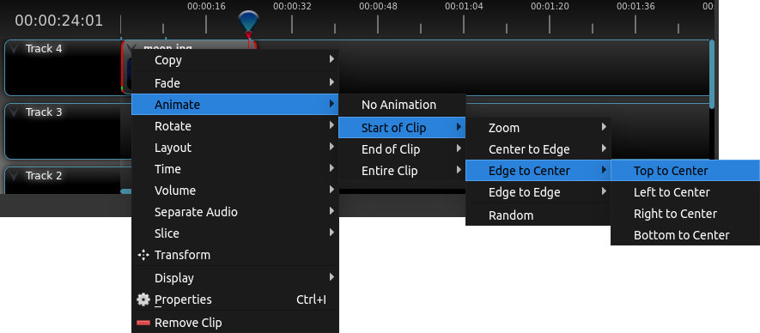

| **Name** | **Description** |
| --- | --- |
| Fade | Fade in or out a clip (often easier than using a transition) |
| Animate | Zoom and slide a clip |
| Rotate | Rotate or flip a video |
| Layout | Make a video smaller or larger, and snap to any corner |
| Time | Reverse and speed up or slow down video |
| Volume | Fade in or out the volume for a clip |
| Separate Audio | Create a clip for each audio track |
| Slice | Cut the clip at the play-head position |
| Transform | Enable transform mode |
| Display | Show waveform or thumbnail for a clip |
| Properties | Show the properties panel for a clip |
| Copy / Paste | Copy and paste key frames or duplicate an entire clip (with all key frames) |
| Remove Clip | Remove a clip from the timeline |

## Transform

To quickly adjust the location and scale of a clip, select a clip on the timeline, right click and choose **Transform**. Grab any of the small blue handles to adjust scale, and grab the middle circle to move the image. Note: Pay close attention to where the play-head (i.e. red playback line) is. Key frames are automatically created at the current playback position, to help create animations.

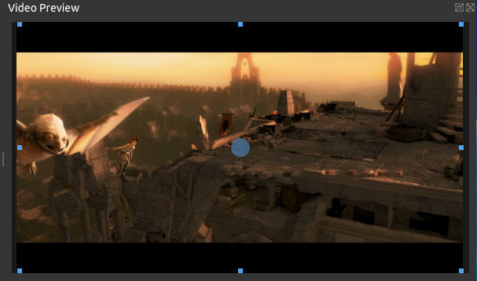

For more info on key frames and animation, see [Animation](https://cdn.openshot.org/static/files/user-guide/animation.html#animation-ref).

## Effects

In addition to the many clip properties which can be animated and adjusted, you can also drop an effect directly onto a clip. Each effect is represented by a small letter icon. Clicking the effect icon will populate the properties of that effect, and allow you to edit (and animate) them.

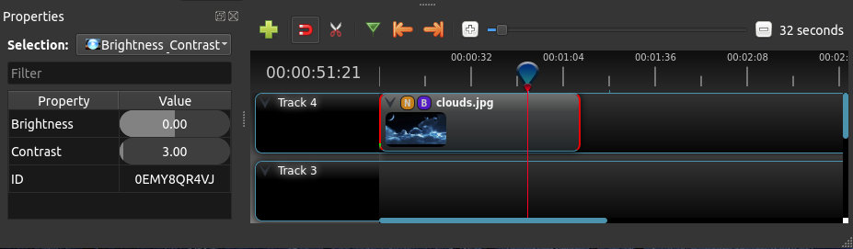

## Properties

Below is a list of clip properties which can be edited, and in most cases, animated over time. To view a clip’s properties, right click and choose **Properties**. The property editor will appear, where you can change these properties. Note: Pay close attention to where the play-head (i.e. red playback line) is. Key frames are automatically created at the current playback position, to help create animations.

| **Name** | **Description** |
| --- | --- |
| Gravity Type | The gravity of a clip determines where it snaps to its parent |
| Scale Type | The scale determines how a clip should be resized to fit its parent |
| Frame Display Type | The format to display the frame number (if any) |
| Scale X | Curve representing the horizontal scaling in percent (0 to 1) |
| Scale Y | Curve representing the vertical scaling in percent (0 to 1) |
| Location X | Curve representing the relative X position in percent based on the gravity (-1 to 1) |
| Location Y | Curve representing the relative Y position in percent based on the gravity (-1 to 1) |
| Rotation | Curve representing the rotation (0 to 360) |
| Alpha | Curve representing the alpha (1 to 0) |
| Time | Curve representing the frames over time to play (used for speed and direction of video) |
| Volume | Curve representing the volume (0 to 1) |
| Shear X | Curve representing X shear angle in degrees (-45.0=left, 45.0=right) |
| Shear Y | Curve representing Y shear angle in degrees (-45.0=down, 45.0=up) |
| Channel Filter | A number representing an audio channel to filter (clears all other channels) |
| Channel Mapping | A number representing an audio channel to output (only works when filtering a channel) |
| Has Audio | An optional override to determine if this clip has audio (-1=undefined, 0=no, 1=yes) |
| Has Video | An optional override to determine if this clip has video (-1=undefined, 0=no, 1=yes) |
| Waveform | Should a waveform be used instead of the clip’s image |
| Waveform Color | Curve representing the color of the audio wave form |