Common Rejects

# System Rejects

Some transmissions won’t even make it to CBSA because something is wrong or missing in the data in our system. The typical message for this will be ‘unable to process query/request’ possibly followed by a vague description of where the problem occurred, such as ‘getting invoice lines details’.



The most common reason for this reject is a $0 or missing value on one of the lines, but there could be other causes such as an invoice without any lines attached, or invalid characters somewhere in the invoice or lines.

# Syntax Rejects

Syntax rejects are ones where the message never fully made it through to CBSA’s system, getting bounced back by during their initial data check, because the data does not match the specified format. Common rejects of this type include ‘invalid characters’, ‘element too long or short’, or ‘mandatory element missing’, usually followed by an indication of which segment of data contains the error. Some common segments include:

* **DOC** refers to a PO/Invoice identification, so the error will be in the invoice number or PO number on one of the invoices.
* **NAD** refers to a name and address, so the error will be in the name or address of one of the trade chain partners. Possibly the shipper or consignee on one of the invoices, the delivery party or destination, or even the importer (although that’s unlikely unless it’s a new importer that was recently added).
* **IMD** refers to an item description, so the error will be in the description on one of the lines.
* **MEA** refers to the unit of measure, so the error could be anywhere a unit of measure is indicated, such as the quantity or weight on the header, the quantity or weight on an invoice, or the quantity on a line.
* *Refer to the bottom of this document for a full list of data segments.*

If the error repeats itself within the same reject message, it could indicate there are multiple errors that need to be fixed, but sometimes it’s still just one error.

With syntax rejects, once the error has been fixed the entry must be re-transmitted again as an ‘original’ message since the data never fully made it through to Customs’ system the first time.

## Invalid Characters

For invalid characters, it could be a strange character like @ or ¿ or □ or even just an extra blank space somewhere that doesn’t belong (eg. extra blank spaces after the invoice number). Another common one is an apostrophe that just looks different than the other apostrophes in the file (ʼ instead of ˈ).

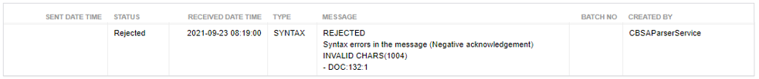

The above reject indicates an invalid character in the PO number or invoice number in an invoice.

## Element too long

Certain data fields are restricted by length. A postal code can only be 6 digits, a zip code can only be 5 digits, and some fields like item descriptions and addresses have a maximum length.

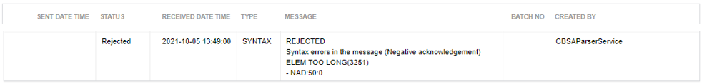

The above reject indicates too many characters in the name or address of a trade chain partner, possibly the shipper or consignee on an invoice.

## mandatory element missing

This reject occurs when a specified piece of data is missing from the entry. The type of data is indicated underneath (IMD).

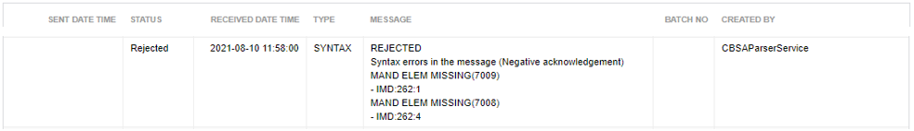

The above reject indicates there is a missing item description on at least one of the lines.

## mandatory segment missing

This reject occurs when an unknown piece of data is missing from the entry.

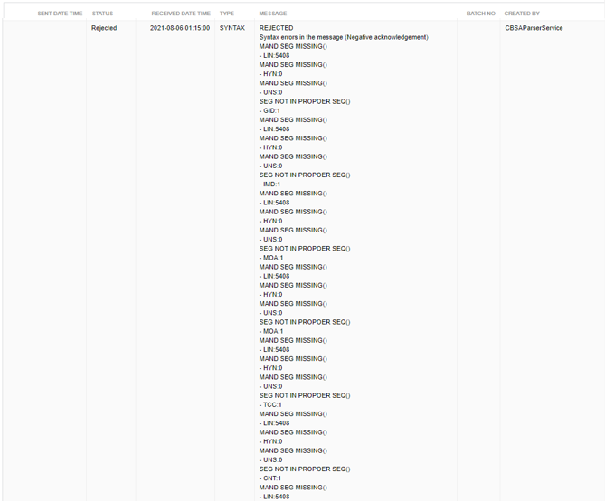

The above reject indicates there is something missing on at least one line (possibly a value, coo, or tt). Don’t be intimidated by the long list of different segments missing. Typically, with this reject, only one or a few details are missing which causes everything else to be out of sequence. (Eg. Missing COO on two lines)

# DATA ERROR rejects

Like the syntax error, this type of reject indicates the message did not meet the initial data check requirements of CBSA’s system and gets bounced back before it ever reaches them, because some essential piece of data is missing. Common rejects include ‘mandatory element missing’, or ‘element too short’, and it will indicate the line number and position in the background data that was transmitted to CBSA.

If you’re not familiar with reading the background data (you can see it by clicking on the batch number beside the last transmission in the transmission log), then a good strategy is to check all lines carefully to see if something is missing or out of place.

Again, like the syntax error, once the error has been fixed the entry must be re-transmitted again as an ‘original’ message since the data never fully made it through to Customs’ system the first time.

## Mandatory element missing / element too short / invalid characters

The most common reason for this reject is something missing on one of the lines, like a country of origin, or a GST code, or a unit of measure. Check all the lines carefully to find the missing element.

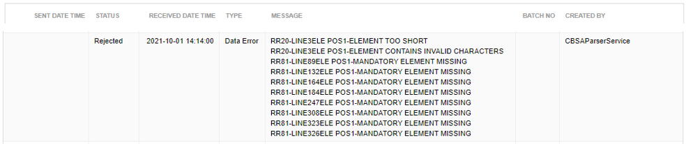

The above reject indicates that one line has an element that is too short and contains invalid characters (same line number), plus 8 different lines that have a missing element.

# rejected by cbsa

Once your message has made it through to CBSA’s system, passing their initial data checks, then you can receive rejects from CBSA’s system for various reasons, the most common of which are listed below.

For this type of reject, you will need to send an subsequent messages as a ‘change’ since the transaction is already existing in Customs’ system.

## INVALID STATUS OF REQUEST

The reject usually happens when the cargo control number already exists in CBSA’s system but you sent a new message as an ‘original’ instead of a ‘change’. You can just immediately resend your message as a change to fix this reject.



You can just immediately resend your message as a change to fix this reject.

## request must exist on file

This reject is the opposite of the ‘invalid status of request’ above. It occurs when the cargo control number does not exist CBSA’s system, but you have sent a new message as a ‘change’ instead of an ‘original’. This usually happens when the previous message came back with a data or syntax error and someone accidentally sent a new message as a change after fixing it.



You can just immediately resend your message as an original to fix this reject.

## duplicate field

This reject usually occurs when our transaction number is already in CBSA’s system, but a significant piece of data has changed, causing CBSA to recognize it as a different shipment, therefore declaring it as a duplicate. The most common reason for this is that someone changed the client code without cancelling the entry first.



The way to fix this reject is to change the entry back to what it was originally and send it as a cancel first. Once the cancel comes back accepted, then the information can be changed and re-transmitted as a new original message.

## related request in history

This reject usually happens when another transaction number already exists with the same cargo control number. The most likely reasons are either we already set up the same PARS on a different file number, or another broker set up the same PARS.



If we accidentally duplicated 2 PARS in our own system, we can just disregard one of them, but if there are no other entries in our system for the shipment, then the carrier would have to be notified that the PARS they provided is a duplicate.

## edi changes not accepted after arrival

This reject occurs when the driver has already arrived at the border and his ACI manifest has been scanned by the CBSA officer.



Once this happens you can no longer send a ‘change’ message to correct the entry, but instead you must send an ‘amendment’ message.

## LINE CLASSIFICATION VALUE

This reject occurs when there is an invalid HS code on one of the lines.



Look for the line with an incorrect HS code (with a red box around it) and then resend as a change with the corrected HS.

## invoice quantity unit of measure

This reject occurs when an invalid unit of measure is used on the invoice quantity.



There are only certain unit of measures that are valid for the invoice quantity (PCS, SKDS, etc) and the invoice weight must be in KGM.

## line canadian product category code

This reject comes from CBSA but is actually related to PGA info, specifically HC in this case. It happens when a PGA detail is partially added but not properly closed before saving the line, which results in a glitched duplicate PGA detail and causes a reject. It can also happen with other PGA fields besides the product category code.



The only way to fix this is to delete the glitched line and rekey a new one. For assistance with finding which line is glitched, ask Esther the Operations Assistant.

# OFFICER MANUAL REJECt

This type of reject message comes directly from an officer, not the CBSA’s system. It will still show up as ‘Rejected by CBSA’ but will be indicated underneath with the words ‘Officer Manual Reject’, followed by the words that an officer manually typed.

There are some common reasons for this type of reject that are more generic, as listed below. However, an officer can also use this type of reject to request further information (like better descriptions) or to give specific instructions, and it’s important to follow the instructions as accurately as possible. Having an officer make a request like this usually means they are already reviewing the entry, and further rejects could result in an AMPS penalty for non-compliance. If you don’t understand the officer’s instructions, it is probably best to call the port and clarify what they are looking for, rather than continuing to send messages that could result in additional rejects.

## related cargo at a different port

This reject usually happens when the driver shows up at a different port than what we declared in our entry. The wording could vary with each instance depending on the officer, but all of them will indicate that a port change is needed:

‘RELATED CARGO AT A DIFFERENT PORT – PLEASE CORRECT AND RESUBMIT’

‘CARGO SET TO GO IN BOND TO 0453 - PLEASE CLEAR 0440’

‘CCN SET UP TO CLEAR IN SASK NOT ALBERTA’

‘PORT HAS TO BE CHANGED TO 496 TO MATCH PORT OF CLEARANCE OF CARGO’

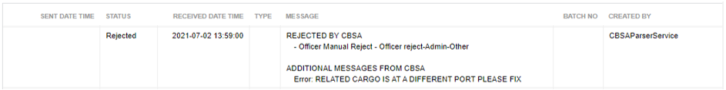

If the reject doesn’t mention which port it needs to be changed to, then you will need to contact the carrier first to confirm.

# rejected by pga

If the entry has PGA information that is being transmitted, the message will go to both CBSA and whichever PGA is involved. Therefore, the entry can also be rejected by one of the PGAs for invalid or incomplete PGA information. Some of the PGAs will identify themselves by including their own contact information at the bottom of the reject, and some will have no such identification but you may be able to tell which PGA is rejecting the entry based on the fields mentioned in the reject message. Some common examples are included below.

## CFIA rejects

CFIA includes their NISC (National Import Service Centre) contact information at the bottom of their reject message. This is your indication that the reject is on a line with CFIA. They will also often include the line number that contains the error.

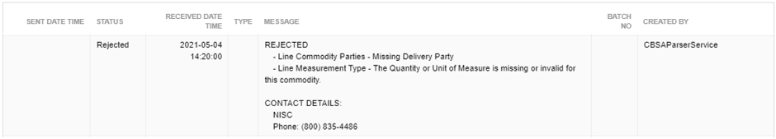

The above reject indicates the delivery party (or destination) is missing and the PGA quantity is missing or invalid.

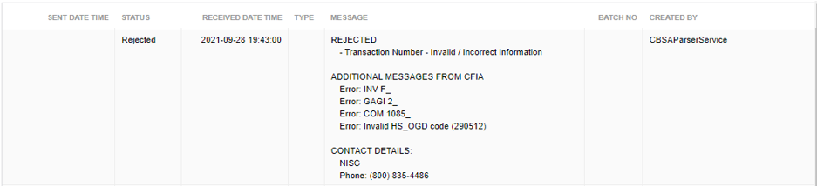

The above reject indicates the OGD code is invalid on line 1085. When CFIA refers to HS_OGD code, it always means OGD code, and the number beside COM is the line number in the entry.

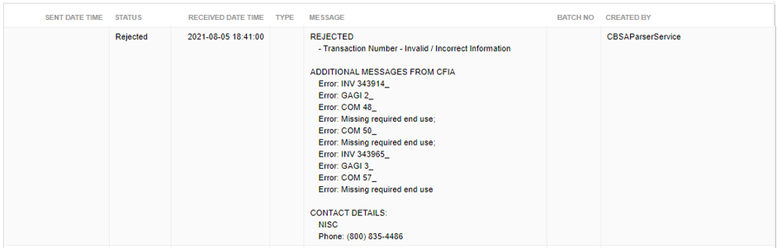

The above reject indicates the end use is missing on lines 48, 50, and 57.

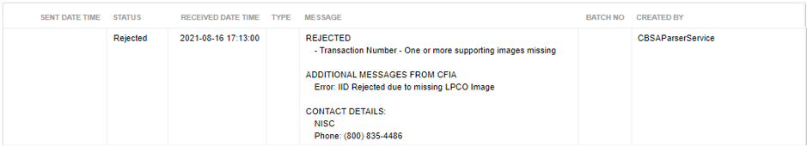

The above reject indicates there is an LPCO attachment missing for one or more of the lines.

## TC rejects

TC includes their RIV (Registrar of Imported Vehicles) contact information at the bottom of their reject message. This is your indication that the reject is on a line with TC.

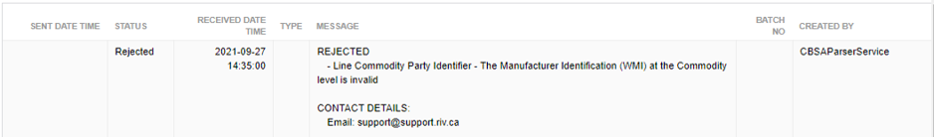

The above reject indicates the WMI code is missing in the Manufacturer’s TCP profile. A manager or 2IC should be able to edit the TCP profile and update this code.

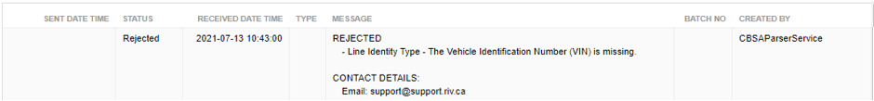

The above reject indicates the VIN number is missing on one of the lines with TC.

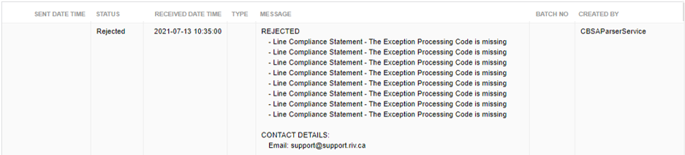

The above reject indicates the Exception Processing Code is missing on one or more lines with TC.

## ECCC rejects

ECCC includes the contact information for TCCU (Technical Commercial Client Unit) at the bottom of their reject messages. This contact is not exclusive to ECCC so there could be other PGAs that use the same contact info. For ECCC, you may have to guess the PGA based on the reject message itself.

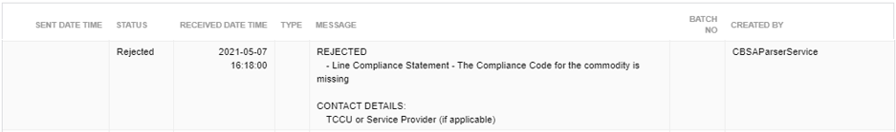

The above reject indicates there is a compliance statement missing on one of the lines. The only PGAs that use compliance statements are TC and ECCC, and TC includes the RIV contact info at the bottom of their rejects, so this will likely be a reject for a line with ECCC.

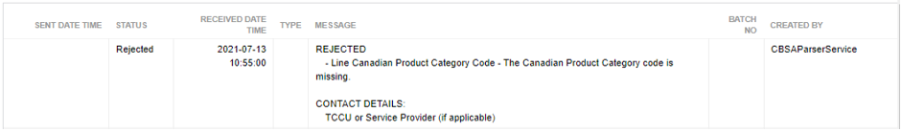

The above reject indicates the product category code is missing on one of the lines. ECCC is one of the PGAs that use product category codes, so the reject could be for one of the lines with ECCC.

## NRCAN rejects

NRCAN includes the contact information for TCCU (Technical Commercial Client Unit) at the bottom of their reject messages. This contact is not exclusive to NRCAN so there could be other PGAs that use the same contact info. For NRCAN, you may have to guess the PGA based on the reject message itself.

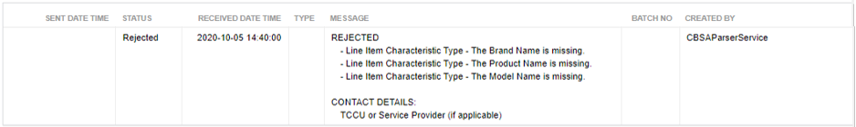

The above reject indicates the brand name, product name, and model name are missing on one of the lines. This grouping of PGA details is usually provided for NRCAN so the reject is likely on a line with NRCAN.

## GAC rejects

GAC includes their EICS (Export and Import Controls System) contact information at the bottom of their reject message. This is your indication that the reject is on a line with GAC.

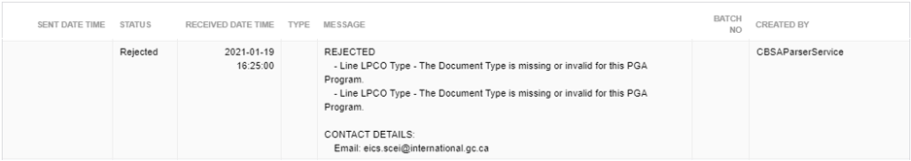

The above reject indicates the LPCO attachment is missing or incorrect on one of the lines with GAC.

## HC rejects

HC includes the contact information for TCCU (Technical Commercial Client Unit) at the bottom of their reject messages. This contact is not exclusive to HC so there could be other PGAs that use the same contact info. For HC, you may have to guess the PGA based on the reject message itself.

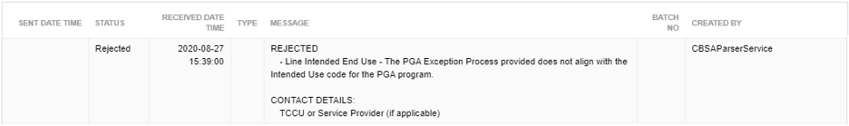

The above reject indicates there is something wrong with the intended use code on one of the lines. Intended use is one of the required fields for HC, so this reject could be for a line with HC.

# list of data segments

Please not there could be more than one occurrence of the same data segment. For example, **LOC** could refer to CBSA Port of Release, Place/Location Identification, Country of Export, Country of Origin, or Commodity Origin.

**UNA** Service string advice

**UNB** Interchange header

**UNG** Functional group header

**UNH** Message header

**BGM** Beginning of message

**DTM** Estimated Time of Arrival at the First Point of Arrival

**MOA** Total Value for Duty

**IFD** Exception Code

**RFF** Secondary Business Identifier

**RFF** Cargo Control Number

**SG3** PGA Processing Requirements

**GOR** Governmental requirements

**LOC** CBSA Port of Release/PGA Processing Location

**SG7** Declaration/Secondary Notify Parties

**NAD** Declaration/SNP Party Identification

**IFD** SNP Notice Type

**SG8** Contact Information

**CTA** Contact Identification

**COM** Contact Method

**SG9** License/Permit/Certificate/Other Documents

**DOC** Document Identification Details

**RFF** Secondary Reference Information

**DTM** Issue/Effective/Expiry Dates

**QTY** Documented Alternative Quota Quantity

**SG10** LPCO Parties

**NAD** Name and address

**SG11** Contact Information

**CTA** Contact Identification

**COM** Contact Method

**SG12** LPCO Issuing/Place of Authentication Location

**LOC** Place/location identification

**SG13** Additional Inspection/Exception Details

**RCS** Requirements and conditions

**FTX** Free text

**SG15** Amendment Reason

**AJT** Amendment Reason Code

**SG25** PGA Payment Details

**TAX** Fee Details

**SG26** PGA Payment Details

**PAI** Payment instructions

**RFF** Reference

**MOA** Monetary amount

**UNS** Section control

**SG47** Goods Group/Invoice Level

**SEQ** Sequence details

**RFF** Cargo Control Number

**SG48** Vendor/Invoice Parties

**NAD** Name and address

**SG49** Contact Information

**CTA** Contact Identification

**COM** Contact Method

**SG50** Country/Facility of Export/Direct Shipment

**LOC** Country of Export/Direct Shipment/Foreign Facility Details

**DTM** Date/time/period

**SG51** P.O./Invoice Details

**DOC** P.O./Invoice Identification

**SEQ** Sequence details

**DTM** Invoice Date of Issue

**MOA** Invoice Total Amount

**SG68** Invoice Total Weight/Volume and Quantity

**MEA** Measurements

**QTY** Invoice Quantity

**SG101** Government Agency Goods Item Details (GAGI)

**LIN** Line item

**SG102** Manufacturer

**NAD** Name and address

**SG103** Contact Information

**CTA** Contact Identification

**COM** Contact Method

**SG104** Country of Origin

**LOC** Country of Origin

**SG115** Invoice Level Packaging Quantity and Type

**PAC** Shipping Package Type and Quantity

**SEQ** Sequence details

**PCI** Package identification

**SG117** Commodity Details

**GID** Goods item details

**IMD** Item description

**APP** Intended End-Use

**RFF** Lot Number/Meter Reading

**DTM** Production/Expiry Date

**GIR** Commodity Identity Codes

**GIN** Commodity Identifier Codes

**MEA** Commodity Size

**MOA** Commodity Pricing

**PGI** Canadian Product Category

**TCC** Commodity Classification Codes

**CNT** Commodity Unit Count

**SG118** Commodity Country of Origin

**LOC** Commodity Country of Origin

**SEQ** Sequence details

**SG119** Manufacturer / Commodity Party

**NAD** Name and address

**SG120** Contact Information

**CTA** Contact Identification

**COM** Contact Method

**SG121** License/Permit/Certificate/Other Documents

**DOC** Document Identification Details

**RFF** Secondary Reference Information

**DTM** LPCO Issue/Effective/Expiry Date

**QTY** Documented Alternative Quota Quantity

**SG122** LPCO Parties

**NAD** Name and address

**SG123** Contact Information

**CTA** Contact Identification

**COM** Contact Method

**SG124** LPCO Issuing/Place of Authentication Location

**LOC** Place/location identification

**SG125** Compliance Statements

**RCS** Requirements and conditions

**SG127** Retail Level Packaging Quantity and Type

**PAC** Retail Package Type and Quantity

**FTX** Retails Marking Information

**SG128** Component/Ingredient Details

**COD** Ingredient

**QTY** Ingredient Quantity

**PCD** Ingredient Concentration

**SG140** Commodity Temperature

**TMP** Temperature

**SG142** Commodity Process Type

**PRC** Process identification

**SEQ** Sequence details

**DTM** Process Timing Details

**SG143** Processor

**NAD** Name and address

**SG144** Contact Information

**CTA** Contact Identification

**COM** Contact Method

**HYN** Hierarchy information

**UNS** Section control

**UNT** Message trailer

**UNE** Functional group trailer

**UNZ** Interchange trailer