**Web Tracker**

Webtracker is an interactive web application for our forwarding and US Customs Brokerage applications. Web Tracker allows all US and Canadian shipments processed by Frontier to be monitored and easily accessed by both importers and exporters. Webtracker also offers reports on both your supply chain and costs to better manage your operation.

Clients can log onto Webtracker by using our online web portal. (<http://frownp.webtracker.wisegrid.net/Login/Login.aspx?ReturnUrl=%2fDefault.aspx>)

**Tracking**

Webtracker allows clients to trace shipments that were sent by ocean, air, truck, rail and PAPs. Clients can log into their Webtracker and look at all their shipments or for a specific shipment and see exactly where that shipment is in its journey. Clients are able to check the status of their entries or track their shipments at their own convenience and this increased visibility is a necessity for any supply chain. This function ensures clients are able to transport their orders with the utmost convenience. In today’s world of complex supply chains it’s essential to have peace of mind regarding your shipments tracking.

Clients can search the ETA of incoming shipments.

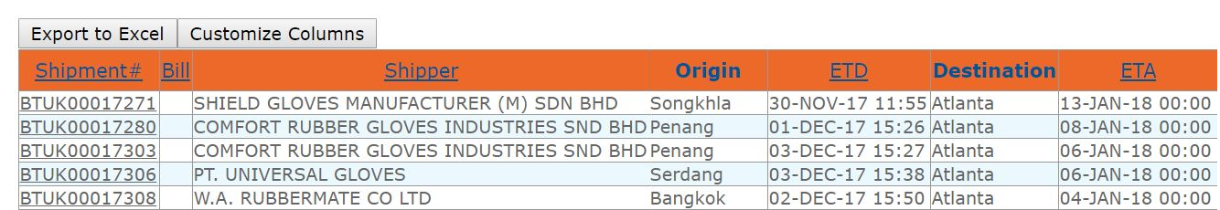

Clients can then go into a specific shipment and see the events regarding that shipment.

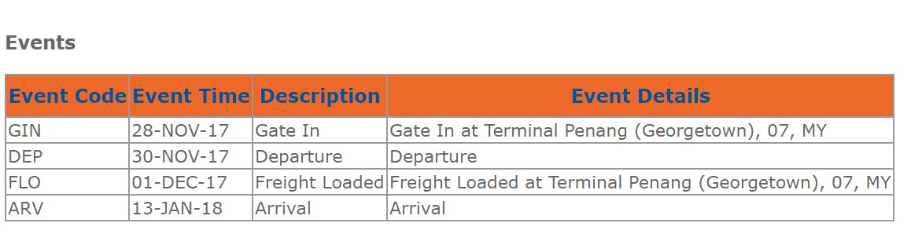

**Reports**

Clients can log into their Web Tracker Account and generate and download relevant reports to their supply chain.

Access to this vital informational regarding their supply chain will give clients peace of mind regarding their supply chains current situation as they have important information only a click away. Web trackers efficient online portal will save clients time as there is no need for outreach on questions regarding relevant reports.

Relevant reports include:

**Booking Summary**

This report produces a list of booking made by an individual client for a given period of time with optional filters by transport mode, origin and destination. This report is grouped by pickup & delivery address and booking date, providing daily booking summary manifest.

**Current Export Shipments**

For a nominated Consignor, this report will produce a list of Export shipments due to depart your login country on or after a selected ETD. Export shipments are Shipments on Consoles with a first load port in your login country. Use this report to advise your Consignor clients about upcoming forwarding shipments due for departure. Used in combination with the CargoWise One report scheduling tool, you can regularly and automatically provide your client/s an update of shipments due to depart.

**Job and Invoiced Charge Summary**

This report will list Forwarding and Declaration jobs for a nominated Client (mandatory filter) if there are revenue charges posted for that client (as debtor). The report will also isolate charges posted for the 'CDS' ratings group (Customs & Disbursement Charges). Use this report in combination with the Report Scheduling tool in order to regularly update your clients on the status of Forwarding and Declaration jobs handled on their behalf.

**Shipment Listing Report**

This is a Client facing report that allows you to generate a list of Forwarding Shipments for a single client. For the nominated client the report selects all shipments where Organization is Consignee, Consignor or Billing Client on a shipment. Additional filter options allow you to limit the report to particular freight dates, ports, transport modes etc. The report also includes Pickup and Delivery date filter options. Use this report to update your client on the latest status of forwarding shipments handled on their behalf.  
  
**Costing**

Importing and exporting is a business of cents. Understanding your costs exactly is extremely important. With WebTracker your organization can gain key insights into the exact costs of your supply chain.

Relevant reports include:

**Landed cost**

This report lists the landed cost detail of invoice lines by product then tariff within supplier. The report shows for a nominated Importer and Date range invoice line details including Origin, Invoice Qty, line prices, landing costs and weighted average landed cost per unit. The report offers selectable columns to detail up to 30 other charges, costs and prices.

**Invoice Summary Report**

The Invoice Summary Report shows a list of shipments with credit notes and invoices.  
  
This report includes Shipment no, # of 20' Container, # of 40' Container, TEU, Transport Mode (e.g. Air Sea), Consignor, Bill To Party, Origin, Destination, Pieces, Actual Kg, Actual M3, Transaction Type (e.g. Invoice, Credit Notes), Transaction Date, Transaction Amount in charge group.

**Statement Accounting Reconciliation Report**

The report lists all the declarations that appear on statements matching the selected criteria and shows Account Payable and Account Receivable amounts for each entry.

**CA Import Declaration Report**

This report makes import declaration information available.