

Consolidated Logistics & Canadian Brokerage Solution to serve:



Confidentiality Agreement

The information contained in this proposal is proprietary. The information contained within should not be disclosed other than to your employees or designates who are responsible for analyzing its contents for approval. No part of this document may be reproduced or distributed in any form or by any means, except for purposes of comparing data, without the prior written permission of Frontier Supply Chains Solutions Inc. This document remains the property of Frontier Supply Chain Solutions Inc. and must be returned or destroyed if requested.

Frontier Supply Chain Solutions Inc.
1450 W Thorndale Ave
Itasca, IL 60143

Tel: 630-250-3544 X 417
Fax: 630-250-4977
www.frontierscs.com

March 18, 2021
Private and confidential
SmartSource Rentals
2025 Glen Ellyn Road
Glendale Heights, IL

Subject: Consolidated logistics and custom brokerage solution for Canada
Scott/Team,
Thank you for the opportunity to present our customized logistics and Canadian custom brokerage solution to SmartSource. We believe the following proposal not only provides the service levels you and team have outlined, but it also outlines Frontier recommendations to help grow sales in Canada. Based on the uncertain shipping projections/sales we are suggesting that all Canadian shipments be routed from our Itasca, IL facility to start. As SmartSource gains market share in Canada, routing and your consolidation plan can be adjusted to provide the most cost effective and efficient way to ship to your Canadian customers. This proposal will focus on the following areas:
- Consolidated daily shipping with overnight service to eastern and western Canada
- Centralized Canadian custom brokerage services with trade compliance support
- “One-team one-provider” service approach
- Blended shipping rates (door to door pricing)
- Customized return process options

As a Canadian-based customs broker, logistics and warehousing partner, Frontier Supply Chain Solution Inc. (Frontier) understands that choosing the right fulfillment partner is an important decision. We believe we are that partner for SmartSource.

Please do not hesitate to contact me at (630) 250-3544 ext. 410 if you have any questions. On behalf of Frontier, we look forward to working with you.

Sincerely,

Ben Mathis
Business Development Manager
Frontier Supply Chain Solutions, Inc.

Consolidated Shipping Solution

Our recommended consolidated shipping solution would provide door to door service from SmartSource’s Glendale Heights location to anywhere in Canada:

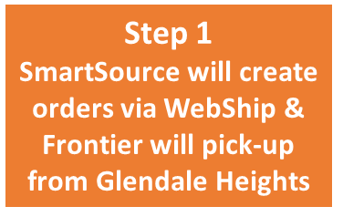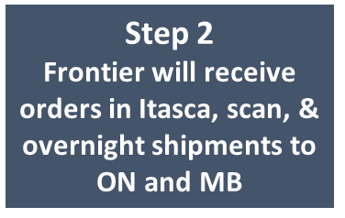
Step 3
Frontier’s Canadian warehouses will receive, scan, & ship the same day received
Coachmen creates carrier compliant Frontier label
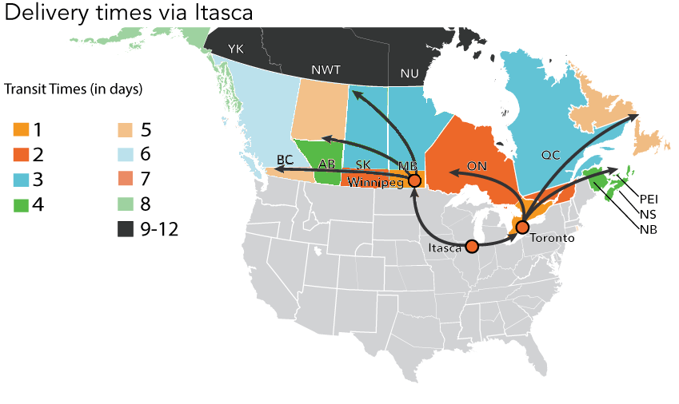
- Frontier has multiple trucks leaving our Itasca facility daily with Frontier trucks & drivers being utilize to reduce risk of border delays or additional handling
- SmartSource will be able to get orders into eastern AND western Canada over night
- Froniter will process and ship LTL and small parcel shipments all the same
- Frontier will further centralize SmartSource Canadian shipments by performing Consolidated Canadian customs on all shipments

Canadian Customs Brokerage
As a Canadian customs broker, Frontier is able to centralize not only, shipping solutions, but we are able to provide a truly “turn-key” solution for SmartSource. Our “one team one provider” solution will cover all of SmartSource’s logistics and customs needs in Canada. By allowing Frontier to implement our pre-arrival review system (PARS) as your carrier and customs broker, we will reduce any risk of delays at the border.
 | A single touch point for all North American customs brokerage, billing and Trade Compliance.
 | Our “One Client - One Team” policy provides your business with a dedicated team of service professionals to improve control and visibility.
 | Online tracking for all shipments ensuring compliance and protecting against border delays.
 | Electronic data transmissions integrate with your business to reduce processing times.
 | Accurate rating of duties and taxes for Canadian and American clearances.
 | Improved efficiency through beneficial trade programs such as NAFTA and the Customs Self-Assessment Program.
 | Recover overpaid duty through the Duty Drawback program in both Canada and The United States.
 | Protecting your business from American and Canadian customs audits with expert consulting and database maintenance

Technology & Tracking
Applied Programming Interface (API) capabilities will allow SmartSource to process all Mail, Parcel, and LTL shipments using servers automatically loading order data from your ERP, creating carrier compliant labels and producing end of day reports with one click (this will be a phased approach once volume is built up)

WebSHIP is Frontier proprietary web-based tracking system that allows users to rate, track, and create orders/label. WebSHIP can be accessed by any device and is easy to use. Regardless of what system is used to generate labels and submit orders, WebSHIP is the interface that is used for tracking. All tracking can be done by simply logging in and going to the “tracking” feature. Proof of deliveries are available in WebSHIP too once the shipment has been delivered
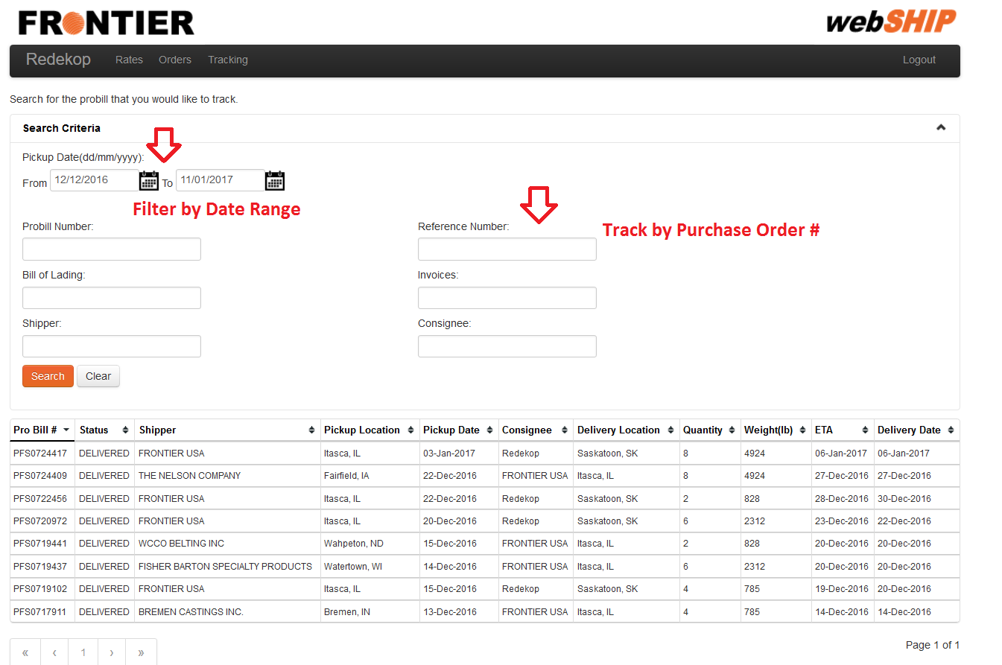
Canadian customers can also track shipments by simply going to Frontier’s home page & clicking “Track Now”
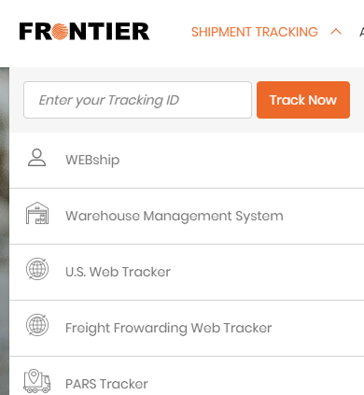

One-Team Service Approach

Any and all services provided by Frontier will be serviced by one team that consist dedicated Frontier employees that understand your account. Upon implementing your account Frontier will create standard operating procurers to outline processes and service expectations. Frontier’s assigned team will understand your business, processes, and service expectations before starting any services for SmartSource. Every team is led by an integrated service rep and account manager:

Integrated Service Representative (ISR)

Every new account will be provided an ISR as part of their team that will manage day-to-day interaction between both our organizations. SmartSource will have the ISR’s direct phone number and e-mail address in case they are needed immediately. Every ISR is backed up by a team of personnel. Providing one point of contact minimizes issues in customs release, tracing, coordinating deliveries, and ensures that you have one individual who is very knowledge in your specific Canadian trading needs.

Account Manager/Trade and Compliance Specialist
Every team will have a person that is experienced in working with CBSA and can act on your behalf on any matters pertaining to your business. This will ensure that all tariff classification, country of origins, North American Free Trade Agreements (NAFTA) and customs programs that may be beneficial to your importing activity is executed properly.

Additional Services

Customized Return Solutions

Frontier has warehouses in Toronto, Winnipeg, and a warehouse partner in Vancouver that allow us to offer customized return services for our customers. We have a warehouse management system that allows customers full visibility to their inventory.

Trade Management Services
Trade Management Services provides importers with the ability to improve their trade processes by accessing knowledgeable counsel in the area of Customs compliance in an attempt, but not limited to:
 | Improve trade facilitation
 | Ensure a compliant customs release occurs
 | Ensure you have expert up-to-date information on continually changing customs and security requirements to facilitate lower costs
 | Minimize the risk of costly penalties

Appendix A – Pricing & Fee Schedule

Small Parcel rates Ex-Glendale Heights, IL

LTL rates Ex-Glendale Heights, IL
Notes:
- The cost of fuel is not included in these rates.
- The greater of the Cubed weight and actual weight will always be used when calculating the freight fee
- Cubed Weight Formula = (LxWxH/1728)x10
- Duties, Taxes and Brokerage are not included in the freight fee
- The rates indicated in this spreadsheet are in USD funds
- Rural and remote destinations are subject to additional charges.

- All “Ex-Glendale Heights” rates were based on an estimated shipping volume of 20+ pieces and 1000+ lbs shipped to Canada weekly

Canadian Customs

The below Canadian customs fee is a consolidated entry fee:
- $60 USD per entry + (CCI line fees may be applicable if data file not received)

Return (CA to Glendale Heights) rates:
Notes:
- The cost of fuel is not included in these rates.
- Maximum weight per skid not to exceed 1650 lbs, Max Size per skid not to exceed 48x40x84
- Duties, Taxes and Brokerage are not included in the freight fee
- The rates indicated in this spreadsheet are in US funds
- Rural and remote destinations are subject to additional charges.

Appendix B – Payment Terms
Month | Release Date | Statement Date3 | CBSA /Frontier  Payment Due Date1 | CBSA Online Payment Due Date2
January | 15 | 25 | 27 | 29
February | 17 | 25 | 24 | 26
March | 17 | 25 | 29 | 31
April | 16 | 26 | 28 | 30
May | 14 | 25 | 27 | 31
June | 17 | 25 | 28 | 30
July | 16 | 26 | 28 | 30
August | 17 | 25 | 27 | 31
September | 17 | 27 | 28 | 30
October | 15 | 25 | 27 | 29
November | 17 | 25 | 26 | 30
December | 17 | 27 | 29 | 31

Payment Options as per CBSA’s Account Receivable Ledger terms:
1
Pay CBSA Electronically
For you to pay CBSA directly, please contact your sales representative or ar@frontierscs.com to update your Frontier account and then you will receive two separate statements from Frontier. One statement for your balance due to Frontier, and one “GST” statement for your current transaction amounts due to CBSA. The customs payment amounts will not be included on your Frontier invoice.
CBSA Electronic Banking is set up for: RBC, Scotia, TD, BMO, Citibank, Bank of America, Tangerine, CIBC, The National Bank, and HSBC as of January 2018. Online banking “Payee” Name is CBSA Duties Taxes Fees, or Canada Border Services Agency or similar. Your account number to reference is your importer number which is your business number including your RM number (BN15). Be sure to check with your financial institution regarding their cut off times to avoid late payments.

Mail Receiver General Payment Directly
2
You can mail your check, money order or bank draft payable to “Receiver General for Canada” with importer number indicated, in Canadian funds, to CBSA as follows:
Canada Border Services Agency (CBSA) MAILROOM
Attention: Accounts Receivable Management Unit 333 North River Road, Place Vanier, Tower A Room 1018 Ottawa, ON K1A 0L8
Your Customs Daily Notice (DN) and Statement of Account (SOA) can be received by Frontier by completing the EDI application and authorizing Frontier to be your authorized custom broker on the application. (See EDI application).

