

Consolidated Logistics & Canadian Brokerage Solution to serve:



Confidentiality Agreement

The information contained in this proposal is proprietary. The information contained within should not be disclosed other than to your employees or designates who are responsible for analyzing its contents for approval. No part of this document may be reproduced or distributed in any form or by any means, except for purposes of comparing data, without the prior written permission of Frontier Supply Chains Solutions Inc. This document remains the property of Frontier Supply Chain Solutions Inc. and must be returned or destroyed if requested.

Frontier Supply Chain Solutions Inc.
1450 W Thorndale Ave
Itasca, IL 60143

Tel: 630-250-3544 X 417
Fax: 630-250-4977
www.frontierscs.com

April 9, 2020
Private and confidential
Pampered Chef
1 Pampered Chef Lane
Addison, IL 60101

Subject: Consolidated logistics and custom brokerage solution for Canada
Pampered Chef Team,
Thank you for the opportunity to present our customized logistics and Canadian custom brokerage solution to Pampered Chef. We believe the following proposal not only provides the service levels you and team have outlined, but it also outlines Frontier recommendations that will improve your team and your customer’s overall experience as it relates to shipping to Canada. Based on our conversations and analysis of data, we are confident that we are the right partner for your business and look forward to opportunity to review the following with you:

- Consolidated daily shipping with overnight service to eastern and western Canada
- Centralized Canadian custom brokerage services with trade compliance support
- “One-team one-provider” service approach
- Blended shipping rates (door to door pricing)
- Customized return process options

As a Canadian-based customs broker, logistics and warehousing partner, Frontier Supply Chain Solution Inc. (Frontier) understands that choosing the right fulfillment partner is an important decision. We believe we are that partner for Pampered Chef.

Please do not hesitate to contact me at (630) 250-3544 ext. 410 if you have any questions. On behalf of Frontier, we look forward to working with you.

Sincerely,

Ben Mathis
Business Development Manager
Frontier Supply Chain Solutions, Inc

Consolidated Shipping Solution

Consolidate in Itasca, IL (Ex-Addison, IL)
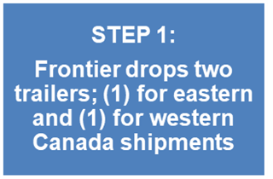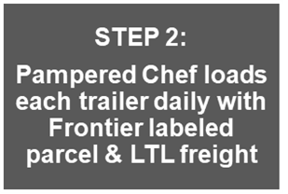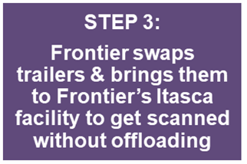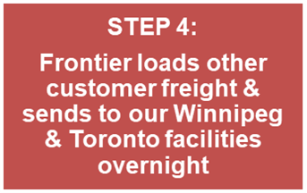
Coachmen creates carrier compliant Frontier label
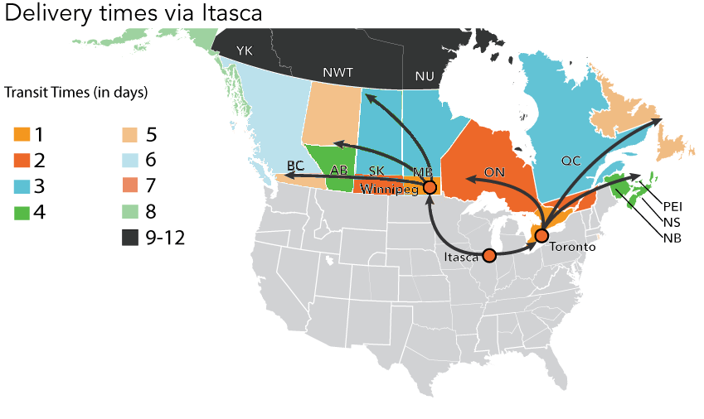
- Frontier has multiple trucks leaving our Chicago (Itasca), IL facility and will dedicate trailers to provide overnight daily service for Pampered Chef
- Frontier’s proposed solution will allow Pampered Chef customers in western Canada (48% of all shipments) to go directly to Frontier-Winnipeg overnight before going out of end delivery (This will save money & approx. 1-3 days in transit)
- Pampered Chef will be able to process all parcel and LTL shipments to Canada the same and nothing will be taken off either Frontier truck until they arrive in Canada
- All line hauls are performed by Frontier team drivers on Frontier 53’ trailers
Canadian Customs Brokerage
As a Canadian customs broker, Frontier is able to centralize not only, shipping solutions, but we are able to provide a truly “turn-key” solution for Pampered Chef. Our “one team one provider” solution will cover all of Pampered Chef’s logistics and customs needs in Canada. By allowing Frontier to implement our pre-arrival review system (PARS) as your carrier and customs broker, we will reduce any risk of delays at the border.
Frontier also understands the importance of leveraging new technology to improve our customers experience. As proof of this, Frontier recently made a substantial investment in a new Canadian brokerage software system (Visual Importer) which allows customers real time shipment updates, on demand reporting, CBSA ARL data, shipment document retrieval/imaging, and key performance indicator tracking, among other things.
Visual Importer Benefits:

- Pampered Chef users will be able to view real time shipment status by confirmation day:
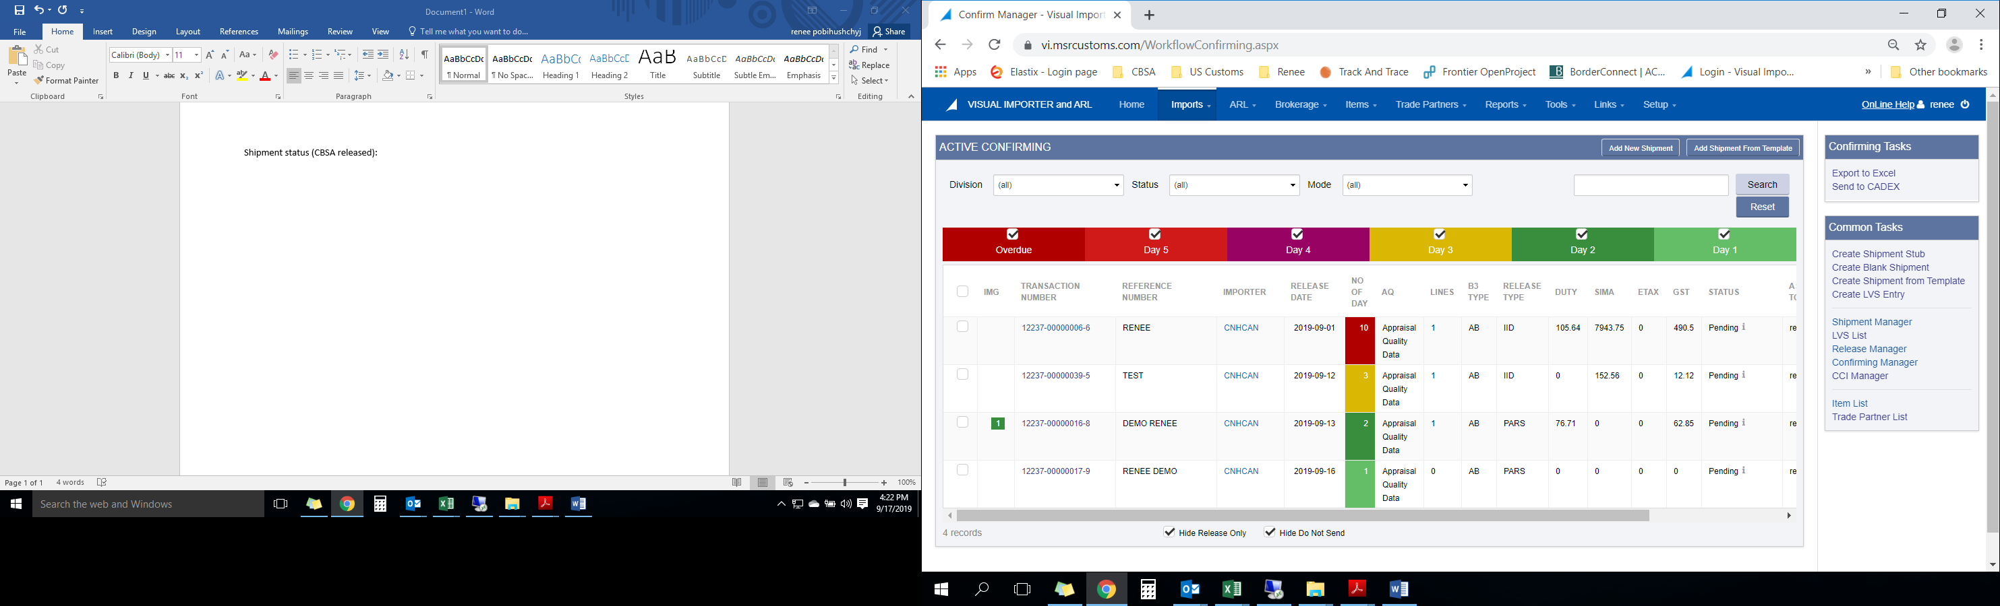

CA Customs Brokerage Continued
- Pampered Chef users will have access all custom doc via our imaging document system:
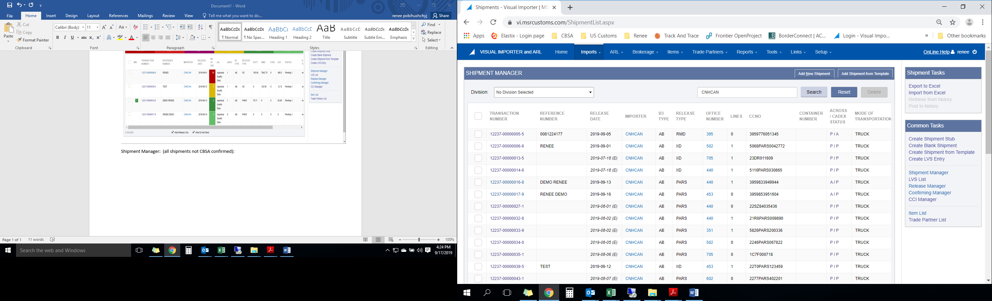
- Visual importer also provides up to date real time CBSA ARL tracking:
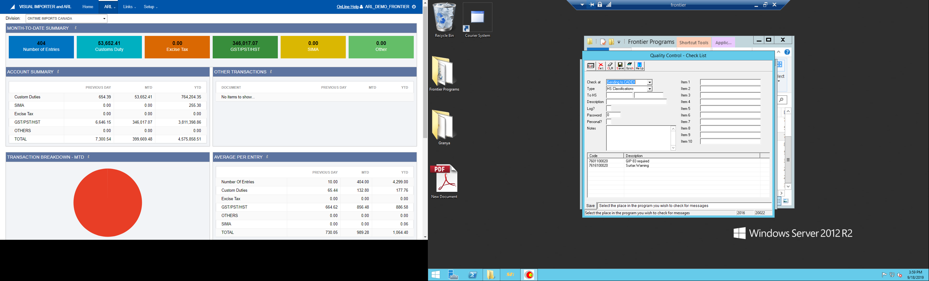
Other Technology & Tracking Tools
Applied Programming Interface (API) capabilities will allow Pampered Chef to process all Mail, Parcel, and LTL shipments using servers automatically loading order data from your ERP, creating carrier compliant labels and producing end of day reports with one click.

WebSHIP is Frontier proprietary web-based tracking system that allows users to rate, track, and create orders/label. WebSHIP can be accessed by any device and is easy to use. Regardless of what system is used to generate labels and submit orders, WebSHIP is the interface that is used for tracking. All tracking can be done by simply logging in and going to the “tracking” feature. Proof of deliveries are available in WebSHIP too once the shipment has been delivered
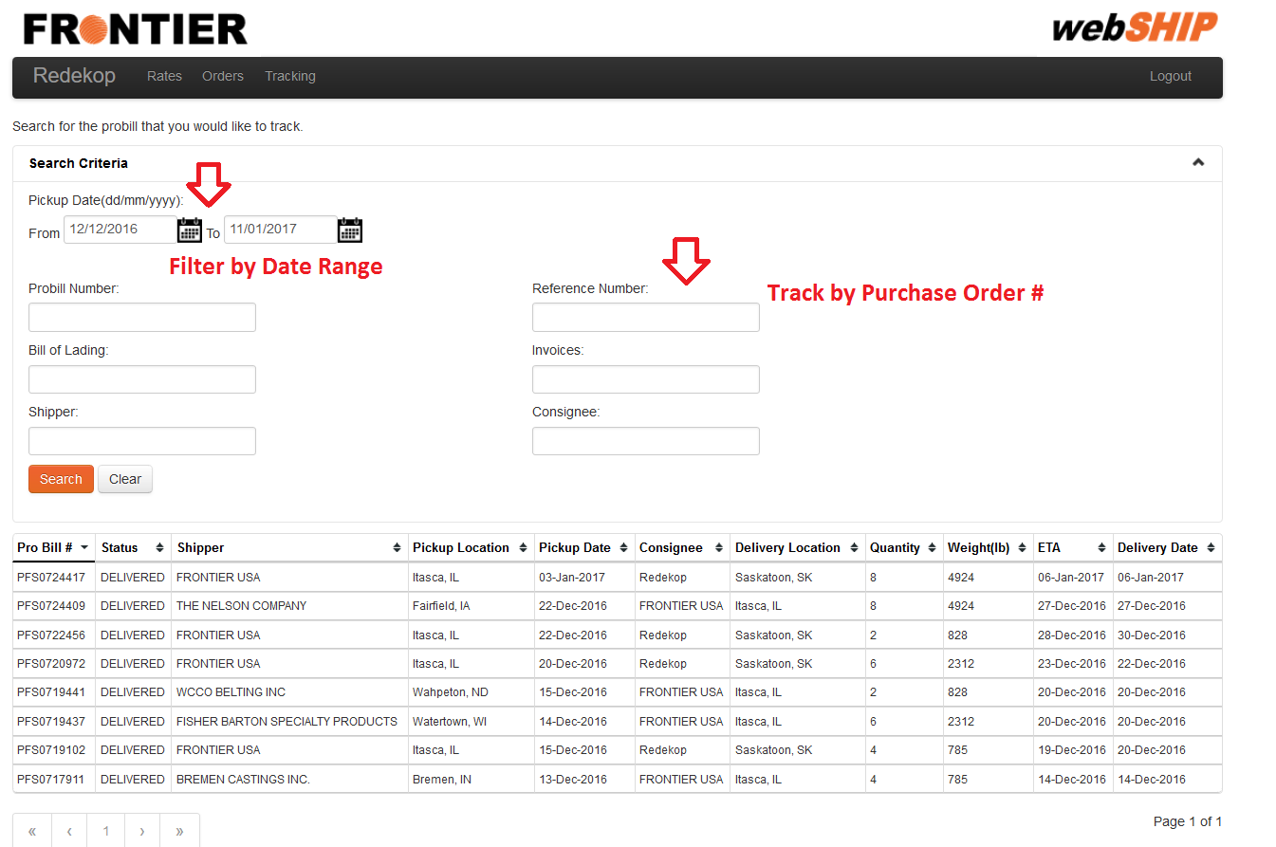
Canadian customers can also track shipments by simply going to Frontier’s home page & clicking “Track Now”
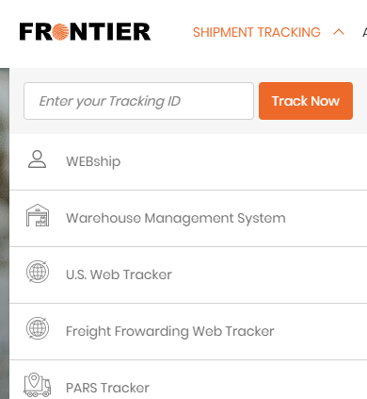

One-Team Service Approach

Any and all services provided by Frontier will be serviced by one team that consist of 5-7 full time employees and after hour support. Upon implementing your account Frontier will create standard operating procurers to outline processes and service expectations. Frontier’s assigned team will understand your business, the agreed to processes, and service expectations before starting any services for Pampered Chef. Every team is led by an integrated service rep and account manager:

Integrated Service Representative (ISR)

Every new account will be provided an ISR as part of their team that will manage day-to-day interaction between both our organizations. Pampered Chef will have the ISR’s direct phone number and e-mail address in case they are needed immediately. Every ISR is backed up by a team of personnel. Providing one point of contact minimizes issues in customs release, tracing, coordinating deliveries, and ensures that you have one individual who is very knowledge in your specific Canadian trading needs.

Account Manager/Trade and Compliance Specialist
Every team will have a person that is experienced in working with CBSA and can act on your behalf on any matters pertaining to your business. This will ensure that all tariff classification, country of origins, North American Free Trade Agreements (NAFTA) and customs programs that may be beneficial to your importing activity is executed properly.

Additional Services

Customized Return Solutions

Frontier has warehouses in Toronto, Winnipeg, and a warehouse partner in Vancouver that allow us to offer customized return services for our customers. We have a warehouse management system that allows customers full visibility to their inventory.

Eliminate/Reduce costs in Markham – By utilizing Frontier’s warehouses, Pampered Chef can route returns to any of our warehouses instead of sending everything back to Markham, ON. Frontier can customize a return solution that involves online WMS access, disposal of products, and/or consolidation of products back to the US.

Trade Management Services
Trade Management Services provides importers with the ability to improve their trade processes by accessing knowledgeable counsel in the area of Customs compliance in an attempt, but not limited to:
 | Improve trade facilitation
 | Ensure a compliant customs release occurs
 | Ensure you have expert up-to-date information on continually changing customs and security requirements to facilitate lower costs
 | Minimize the risk of costly penalties

Appendix A – Pricing & Fee Schedule

Canadian Customs

The below Canadian customs fee is a consolidated entry fee:
- $60 CAD per entry + (CCI line fees may be applicable if data file not received)

Small Parcel Rates Ex-Addison, IL
Origin | Lbs | 1 - 10 lbs. | 11+
Addison, IL | ON - GTA | 6.27 | 0.27
Addison, IL | ON - South | 7.43 | 0.30
Addison, IL | ON - Central | 7.43 | 0.30
Addison, IL | ON - East | 7.62 | 0.33
Addison, IL | ON - North | 9.34 | 0.39
Addison, IL | QC - Montreal | 7.57 | 0.28
Addison, IL | QC - Province | 9.34 | 0.39
Addison, IL | Maritimes | 13.85 | 0.34
Addison, IL | NL - Province | 17.47 | 0.43
Addison, IL | MB - Winnipeg | 7.50 | 0.30
Addison, IL | MB - Province | 8.58 | 0.38
Addison, IL | SK - Regina | 8.10 | 0.36
Addison, IL | SK - Province | 9.93 | 0.42
Addison, IL | AB - Calgary | 10.94 | 0.42
Addison, IL | AB - Edmonton | 10.94 | 0.42
Addison, IL | AB - Province | 13.10 | 0.46
Addison, IL | BC - Vancouver | 13.10 | 0.46
Addison, IL | BC - Province | 14.41 | 0.52

Notes:
- The cost of fuel is not included in these rates.
- The greater of the Cubed weight and actual weight will always be used when calculating the freight fee
- Cubed Weight Formula = (LxWxH/1728)x10
- Duties, Taxes and Brokerage are not included in the freight fee
- The rates indicated in this spreadsheet are in CAD funds
- Rural and remote destinations are subject to additional charges.

Appendix A – Continued

LTL Rates Ex-Addison, IL
Origin | Destination | Prov | M/C | L5C | M5C | 1M | 2M | 5M | 10M
Addison, IL | Winnipeg | MB | 105.00 | 23.24 | 21.63 | 20.01 | 18.57 | 17.42 | 15.77
Addison, IL | Regina | SK | 105.00 | 26.98 | 22.31 | 20.48 | 18.89 | 18.38 | 18.05
Addison, IL | Saskatoon | SK | 105.00 | 28.17 | 23.12 | 21.17 | 19.67 | 18.96 | 18.59
Addison, IL | Edmonton | AB | 106.94 | 32.39 | 26.98 | 24.48 | 22.32 | 21.27 | 20.74
Addison, IL | Calgary | AB | 106.94 | 32.39 | 26.98 | 24.48 | 22.32 | 21.27 | 20.74
Addison, IL | Vancouver | BC | 130.01 | 41.67 | 32.88 | 27.14 | 24.56 | 23.82 | 23.51
Addison, IL | Toronto | ON | 105.00 | 24.32 | 23.99 | 18.99 | 17.69 | 16.77 | 16.10
Addison, IL | Ottawa | ON | 107.41 | 34.28 | 29.46 | 25.44 | 23.06 | 20.48 | 19.27
Addison, IL | Montreal | QC | 105.00 | 29.97 | 26.76 | 23.09 | 21.40 | 20.03 | 18.65
Addison, IL | Quebec | QC | 105.00 | 32.16 | 28.61 | 24.55 | 22.62 | 21.02 | 19.67
Addison, IL | Halifax | NS | 116.03 | 37.26 | 33.75 | 29.66 | 27.63 | 25.71 | 23.87
Addison, IL | Moncton | NB | 108.68 | 34.09 | 30.73 | 26.78 | 24.82 | 23.08 | 21.48
Addison, IL | St Johns | NL | 168.17 | 59.03 | 54.34 | 48.83 | 46.09 | 42.46 | 39.05
Notes:
- The cost of fuel is not included in these rates.
- The greater of the Cubed weight and actual weight will always be used when calculating the freight fee
- Cubed Weight Formula = (LxWxH/1728)x10
- Duties, Taxes and Brokerage are not included in the freight fee
- The rates indicated in this spreadsheet are in CAD funds
- Rural and remote destinations are subject to additional charges.

Appendix B – Implementation

Estimated Timeline (PC = Pampered Chef/FSC = Frontier Supply Chain)
Task | Responsibility | Time Needed to Complete
Pampered Chef signs/returns T&C, credit application, & GAA | Pampered Chef | 1 day
API set-up  - Intro call with PC and FSC IT personnel  - Establish set-up timeline and responsibilities  - Complete Programming  - Test | Pampered Chef &  Frontier | 2-4 weeks
Establish tariff database  - PC sends database  - PC & FSC service team discuss how to keep it updated  - PC & FSC IT teams determine how push data to FSC | Pampered Chef & Frontier | 2-3 days
Develop Standard Operating Procedures  - Pertinent contact information is exchanged  - Processes are outlined and agreed to  - Contingency plans are prepared  - Expectations for both parties are made | Pampered Chef & Frontier | 2-3 days
Upload NAFTA Certificates  - At Pampered Chef’s request Frontier will collect NAFTAs  - NAFTA will be uploaded in Frontier’s operating system | Pampered Chef & Frontier | 2-3 days
Internal On-boarding meeting  - Frontier meets internally to discuss all matters of the transition  - Key Frontier members involve our customs operation teams  - Questions are gathered which your sales rep will collect and bring forward | Frontier | 1 day
Final questions are prepared & brought forward to PC  - This will be the final specific questions your team will have about your expectations, products, etc. | Frontier & Pampered Chef | 15-30 minutes
SOP updated and Finalized  - Final changes are made if any | Frontier | 15-30 minutes
Final SOP reviewed between Frontier & Pampered Chef  - At this time you are personally introduced to your team and other key members | Frontier | 15-30 minutes
Pampered Chef alerts vendors of change of broker  - This can be done beforehand or as your send in POs  - Internal communication to the rest of Pampered Chef employees can be made at this time as well | Pampered Chef | 30-60 minutes

In summary the total estimated time from receiving set-up docs to starting = 3-4 weeks

Appendix C – Payment Terms
Month | Release Date | Statement Date3 | CBSA Cheque/Frontier Payment Due Date1 | CBSA Online Payment Due Date2
January | 17 | 27 | 29 | 31
February | 14 | 25 | 26 | 28
March | 17 | 25 | 27 | 31
April | 17 | 27 | 28 | 30
May | 14 | 25 | 27 | 29
June | 17 | 25 | 26 | 30
July | 17 | 27 | 29 | 31
August | 17 | 25 | 27 | 31
September | 17 | 25 | 28 | 30
October | 16 | 26 | 28 | 30
November | 17 | 25 | 26 | 30
December | 17 | 28 | 29 | 31

Payment Options as per CBSA’s Account Receivable Ledger terms:
1
Pay CBSA Electronically
For you to pay CBSA directly, please contact your sales representative or ar@frontierscs.com to update your Frontier account and then you will receive two separate statements from Frontier. One statement for your balance due to Frontier, and one “GST” statement for your current transaction amounts due to CBSA. The customs payment amounts will not be included on your Frontier invoice.
CBSA Electronic Banking is set up for: RBC, Scotia, TD, BMO, Citibank, Bank of America, Tangerine, CIBC, The National Bank, and HSBC as of January 2018. Online banking “Payee” Name is CBSA Duties Taxes Fees, or Canada Border Services Agency or similar. Your account number to reference is your importer number which is your business number including your RM number (BN15). Be sure to check with your financial institution regarding their cut off times to avoid late payments.

Mail Receiver General Cheque Directly
2
You can mail your cheque, money order or bank draft payable to “Receiver General for Canada” with importer number indicated, in Canadian funds, to CBSA as follows:
Canada Border Services Agency (CBSA) MAILROOM
Attention: Accounts Receivable Management Unit 333 North River Road, Place Vanier, Tower A Room 1018 Ottawa, ON K1A 0L8
Your Customs Daily Notice (DN) and Statement of Account (SOA) can be received by Frontier by completing the EDI application and authorizing Frontier to be your authorized custom broker on the application. (See EDI application).

Appendix D – Accessorial Fees

 | Fee Explanation
Additional Insurance | Additional insurance can be purchased if required. Please contact Frontier for more information.
Address Correction and Re-Delivery | For parcel service an additional $18.00 charge will apply when the receiver address is incorrect, incomplete or not legible. Re-Delivery of parcels is an additional $15.00 charge. Please note that Frontier must utilize postal carriers to deliver to a post office box or R.R. # location. Therefore, a delivery address must be provided (including a postal or zip code) for sorting purposes. LTL re-delivery charges will be assessed a $70.00 minimum with a $3.00 charge per CWT.
Administration Charge | A fee of 3% will be applied when the payment is anything other than a cheque or direct deposit.
After Hours P/U or Deliveries | All pick up or deliveries made between 6 p.m. and 7 a.m. or on weekends are subject to an additional charge of $90.00 minimum, $70.00 per hour. This is subject to change.
Air Cargo Security Screening Fee | Due to Transport Canada regulations, any freight destined to a remote location that must travel as air freight is subject to an additional screening charge of $8.50 (0-10 lbs) + $0.25/lb thereafter based on billable weight. Surcharge is subject to change.
Appointment Charge | All non-courier pre-booked appointments will be subject to an additional $30.00 charge. *Special delivery charges may apply for delivery to Wal-Mart Distribution Centers, Home Depot Stores, Lowe’s Stores and other receivers requiring special delivery requirements, along with weekend and holiday pickups or deliveries.
Aviation Insurance Surcharge | All shipments traveling through the Frontier agent air network will be subject to an additional percentage surcharge, based on the total air freight charges.
Beyond Charge | Should the point be deemed a Beyond location by delivering carrier, an additional charge may apply.
Carbon Surcharge | 0.9% Surcharge applicable on the freight charges. This Levy will apply to all carbon-emitting fuels throughout the fuel supply chain. The carbon tax surcharge will apply to the freight charges of all shipments moving to/from the province of Manitoba.
Cheque Return | This service will apply for the pick up and return of non-certified checks. The fee for service will be $25.00 per check.
COD | The COD charge will be 6% of the amount or a $45.00 minimum per shipment.
Collect/Third Party Bill Surcharge | All shipping charges will be considered “prepaid” unless otherwise noted on the Bill of Lading at the time of shipping. An additional charge will be applied when transportation charges are paid by the third party.
Construction Site, Mine Site, or Carrier Storage Facility P/U or Deliveries | All shipments picked up or delivered to a construction site, prison or storage locker are subject to an additional fee of $5.00 per CWT, Min $80.00, Max $225.00
Cross Border Examination Fee | Shipments crossing the Canada/US border requiring inspection by the Canada Border Services Agency or US customs + Border protection, will be subject to off-loading service fees. Shipments requiring inspection will be subject to off-loading fees invoiced by customs or affiliate. Frontier cannot be held responsible for any delays, caused by customs. Should the shipment be delayed, the customer will be subject to fees.
Cross Border Security Fee | A Fee of $28.00 per consolidation or if not consolidated per individual shipment. Please note the customer is responsible for having their own customs broker.
Dangerous Goods | Charges are calculated on the actual weight of the dangerous goods shipment. LTL Shipments (0-9,999 lbs): $35.00 per shipment.  TL Shipments (10,000 lbs or more): $250 per placard
Dead Call/Missed Pick Up | Any dispatched shipment that is not available upon arrival of the carrier will be subject to a dead call/missed pick up fee.
Domestic Pickup and Delivery Charges | Frontier’s applicable rural and inter-line charges are based on delivering carriers schedule. Please contact your Frontier representative for a schedule and listing.
E-Returns | Frontier will ship returned goods from your customer's location back to your warehouse for an additional charge of $2.00. Should Frontier be "unable to pick-up" an E-Returns shipment, a $5.00 additional charge will be applied.
Excess Valuation Surcharge | When the Bill of Lading indicates that Frontier is required to accept liabilities up to a stated declared value, an excess valuation charge of 6% of the total declared value in excess of $2.00 per pound based on the actual weight of the shipment will be assessed. The minimum excess valuation surcharge will be $5.00 per shipment.
Exhibitions, Expositions, Trade Fairs | Additional fees may be applied to pick up or deliver to exhibitions, expositions and trade fairs. Also subject to waiting time.
Extra Delivery (Lumper Fee) | When extra labor is required to load or offload a shipment. Subject to an additional fee of $65.00 / hour or part thereof, subject to a minimum of four (4) hours.
Ferry Surcharge | LTL shipments between Newfoundland and other Canadian provinces or territories will be subject to a surcharge of 8.2 % minimum $10.00 with shipment or volume weights less than 40,000 lbs. Truckload surcharges may also apply.
Fuel Surcharge | All shipments traveling through the Frontier networks will be subject to an additional surcharge without notice. The pricing will be based on the DOE index for all US/Canada transportation without separate notice being issued. By tendering a shipment to Frontier, the customer agrees to pay the surcharges, as determined by Frontier.
Fragile | An additional $5.00 will be added per fragile item.
Inside Delivery | A $50 charge will be applied when inside delivery services are provided.
Interline Shipments | All interline shipments are subject to interline carrier rules and regulations.
Long Freight | Parcel freight over 60 inches in length will be subject to a $7.00 surcharge. LTL freight containing a piece that exceeds 10 feet in length will be subject to an additional charge of $50.00 per piece in addition to normal freight charges. Freight weighing more than 70lbs will be billed at 150lbs per linear foot.
Missing or Invalid Account Number | An additional $10.00 charge will apply where an incorrect or no account number is inserted on the Bill of Lading by the shipper.
No Appointment Deliveries | All courier deliveries with no appointments will be delivered at the door free of charge.
Non-Standard Parcel Shipment Surcharge | An additional $7.00 charge will apply to any package or article equal to or greater than 75 lbs.
OverMax Fee | A package is considered Overmax when any one of the following size limitations apply;
 | (a) The actual weight exceeds 150 pounds (68 kilograms)
(b) Any single side exceeds 108 inches (274 centimetres)
in length
 | (c) The length and girth exceeds 165 inches (419 centimetres)
 | Length is defined as the longest side of the package. Girth is the distance around the two smallest sides of a package or object. Girth = 2 (W+H).
Payment Terms | Net 30 days. Unpaid balances are subject to a charge of 2.5% per month. Customer is permitted 90 calendar days from the date of invoice to dispute invoice and charges. If Frontier does not receive a written dispute with ninety (90) calendar days the customer waives any right to dispute invoices.
Peak Season Surcharge | Peak season surcharges may apply from November 1 to January 15.
Power Tailgate, Hydraulic Lift Service | Charges calculated on the billed weight of the shipment. LTL: Minimum of $50.00, $1.81 per CWT.
Proof of Delivery (POD) Request | Request for a hard copy is $5.00 charge.
Reports | A charge for any report requested will be $50.00 minimum per report.
Residential Delivery | A surcharge of $50.00 minimum, CWT $5.00 for LTL shipments and $3.00 for small parcel shipments being picked-up from or delivered to residential addresses.
Returns Processing Fee | Frontier will ship goods from your customer’s location back to Frontier’s warehouse should the consignee refuse the item, or if the shipment was “unable to deliver”. An additional charge of $5.00 per shipment will be applied, plus delivery costs.
Reweighing of Shipments | Frontier reserves the right to re-weigh all shipments or take the volumetric weight (also referred to as Dimensional or Cubic Weight), and charge the highest of the total re-weigh or total volumetric weight per shipment.
Special Handling Charge (non-packaged & oversize goods) | Any package measuring more than 60" (152.4 cm) in length, or any article, pail or container not fully encased in an appropriate shipping container will incur a surcharge per shipment. This surcharge will also be applied to shipments that require repackaging due to inappropriate or insufficient original packaging. Large Package: Any package or article where the girth exceeds 130 inches (330 centimeters). Girth is calculated by measuring the length (longest side of the package) plus [(2 x width) + (2 x height)]. $15 (Per package) Oversize: $7.00 (Per package) Non-Packaged: $7.00 (Per package)
Spot Quotes | All spot quotes are valid for 5 business days.
Storage | Demurrage or storage once goods are released to LTL Carrier prior to delivery. $75.00 per day Minimum per shipment, Maximum $150.00 per day or $2.50 cwt. per day.
Volumetric Weight Calculation | Volumetric weight is calculated by multiplying the dimensions of your package by a cubing factor. Length x Width x Height (in inches) / 1,728 x 10 = volumetric weight in pounds or cubic weight. Air Cubing Factor: 15 Ground Cubing Factor: 10 Int’l Cubing Factor: 15 Rates are subject to a minimum weight restriction of 10.00 lbs per cubic foot up to 10.00 feet of trailer space; thereafter shipments move at 1000 lbs per linear feet of trailer space occupied. Any piece, or group of pieces, measuring at least 10 inches in length.
Waiting Time | Detention charges will be assessed when vehicles and drivers, through no fault of the carrier, are delayed during pick up or delivery. On LTL shipments up to and including 5,000 lbs a ½ hour is allowed free time, for 5,001 lbs up to and including 10,000 lbs one hour, and on 10,001 lbs and over 2 hours is the maximum time for loading and unloading. The charge will be $75.00 per hour or part thereof.
Warehousing Accessorial Fees | (a) Bill of lading: $6.50 each
 | (b) Pallets: 40 x 48: $10.00 per pallet
 | (c) Shrink wrap: $5.50 per pallet
 | (d) Labels Small Parcel: $0.35 each
 | (e) Labels LTL: $1.00 each
 | (f) Miscellaneous labor: $40.00 per hour (may increase by warehouse location)
 | (g) Cancelled or changed orders (prior to Picking & Staging): $5.00 per order
 | (h) Restocking fee: Outbound Handling Costs + $30.00
 | (i) Custom Materials: Frontier Cost = 15%
 | (j) Collect Shipment Fee: $7

Appendix E – Terms & Conditions

Terms & Conditions

These Terms and Conditions apply to Frontier Supply Chain Solutions Inc. services when shipping between points in Canada, or between points in Canada and the United States. In the event of any conflict or inconsistency between these Terms and Conditions and any other written or oral statement (including Bill of Lading or other transit documentation), these Terms and Conditions shall govern.

These Terms and Conditions together with the applicable Bill of Lading constitute the entire agreement with respect to Frontier’s logistics services and set out all covenants, promises, warranties, representations, conditions, understandings and agreements with respect to Frontier’s services, and supersede all previous terms and conditions and any other prior documentation concerning Frontier’s services.

Frontier Supply Chain Solutions Inc. (“Frontier”) reserves the right from time to time to unilaterally modify, amend or change these Terms and Conditions without notice.

Frontier DOES NOT MAKE ANY WARRANTIES, EXPRESS OR IMPLIED, AND DISCLAIMS ALL REPRESENTATIONS, WARRANTIES AND CONDITIONS. Frontier does not guarantee any delivery times.

- Services: Frontier agrees to provide, at Frontier’s specified rates and services in accordance with the terms and conditions set out in these Terms and Conditions and those set out in the applicable Bill of Lading. In these Terms and Conditions, “Bill of Lading” includes any Frontier shipping document, label, waybill, manifest or similar document. Frontier does not deliver to P.O. Boxes unless shipped via Postal Carrier.

- Terms of Payment: Customers shall pay FRONTIER within 30 (thirty) days from date of invoice. Freight, service fees, duty and GST must be paid. In the event the customer fails to pay an invoice in full, when due, interest calculated at the rate of 2.5% per month (with an effective rate of 26.95% per annum) shall accrue and be payable to FRONTIER, on all outstanding amounts.

- Right to Refuse Shipments: Frontier reserves the right to refuse to accept (in whole or in part) any shipment which Frontier determines, in its sole discretion, may result in damage or delay to other shipments, equipment or personnel, or when the carriage of the shipment is prohibited by law or is contrary to any of these Terms and Conditions.

- C.O.D. Shipments and Third Party Billing: If the customer requests Frontier to bill the receiver or a third party, the customer agrees that it will ultimately be liable for and agrees to pay all charges relating to such shipment (including without limitation all taxes and duties) if the receiver or third party does not pay.

- Reweighing of Shipments: At any time during the shipment and notwithstanding that a weight may be declared on the Bill of Lading, Frontier may reweigh or cube any shipments and assess additional transportation charges based on the IATA volumetric standard.

- Volumetric Weight Calculation: To calculate the cubed imperial weight for all Canadian and International shipments, use: l x w x h (in inches) / 1,728 (1 cubic foot) x 10* (cubing factor in Lbs) = volumetric weight in pounds. To calculate the metric weight for all Canadian and International shipments, use l x w x h (in centimeters) / 28,317 (1 cubic foot) x 6.804* (cubing factor in Kgs) = volumetric weight in Kgs.

*Refer to service agreement to determine cubing factor.

- Size and Weight Restrictions: Domestic Parcel: For shipments within Canada, Frontier will accept individual pieces for shipment provided they do not exceed 150 lbs and are within 36”x 24”x 72” dimensions.
Shipments over this size and dimensions will be shipped less than truckload (LTL) and are subject to additional charges.

- Dangerous Goods: Frontier will accept for shipment certain classes of Dangerous Goods subject to compliance with all applicable legislation, including without limitation the International Air Transport Association (“IATA”) Regulations and the Transportation of Dangerous Goods Act. In no event will Frontier accept any of the following Dangerous Goods:
- Explosives
- Radioactives which are pyrophoric or explosive
- Infectious substances packed with other goods
- Unsecured cylinders
- Loaded firearms
- Wastes

Frontier does not accept any Dangerous Goods shipments to be sent “via air”. An additional fee will apply to each Dangerous Goods shipment. Frontier may change its policies in connection with Dangerous Goods without notice. Certain exceptions and restrictions apply.

- Prohibited Items: Frontier imposes the following additional restrictions on shipments:

(a) Domestic Destinations: Items which Frontier will not accept for shipment within or to Canada include, without limitation, the following:
- Shipments containing in excess of 30% glass content
- Live animals, insects, plants or fish
- Toxic gases (Class 2.3)
- Human remains
- Drugs prohibited by law
- Jewellery or original artwork
- Explosives, except Class 1.4S or exempted items
- Seafood, meat, poultry or fish
- Water Reactive substances (Class 4.3) Packing Group 1
- Cash, bonds, stocks or other negotiable instruments
- Radioactives (Class 7), other than exempted items
- Tobacco (in excess of 50 cartons and/or in excess of 10 kg, unless under contract to dealer)
- Items restricted by IATA or ICAO (International Civil Aviation Organization)
- Items which Frontier determines, in its sole discretion, that it cannot transport safely or legally.

(b) US Destinations: In addition to those set out above under “Prohibited Items: Domestic Destinations”, items which Frontier will not accept for shipping to, from or within the US include, without limitation, the following:
- Cuban cigars
- Coins of any kind
- Furs and fur clothing
- Alcohol
- Weapons and ammunition
(c) International Destinations (other than the US): Restricted items vary by country.
Frontier may change its policies in connection with restricted and prohibited shipments without notice.

- Inspection of Shipments: Without notice, Frontier may, at its sole discretion, open and inspect any shipment and its contents at any time. Customs authorities, or other governmental authorities, may also open and inspect any shipment and its contents at any time.

- Routing: Customer agrees to all routing and diversion, including the possibility that the shipment may be carried via intermediate stopping places which Frontier deems appropriate. Frontier reserves the right to substitute alternate methods of transport for those selected by the customer. Frontier’s exercise of any of its rights under this paragraph shall in no way affect Frontier’s maximum liability as provided in these Terms and Conditions (see “Maximum Liability”).

- Re-Attempted Deliveries and Undeliverable Shipments: Undeliverable shipments and re-attempts at deliveries shall be dealt with in accordance with Frontier’s then current policies and procedures. Additional charges may apply.

- Warsaw Convention: In these Terms and Conditions, references to the Convention mean the Convention for the Unification of Certain Rules relating to International Carriage by Air, signed at Warsaw, October 12, 1929, or that Convention as amended by the Hague Protocol 1955, the Montreal Protocol No. 4 and/or the Convention Supplementary to the Warsaw Convention for the Unification of Certain Rules Relating to International Carriage by Air Performed by a Person Other than the Contracting Carrier, or at that Convention as may otherwise be amended, as applicable. When a shipment involves a destination or stop in a country other than the country of departure, the Convention may apply and, in most cases, will limit Frontier’s liability with respect to loss or damage to, or in delay in carriage of, such shipments.

- Maximum Liability: Where the Convention does not apply to a shipment, the maximum amount of any losses or damages, how so ever caused, for which FRONTIER may be liable is $4.41 CDN. Per kilogram (or $2.00 CDN. per pound) computed on the total weight of such shipment, unless a higher value is declared on the Bill of Lading at the time of pickup and the sender has paid any applicable surcharge.

Notwithstanding the weight of any shipment, in no event shall Frontier’s liability in respect of any shipment be greater than the allowable maximum declared value provided in paragraph 15.
In no event, however, will Frontier be liable for consequential, incidental, or indirect damages, including loss of profits or income, whether or not Frontier had knowledge that such damages might be incurred.
Where the Convention applies to the shipment, Frontier’s maximum liability will be subject to the rules of liability established by the Convention.

- Shipment Value Protection: “Declared value for carriage” is required by Frontier to determine transport liability limits, while “declared value for customs” is required by customs officials for possible assessment of duties and taxes. The declared value for carriage of any shipment represents Frontier’s maximum liability in connection with a shipment, subject to the rules of liability established by the Convention where the Convention applies. In no event, however, shall there be a declared value in excess of $99,999.99 and any value declared in excess of same will be deemed to be invalid. The shipment value must be declared on the Bill of lading at the time of pickup.

Notwithstanding any disclosure of the nature or value of any shipment, the amount of any loss or damage (including, without limitation, loss of earnings or profits) in any manner resulting whether or not from negligence or gross negligence, from loss of or damage to the goods and/or mis-delivery, or failure to deliver the shipment, for which Frontier may be liable to the sender, owner, receiver and/or any third party whether in contract, tort or otherwise, shall in no event exceed an amount equal to Frontier’s maximum liability as provided in paragraph 14 or 15. It is the shipper’s responsibility to prove actual damages. Exposure to, and risk of, any loss in excess of the declared value for carriage (or in excess of the maximum declared value) is assumed by the shipper. The shipper may transfer this risk to an insurance carrier of its choice through the purchase of an insurance policy. Contact an insurance agent or broker for insurance coverage. FRONTIER DOES NOT PROVIDE ADDITIONAL INSURANCE COVERAGE OF ANY KIND.
In no event will Frontier be liable in any amount for damage to any shipment of used or personal goods. Liability limits for lost shipments of used or personal goods is as provided in paragraph 14 and 15.

- Notice of Claim for Loss or Damage: In case of damage, please call Frontier within 48 hours and request an immediate inspection. With respect to any claim, including a claim for loss, delay or damage where the Convention does not apply, the customer must submit a written notice of claim (along with the Bill of Lading and other supporting documentation) within 60 days from the date of delivery. In the event that Frontier fails to make delivery, claim must be submitted within nine (9) months after the date of shipment. In the event of a claim for concealed damage not discovered at the time of delivery, customer must promptly provide Frontier with written notice after discovery of the damage, and in any event not later than 48 hours after the date of delivery. The filing of a lawsuit does not constitute compliance with the above notice provisions. Further, subject to any applicable statutory provisions providing otherwise, a statement of claim instituting an action must be filed within nine (9) months from the date of shipment, together with a copy of the paid freight bill.
In the case of shipments where the Convention does apply, written claims for loss of or damage to the shipment must be received by Frontier within fourteen (14) days from the date of receipt of the shipment; for damages or losses of any kind resulting from delay, within twenty-one (21) days from the date of receipt of the shipment; and for damages or losses of any kind due to non-delivery or mis-delivery, within ninety (90) days after FRONTIER’s acceptance of the shipment for carriage. Further, any action must be brought within two (2) years from the date of delivery of the shipment or from the date on which the shipment should have been delivered or from the date on which carriage stopped. Frontier will not accept liability for cargo claims for product amounts under $50.00 for LTL shipments, and $15.00 for Parcel shipments.
Failure to comply with any of these conditions in this paragraph, including time limits, will result in the denial of customer’s claim, and Frontier will have no liability or obligation to pay the claim.
No claims will be considered until all freight charges have been paid.
- Shipper’s Risk: Shipments containing glass, liquids, ceramics, items requiring temperature control, privately packaged personal items or prohibited items accepted by Frontier will travel at the shipper’s risk on a no-value basis and Frontier’s maximum liability as provided in paragraph 14 cannot be increased by the customer (even if a higher value has been declared on the Bill of Lading). For a list of prohibited items, please refer to paragraph 9. Shipment Value Protection does not apply to these shipments.

- No Liability: Frontier assumes no liability for any loss, damage or delay due to improper packing or marking of shipments.

- Delayed Shipments: Frontier will make every reasonable effort to deliver customers’ shipments according to Frontier’s regular delivery schedules; these are not, however guaranteed and do not form part of these Terms and Conditions. Frontier is not liable for any delays and is not responsible for the consequences of a failure to deliver by a stipulated time.

- Circumstances beyond Frontier’s Control: Frontier is not liable if a shipment is lost, damaged or mis-delivered because of circumstances beyond Frontier’s control. These include, without limitation:
- “Act of God” (e.g. earthquake, cyclone, storm, flood)
- “Force majeure” (e.g. war, terrorism, plane crash or embargo)
- Strikes or labour disruptions
- Any defect of characteristic to do with the nature of the shipment, even if known to us when we accepted it.
- Any action or omission by anyone outside Frontier. For example:
  - The sender of the shipment
  - The receiver of the shipment
  - An interested third party
  - Any public authority (including Customs and other Government officials)

Frontier is also not liable for electrical or magnetic damage to, or erasure of, electronic or photographic images or recordings.

- No Warranties: Frontier makes no warranties, expressed or implied, and expressly disclaims any and all representations, warranties and conditions.

- Customer Warranty: Shippers warrant that each item in a shipment to be carried under these Terms and Conditions are properly described on the Bill of Lading and that such items are acceptable for transport by Frontier, and that the shipment is properly marked, addressed and packed, and in accordance with these Terms and Conditions and all applicable law (including, without limitation, Dangerous Goods legislation and IATA and ICAO regulations). The shipper indemnifies Frontier for any and all claims arising out of the shipper’s breach of such warranty.

- Privacy: By sending or receiving a shipment, or being identified as a third party for billing purposes, customers consent to the collection, use, or disclosure of their personal information by Frontier for the purposes of providing the carrier services. In particular, with respect to a shipment, customers consent to Frontier’s disclosure of personal information to the shipper, the recipient and, if applicable, the third party identified for billing purposes.

- Governing Law: The Bill of Lading and these Terms and Conditions shall be governed by the laws of Manitoba jurisdiction, and the customer irrevocably submits to the non-exclusive jurisdiction of the courts of Manitoba jurisdiction, unless contrary to applicable law.

- Severability: If, in any jurisdiction, any provision of these Terms and Conditions or its application to any party or circumstance is restricted, prohibited or unenforceable, such provision shall, as to such jurisdiction, be ineffective only to the extent of such restriction, prohibition or unenforceability without invalidating the remaining provisions of these Terms and Conditions and without affecting the validity or enforceability of such provision in any other jurisdiction or without affecting its application to other parties or circumstances.

- Customs Clearance: Shipper authorizes Frontier (however, Frontier is under no obligation) to complete on shipper’s behalf any documents required to comply with applicable laws and regulations, and to act as shipper’s forwarding agent for customs and export control purposes.
Shipper agrees that Frontier may abandon and/or release any item which Frontier declares to be unacceptable or which shipper has undervalued for Customs purposes or misdescribed, whether intentionally or otherwise, without incurring any liability whatsoever to shipper, receiver or any other third party and shipper will reimburse Frontier upon demand all claims, damages, fines and expenses arising there from and for costs incurred in returning the shipment
to the shipper or warehousing the shipment pending disposition.
- Amendment: Frontier reserves the right to amend rates upon 30 days written notice.

- Termination: Either party may terminate this agreement at any time, with or without cause, by providing 30 days notice to either party.

- Customs Brokerage Rates: These charges are in addition to any duties or fees assessed by Canadian Customs, as well as any storage/demurrage fees assessed by the airline/steamship line. In order to perform Canadian Customs business on your behalf we require a Customs Power of Attorney to be signed. Fees, duties and taxes must be paid in the functional currency of the country. If payment is requested to be paid in different currency, a premium exchange rate will be charged.

- Shipper Payment Guarantee:
The shipper shall pay Frontier all shipping charges
including all accessorial, taxes and fuel charges, in the
event that the receiver, on a collect shipment or third party
shipment refuses to pay Frontier, when a shipment
is undeliverable (including when the receiver is unable to
accept delivery of the shipment for any reason), the
shipper shall pay all the charges incurred in the delivery
and the return of the shipment to the shipper (including all Taxes and Surcharges).

Acceptance

This contract including accessorial charges endorsed on or attached hereto must be accepted within 30 days from the proposal date by signature of depositor on the contract. In the absence of written acceptance, the act of tendering goods described herein for storage or other services by warehouseman within 30 days from the proposal date shall constitute such acceptance by depositor.

Please sign and return this document to Frontier Supply Chain Solutions Inc. prior to initial receipt of goods. If you have any questions regarding any information listed in this document, please contact us immediately so we can help you. If this document is not sent back to Frontier we will assume your company has full understanding of each section.

Frontier Supply Change Solutions Terms and Conditions are subject to change without notice.

Prices are subject to an annual general rate increase.
This Rate Agreement and Terms and Conditions are effective January 1, 2020.

Presented By: Signature:

Company Name:

Accepted By: Signature:

