

Canadian Custom Brokerage Proposal for:

Molson Coors Beverage Company



August 13, 2021

Frontier Supply Chain Solutions Inc.

1450 W Thorndale Avenue

Itasca, IL 60143

USA

Tel: 630-250-3544

Fax: 630-250-4977

www.frontierscs.com

**Private and confidential**

Molson Coors Beverage Company

3939 W Highland Boulevard

|  |
| --- |
| Milwaukee, WI 53208 |
|  |

**Subject: Canadian Custom Brokerage Services**

Dear Candice,

Thank you for considering Frontier as your primary Canadian customs broker. As you know Frontier has been acting as Molson Canada’s customs broker for many years by clearing alcohol coming into Canada from the US. These entries are very complex and require the use of a bonded warehouse, proper ex-warehouse documentation, and execution of a B-3-3, Canada customs coding form (type 10). In other words, Frontier already executes the most difficult entries that Molson Coors has going into Canada.

Frontier is proposing to be Molson Coors’ primary Canadian custom broker and not only clear liquor into multiple ports, but also provide clearance on non-alcohol product coming into Canada from the US.

* **Canadian customs clearance for all alcohol and non-alcoholic product**
* **Customs release to multiple Canadian ports**
* **Assistance with getting province liquor board approvals as needed**
* **Technology for online statement of account access (Visual Importer/customized reporting)**
* **One Team, One Client Approach**

Molson Coors is already a valuable Frontier customer, and Frontier is already doing the complex custom entries in Canada on your behalf. This proposal is to expand the partnership and help Molson Coors increase market share in Canada while choosing Frontier as it’s primary customs broker in Canada. We believe the time to expand this partner ship is now as the implementation of CARM will promote using (1) CA customs broker for easier access to import details and transparency to account receivables (ie duty and tax reconciliation).

Please do not hesitate to contact me at (630) 250-3544 ext. 410 if you have any questions. On behalf of Frontier, we look forward to working with you.

Sincerely,

Ben Mathis

Business Development Manager  
Frontier Supply Chain Solutions Inc.

**Canadian Custom Brokerage**

Frontier will continue to clear all alcohol in Canada with Molson Coors as the importer of record. We will continue to provide the required entry “Type 10” process. Type 10 entries are required on all imports into Canada that contain alcoholic beverages and a bonded warehouse must be utilized for each of these type of entries. Frontier already provides this to Molson Coors and will help expand this clearance process throughout Canada if given the opportunity.

All Canadian provinces and territories are regulated by their own commission/liquor board and permission to import alcohol must be granted prior to importing alcohol. Frontier can assist Molson Coors to get set-up as an approved importer of record for each province where importation is desired. Here is a list of the liquor boards throughout Canada:

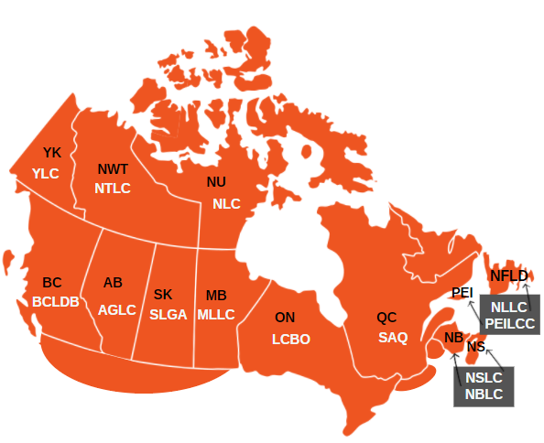

In additional to providing customs clearance for alcohol into Canada, Frontier is proposing to clear all of Molson Coors’ non-alcoholic products that are currently being exporting from the US to Canada. These will all be cleared as standard “AB Type” entries using CBSA’s PARS (pre-arrival) process. All entries that Frontier assists with will provide the following:

|  |  |
| --- | --- |
| http://www.frontierscs.com/localfiles/icons/man.jpg | A single touch point for all North American customs brokerage, billing and Trade Compliance. |
| http://www.frontierscs.com/localfiles/icons/satellite.jpg | Electronic data transmissions integrate with your business to reduce processing times. |
| http://www.frontierscs.com/localfiles/icons/calculator.jpg | Accurate rating of duties and taxes for Canadian and American clearances. |
| http://www.frontierscs.com/localfiles/icons/money.jpg | Recover overpaid duty through the Duty Drawback program in both Canada and The United States. |
|  |  |

**Frontier Technology**

Access to account details is going to be essential once CARM is implemented. Frontier’s Visual Importer portal provides customers with complete transparency to their daily statement of accounts. Online access is provided to manage custom entry activity in real time. With direct integration to CBSA, Frontier provides portal access to easily manage entry data:

**Find entry details/status by transaction:**

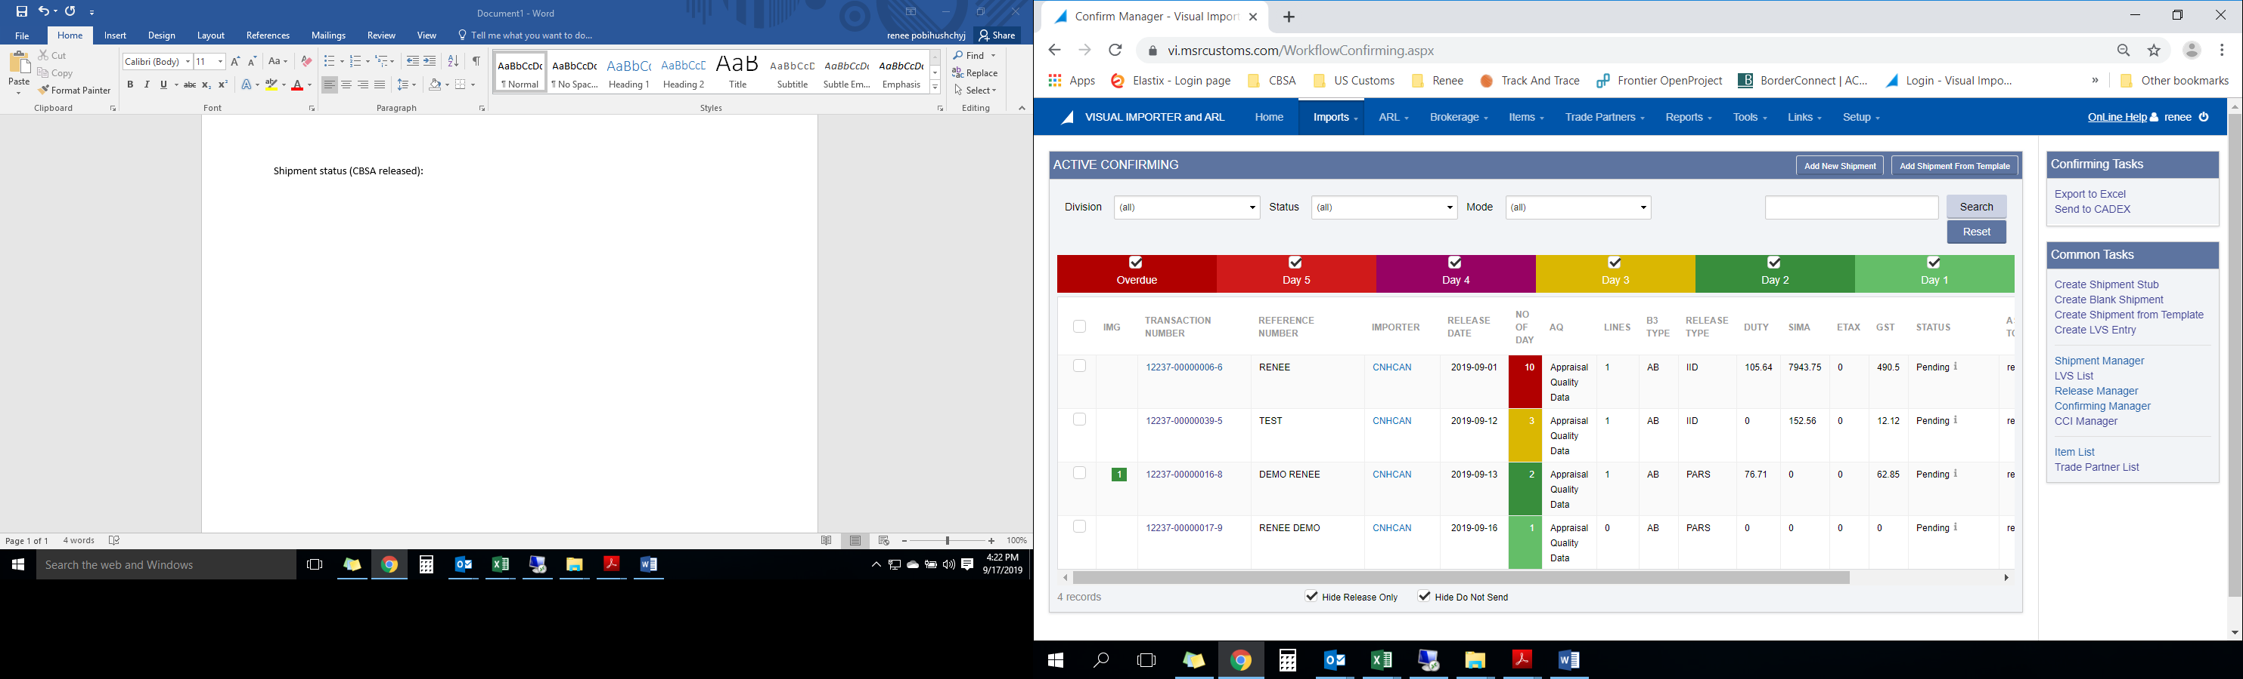

**Account Receivable Ledger access:**

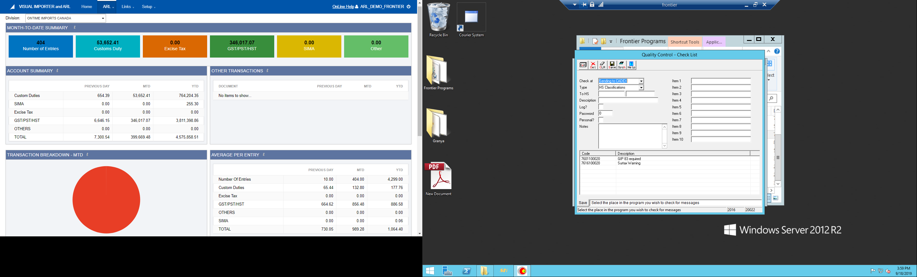

**Customized Reporting**

Visual importer is more than just a portal for data. Document imaging is available for user access to things like B3, commercial invoices and even Frontier invoices. This access is critical in case of a CBSA audit and very useful when doing internal audits. In addition, customized reports can be created and pulled right from the portal to include:

* **B3 line reports**
* **Duty summary reports**
* **Entry summary reports**
* **SIMA reports**
* **Invoice/cost reports**

**One Team, One Approach**

Molson Coors already has a dedicated Frontier service team that is assigned to your account and is ready to do more! This enables us to have consistent communication with Molson Coors and your carriers.

Standard operating procedures will be updated as we clear in more provinces and clear non-alcoholic shipments into Canada.

**Broker Manual Creation Assistance (upon request)** –Frontier can assist in creating a user friendly broker manual to outline CA brokerage/compliance services. This will be an internal document, but will obtain information like bond numbers, importer numbers, SOP information, trade resources, best practices, trade term definitions, port instructions, and training schedules if needed.

**Pricing**

|  |
| --- |
| **Canadian Customs Entry Fee (2,000 – 5,000 entries per year)** |
| **$15 CAD per “AB” entry (Not obtaining alcohol)** |
| **$120 CAD per “Type 10” entry (Entry obtaining alcohol** |
| * **Note;** line fees will be waived if commercial invoice data is received via data file |

***Authorization:***

*I hereby authorize Frontier Supply Chains Solutions Inc. to execute the services as noted for* ***Canadian custom brokerage services*** *under the terms and conditions outlined in the Frontier Services Agreement and in accordance with the rate schedule attached. The services shall terminate upon written notification by an authorized officer or personnel employed by* ***Molson Coors*** *to Frontier Supply Chain Solutions Inc.*

Name: ______________________________

Signature: ______________________________

Date: ______________________________