

Proposal to Serve NFI Group Inc:
Customs Brokerage and Logistics Services



May 2021
Frontier Supply Chain Solutions Inc.
310-555 Hervo St
Winnipeg, MB R3T 3L6
Canada

Tel: 204-784-4800
Fax: 204-784-4803
www.frontierscs.com

May 31st, 2021
Private and confidential
NFI Group Inc.
711 Kernaghan Ave
Winnipeg, MB
R2C 3T4

Subject: Canadian/US Customs Brokerage & Customs Compliance
We are very pleased to propose a partnership that would have Frontier Supply Chain Solutions (Frontier) acting as the sole Canadian and US Customs Broker for NFI Group Inc.
Frontier is a North American supply chain company. We feel we have put together a comprehensive program for New Flyer that will provide value in a number of different areas, and benefit you in to the future. Our main priorities are to:
- Implement procedures that will ensure effective communication with New Flyer and related parties
- Utilize quality checks and a double audit approach to safeguard against tariff issues or customs inspections
- Deliver competitive pricing for a premium service
- Provide one team dedicated to NFI, with exceptional service, high attention to detail and quick responsiveness
- Dedicate a wealth of resources to guarantee a smooth transition
- Offer additional value through our other services (freight forwarding, consolidations, etc.)

As Frontier engages new partnerships, we will work for continuous improvement. This is to ensure NFI Group is always up-to-date on the most effective programs available by CBSA and USCBP.

Choosing a new provider is an important decision. You must assess your needs and select a business that will continuously communicate with you, provide valuable insights, and best understand your business needs today and in the future. We believe we are that provider.

Please do not hesitate to contact me at (204) 784-4800 Ext. 127 if you have any questions. On behalf of Frontier, we look forward to working with you.

Sincerely,
Chris Borecky
Business Development Manager
Frontier Supply Chain Solutions Inc.

Canadian and US Customs Brokerage Services

Frontier’s head office and main operations is in the Fort Garry Industrial Park in Winnipeg, MB. We employ over 100 people in this office, a bulk of which are part of our customs brokerage operation. Frontier has offices and cross-dock centers in Vaughan, ON, Regina, SK, Saskatoon, SK, Port Coquitlam, BC, Itasca, IL, and Tukwila, WA. NFI Group’s Canadian release team would be in Winnipeg, and the US release team would primarily be in Tukwila.

The owners of Frontier, our customs operations manager, and other high-level staff have past experience handling New Flyer’s customs entries and account. Although, this was some ago and with other service providers, there is an internal sense and understanding of what is required to make the partnership successful.

Frontier’s logistics division currently runs a daily consolidation for NFI. We currently handle the paperwork and submit to the current for delivery to Brampton and Winnipeg. Frontier is well aware of the size of New Flyer/MCI consolidations, the timing and frequency in which they are cross the border, and therefore the importance of a timely customs release.

Frontier’s philosophy is a team-based approach to support our clients. Due to volume, New Flyer would be assigned a single team that would only be responsible for New Flyer’s Canadian customs clearances. Each team consists of an Account Manager and 3-5 Integrated Service Representatives (ISR), of which one of these people will be you direct contact for all shipments and processing. This is standard size, but for NFI we estimate 6-7 people per team for each Canada and the US.

Your Account Manager will manage the day-to-day review of your customs releases for all imports. The team will gain a comprehensive knowledge of your product and the plethora of needs and procedures required to support New Flyer and related parties.

Our customs release system and software allow your brokerage team to submit your information the quickest way possible, ensuring there are no delays at the border. This is key given the proximately to the border, and timing of bus shells and consolidations leaving at multiple times throughout the day.

Our Canadian Customs Brokerage system, allows us to export the data in a spreadsheet, where we audit from that. This is especially helpful for auditing high-lineage shipments. We tailor each report to the client.

Our system performs automatic quality checks to ensure any entry that may be subject to a Free Trade Agreement (FTA), is taken advantage of. If the tariff treatment and/or country or origin provided are accurate, our system catches it and alerts the needs for a FTA. We also have a two-step post-entry audit process.

Frontier has a heavy focus on trade compliance. Our goal is not only a timely customs release, but just as important is the accuracy. To ensure an effective transition, there would be added focus on the accuracy and completeness of information transmitted.

Our trade compliance team is also proficient in duty drawback. Canadian drawbacks are completed in-house, and US drawbacks are done in partnership with a top trade lawyer that Frontier has partnered with.

We also have a data portal through Visual Importer, which provides document retrieval, shipment tracking, ability to run reports, access to tariff database, etc. More information is provided in Appendix B.

EDI and IT

Frontier utilize’s EDI data transfers whenever possible to reduce human error. We recommend implementing this for New Flyer into Standard Operating Procedures. This would increase accuracy, reduce errors, and take less time and resources away from New Flyer’s normal course of business.

Frontier’s Canadian release system Visual Importer, and US system, CargoWise, both support multiple data integrations. The most common and potentially easiest to implement would be the import of a CSV file for high lineage consolidations. The data takes 10-30 minutes to import, and saves potentially hours of keying in data. This allows us to treat as a normal customs entry, perform a quicker submission, and ensure the shipment is released before the driver gets to the border. More information on Cargowise provided in Appendix B.

Electronic data transmissions integration can be essential for high lineage consolidations. Frontier has been able to accommodate all integration requests including the (2) key systems listed below:

- Integration Point Process:

Step 1: Frontier retrieves a data file each evening of all Canada parts that have been added/updated in Integration Point on a daily basis.
Step 2: Frontier performs a data integrity validation on the file to identify any items not matching the current Canada customs tariff and records all changes for historical tracking purposes.
Step 3: Frontier then creates discrepancy reports and upload files, all of which are emailed to New Flyer for transparency.

- ERP (Oracle) Integration:
Frontier accesses New Flyer’s Oracle system to retrieve values & origin information required to complete documentation for whole goods imports. This can be set up through our API (Application Programming Interface) call.

Frontier can also offer online imaging of documents, for instant retrieval by New Flyer staff.


Trade Consulting and Compliance
Trade Management Services provides New Flyer with the ability to improve their trade processes by accessing knowledgeable counsel in the area of Customs compliance. Over the years Frontier has helped many large importers on the different programs and regulatory updates issued by CBSA and USCBP, while providing constant communication and reporting on opportunities and exposures.
Frontier understands the importance of trade compliance and has a primary Frontier expert who oversees the team of compliance specialists that will assist you on a regular basis. The below topics/programs reflect New Flyer’s current environment areas of focus:

 | Improve trade facilitation and minimize duty when possible:  - Tariff Database Audit: Frontier can audit the list of parts, tariff codes and countries of origin for all the parts provided by New Flyer upon request  - USMCA Verification: Frontier can audit New Flyer USMCA certificates for accuracy  - Duty Drawback: Frontier can manage New Flyer’s US and Canadian Drawback  - B2 Corrections: Frontier will correct overages/shortages/exception reporting
Frontier also offers a proactive approach to customs compliance to help your Frontier Team be more efficient and help you avoid future problems at the border. Trade Management Services was developed as a monthly retainer to keep the importer compliant with both CBSA and USCBP. Instead of waiting for a desk review or audit, and then scrambling to make changes or collect paperwork and records, Frontier offers a year round compliance service.

This service takes the guesswork out of your monthly bills as client will be billed a flat rate every month regardless of the hours worked.

Frontier's team of Trade Compliance Specialists offer three tiers that can be modified based on specified needs:

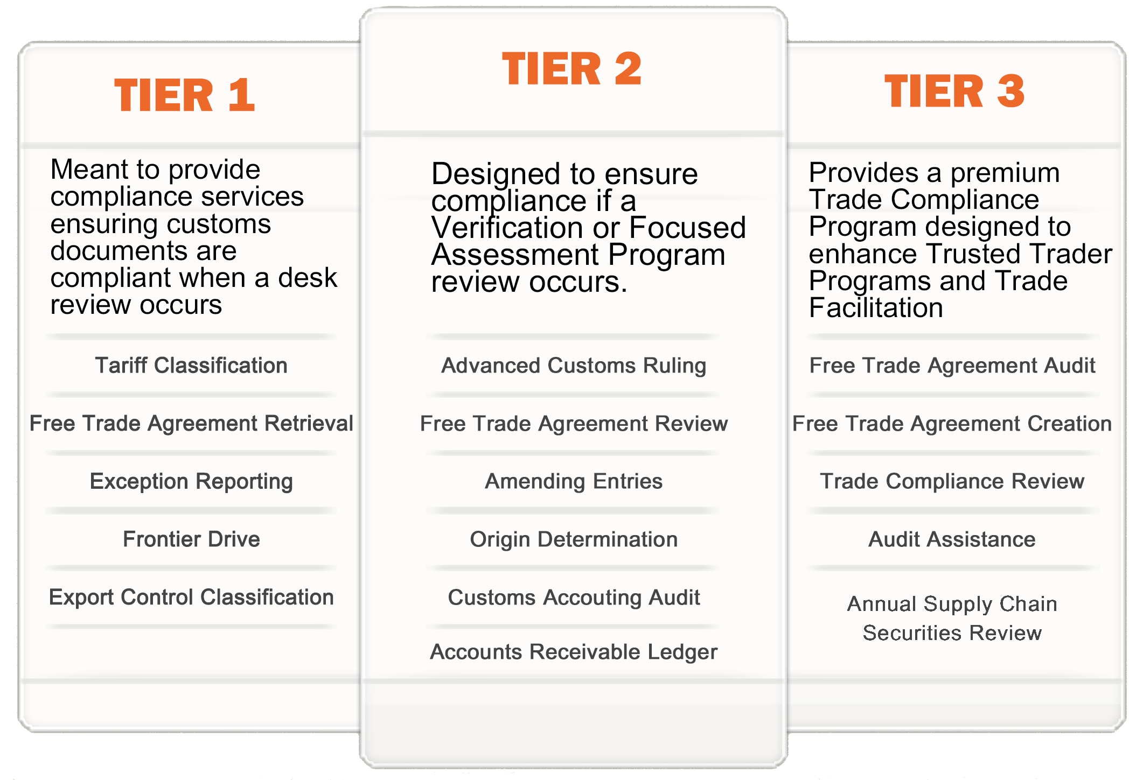

The benefits of working with Frontier Supply Chain Solutions
- Locally based Winnipeg company, with years of experience and specific knowledge of NFI Group’s needs
- Medium sized company that can offer the attentiveness and support that NFI Group requires
- Current partner of New Flyer (and recently of MCI), handling consolidations for parts (production for MCI)
- Compliance department concentrated on accurate consulting work to ensure overpayment of duty is avoided
- Full team support whose only client and focus is NFI Group
- A focus and drive to set up a quick and accurate data transmission via EDI
- Full online reporting capabilities and imaging for invoice retrieval, databases, SOAs, etc.
- Competitive pricing for a premium service
- Dedicated sales rep who will review service internally on a weekly, monthly and/or quarterly

Sample Implementation Timetable

With New Flyer’s input, Frontier would develop a streamlined implementation plan to bring as many pertinent parties into the process as possible. With dozens of moving parts, an in-depth planning of the transition would be needed for a successful implementation. Developing detailed Standard Operating Procedures being the key end goal of a successful implementation.

Set Up Documents
Document | Responsibility | Date to be completed by:
Credit Application | New Flyer | TBD
CDN/US Power of Attorney | New Flyer | TBD
Direct Security Letters | New Flyer | TBD
Bonds | New Flyer | TBD
Cancellation Letter | New Flyer | TBD
Carrier Authority | New Flyer | TBD

Developing Standard Operating Procedures
Task | Responsibility | Date to be completed by:
Internal Hiring/New Team Initiation | Frontier | TBD
Develop Client Profile | Frontier | TBD
Tariff Database Exchange | Frontier and New Flyer | TBD
Tariff Database review/updates | Frontier | TBD
Additional Data Review | Frontier | TBD
Establish daily procedures | Frontier and New Flyer | TBD
Establish Compliance procedures | Frontier and New Flyer | TBD
USMCA retrieval | New Flyer | TBD
SOP First Draft Review | Frontier and New Flyer | TBD
Develop EDI Transmission / API Call | Frontier & New Flyer | TBD
Load HS Codes into system | Frontier | TBD
Provide private rulings, other information | New Flyer | TBD
Exchange Pertinent Contact Information | Frontier & New Flyer | TBD
Final Review of SOP | Frontier & New Flyer | TBD
Final Testing of EDI Transmission | Frontier & New Flyer | TBD
GO LIVE! | Frontier and New Flyer | TBD

Finalizing Transition
Task | Responsibility | Date to be completed by:
Send Cancellation Notice | Frontier and/or New Flyer | TBD
Send Carrier Authority | Frontier and/or New Flyer | TBD
Send Notice to Suppliers | New Flyer | TBD

Appendix A: Fees

Canadian Customs Brokerage
The following fees are based on historical data provided by New Flyer / Motor Coach, for 2019 & 2020:

Customs Release Fees | Additional Fees
Canadian Customs Entry Release for Consolidations: $27.50 | $0.15 per Customs Invoice Line (first 20 lines free)  If EDI/CSV file is provided, Line fees are eliminated
Standard PARS Release Canada-US Border: $11.00
Ocean Customs Release: $30.00
De Minimis Customs release (shipments value under $150): $8 | *All fees are in Canadian Dollars*
Single Window Initiative Fee (PGA Fee): $2.50

US Customs Brokerage
Customs Release Fees | Additional Fees
US Customs Entry Release for Consolidations: $27.50 | $0.15 per additional line over 20  If EDI/CSV file is provided Line fees are eliminated
Standard PAPS Release US-Canada Border: $11.00
Ocean & Air Customs Release: $75Ocean | ISF Fee: $15
Section 321 Release (Truck shipments manifested by carrier, Value < $800): $0 | Partner Government Agency Fee (PGA): $12.50
 | Continuous Bond: $550 US (Renewed Annual)
 | *All fees are in US Dollars
*Additional Accessorial Fees are included as a separate attachment

Appendix B: Tracking and Reporting

Frontier’s customs brokerage system for Canadian Customs has all the tools for shipments to be tracked, giving New Flyer full reporting capabilities and access to their shipments under Visual Importer. Real time statuses can be obtained, ensuring important deadlines and ship by dates are met.

- Visual Importer will allow New Flyer to get real time Shipment status by confirmation day:

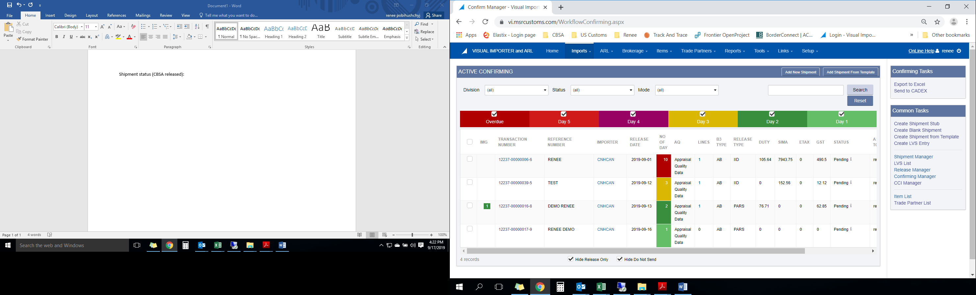
Frontier can set up scheduling and automatic reporting to provide New Flyer an exported file (In Excel format) with any requested or regularly required information.

- Visual Importer will allow New Flyer users to retrieve custom documents by shipment # via imaging document system:

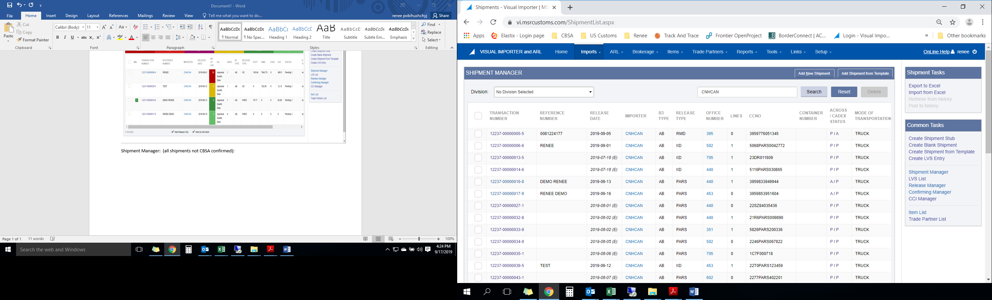
Our Accounts Receivable Ledger solution will give controllers and compliance officers an ongoing and complete overview of all import-related activities recorded by CBSA. This includes duty, taxes, GST, refunds, and adjustments. Your information is consolidated and ready to use in a simplified format.

The appealing dashboard provides you with a single view of your duty/tax liabilities. It is very simple to use, and gives a consolidated view of all brokers and daily notices. So anything cleared by UPS or FedEx will be shown in the same area.

You can view your duty and tax trends over time, allowing for better cash flow and internal planning. Can show totals and averages for B3 transactions, payments paid, interest owing, adjustments, credits, penalties, refunds, etc.

With ARL already implemented by CBSA, the reporting capabilities within this software will be that much more important:

- View your daily notices and monthly statements
- Get notified when values are out of normal range
- Give your finance people what the need, when they need it

PAPs and WebTracker
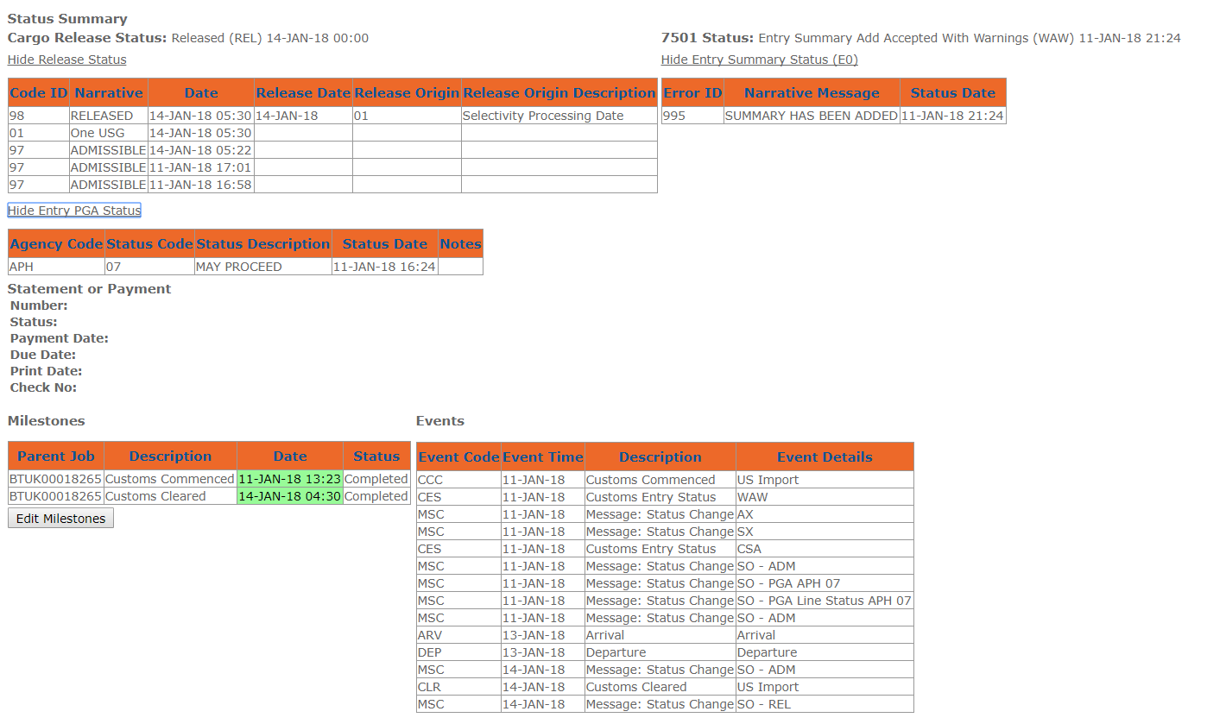

Our system supports interfacing with external applications through the integrated

Webtracker is an interactive web application for our freight forwarding and US Customs Brokerage applications. Web Tracker allows all US and Canadian shipments processed by Frontier to be monitored and easily accessed by both importers and exporters. Webtracker also offers reports on both your supply chain and costs to better manage your operation.

Clients can log onto Webtracker by using our online web portal. (Frontier Web Tracker)


CBSA Appendix C: Payment Schedule 2021

Month | Release Date | Statement Date3 | CBSA Cheque/Frontier Payment Due Date1 | CBSA Online Payment Due Date2
January | 15 | 25 | 27 | 29
February | 17 | 25 | 24 | 26
March | 17 | 25 | 29 | 31
April | 16 | 26 | 28 | 30
May | 14 | 25 | 27 | 31
June | 17 | 25 | 28 | 30
July | 16 | 26 | 28 | 30
August | 17 | 25 | 27 | 31
September | 17 | 27 | 28 | 30
October | 15 | 25 | 27 | 29
November | 17 | 25 | 26 | 30
December | 17 | 27 | 29 | 31

1 | Customers paying by cheque to “Receiver General of Canada” and/or Frontier must be received two business days prior to the CBSA due date allowing for processing and delivery to avoid CBSA late penalties and interest. Administration fees apply when paying Frontier.
2 | Customers paying CBSA through online banking will receive a separate statement for Duty and/or GST and payment must be received by CBSA on the due date listed by 16:30 EST. Payments are due on the last business day of the month.
3 | The statement are generated on the 25th day of each month varying only on weekends and holidays. CBSA's SOA will be available on the 25th.

Appendix D: Periodic Monthly Statement

Entries are always based off of the release date by US Customs on the entry.

- Regular (Daily Statement Processing)

The Customs duties has to be paid to Customs by the 10th working day after release. Consumption entries are paid by the Customs broker while anti-dumping and countervailing duties are paid by the importer. For the importer to be able to pay they must have a payment unit number. The payment unit number is a unique identifier for a specific company.

2. Periodic Monthly Statement Processing (PMS)
If importers have been approved to be on (PMS) this means that they have a longer period of time in which to pay their customs duties.

To be approved onto PMS an importer must have a continuous bond. The broker then files a form 5601 to US Customs to place the importer onto Periodic Monthly Statements. Periodic Monthly Statement filing can happen after US Customs approves the form 5601.

All entries that are released in a month (let’s say November) have until the 15th working day of the next month (Dec), no matter the release date as long as it was in November.

This gives the broker/importer up to 45 days’ credit instead of 10 days (the daily statement processing above).
With anti-dumping duties the importers bank account is directly debited. With anti-dumping duties the importer has to have applied for a payer unit number (which must be applied for with US Customs) beforehand.

All PMS entries are all debited from bank accounts on the 15th working day of the following month of release.

Example 1.
Importer has and entry release on 11/16/2017. If the entry is a regular entry then the last day to pay US Customs (without penalty) would be 10 working days from 11/16/2017 (which would be 12/01/2017.

Example 2.
That same entry (if on PMS) has until the 15th working day of December to pay this entry, or this case 12/21/2017.

