

Customs rules and regulations are always being updated. That's part of what makes them complicated. A proactive approach to customs compliance can help your Frontier Team be more efficient and help you avoid problems in the future. Trade management services was developed to ensure your company stays compliant with both CBSA and USCBP. Instead of waiting for a desk review, or audit then scrambling to make changes, Frontier offers a year round compliances service. Trade Management Services drastically increases Frontier’s efficiency in ­­____ this allows Frontier to pass the cost savings on to your organization as we offer reduced Customs Brokerage fees for our TMS clients.

This service takes the guess work out of your monthly bills as client will be billed a flat rate every month regardless of the hours worked.

Frontier's team of Trade Compliance Specialists offer three service packages with three levels of guidance.

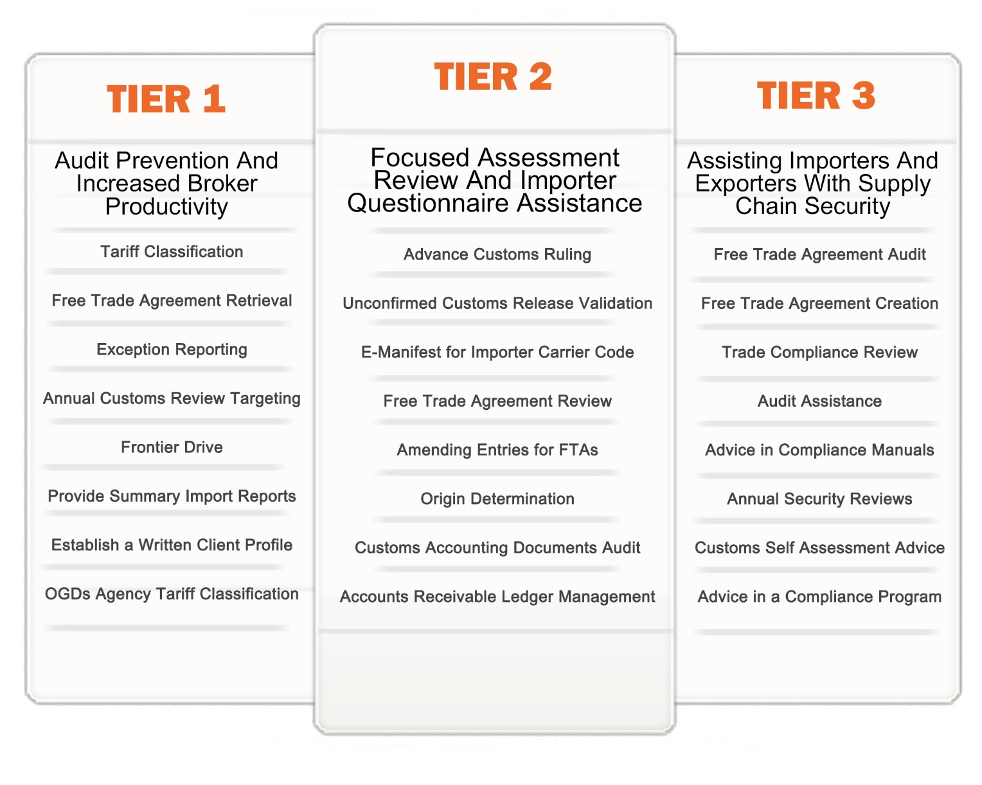

**Tier 1**

The first package “Tier 1” was developed to reduce the chance of a customs audit and to ensure our clients could pass could pass an Audit. Tier 1 also results in increased broker productivity which results in lower brokerage fees for your organization.

Tariff Classification:

Classification is done on a proactive basis where new parts are classified before first importation.

Free Trade Agreement Retrieval:

We will retrieve Free Trade Agreement Certificates from your suppliers throughout the year.

Exception Reporting:

Frontier will handle reporting to government agencies any overages received on an import transaction.

Review of Annual Customs Review Targeting by Tariff:

Every year customs puts out a list of specific tariff codes they will be heavily monitoring over the course of the next year.

FrontierDrive:

You will have full access to our new storage system technology FrontierDrive.

Provide Summary Import Reports:

At the end of each specified time period Frontier will generate an import list showing what was imported during that period and the duty and taxes that were paid on those importers. This is generated into an easy to use spreadsheet.

Establish a Written Client Profile (BKIP!):

Other Government Departments / Partner Government Agency Tariff Classification:

Frontier will identify products that are restricted by Other Government Departments and give an explanation of the agency that restricts that product and the steps that must be taken legally import that product.

**Tier 2**

The second package “Tier 2” was developed to ensure our clients could pass a Verification or Focused Assessment Program review. This package includes:

Advanced Customs Ruling:

When needed Frontier will secure an Advanced Customs Ruling for new products to ensure that your organization is paying the minimum duty and taxes.

Unconfirmed customs release validation (PARS):

Frontier will be respond to customs on your behalf for releases that are outdated due to carrier error.

E-Manifest for Importer carrier code:

For organizations that have their own assets Frontier will submit your e-manifest to customs.

Free Trade Agreement Review:

Frontier will review and summarize the retrieved Free Trade Agreement.

Amending Entries for Free Trade Agreements:

Frontier will amend customs entries for overpaid duty on FTA.

Country of Origin Determination

Frontier will store and manage countries of origin on imported and exported material.

Customs Accounting Documents Audit:

Frontier will ensure your organization is paying the lowest possible duty by reviewing customs accounting documents for overpaid duty, tax, tariff and origin errors. This function is primarily for auditing purposes.

Accounts Receivable Ledger Management:

Frontier will manage your daily notices from customs.

**Tier 3**

The third package “Tier 3” was developed to provide a premium Trade Compliance Program designed to enhance and maintain Trusted Trader Programs. This package includes:

Free Trade Agreement Audit:

Frontier will audit all Free Trade Agreements ensure accuracy of the tariff classification.

Free Trade Agreement Creation:

Frontier will create Free Trade Agreements for new goods being added to your database.

Annual Trade Compliance Review

Audit Assistance:

In the case of an audit or desk review Frontier will assist in ensuring your organization will pass the review or audit.

Guidance in creating a Compliance Manual

Supply Chain Securities Review:

If your organization is on a Trusted Traders program Frontier will review your security procedures to ensure they are compliant with that program.

Customs Self-Assessment Maintenance:

For organization that re on CSA we will uphold your records.

Helping with a compliance program:

**Benefits**

* Clients will receive a discount on their customs brokerage fees
* Offers the client peace of mind in knowing an expert is reviewing their documentation
* Frontier will assist with our expertise in the case of an audit or review
* The client will save money with clerical functions such as Free Trade agreement retrieval, review and audit

4