image009 U

**Sales Edition**

**Module 1 – Web Tracker**

|  |  |
| --- | --- |
| Table of Contents | |
| How to Login | 2 |
| How to Search for Containers | 3 |
| Customizing Columns | 4 |
| Exporting the Data | 5 |
| Container Data | 6 |
| Customs | 7 |
| Shipments | 8 |
| Declarations | 9 |
| Forwarding Reports | 11 |
| Customs Reports | 12 |
| PAPS | 14 |
| How to Log off | 16 |

# How to login

For each login there is a

* Company Code
* User email
* Password

Our test accounts are

* 1. Company Code: BATENTSQV  
     User Name: [lisa@frontierscs.com](mailto:lisa@frontierscs.com)  
     Password: 4n79CT
  2. Company Code: FLOCOUKET  
     User Name: [mbutterfield@frontierscs.com](mailto:mbutterfield@frontierscs.com)  
     Password: 3g99uK
  3. Company Code: AMMEXKET  
     User Name: [lbosques@frontierscs.com](mailto:lbosques@frontierscs.com)  
     Password: 9Av9ao

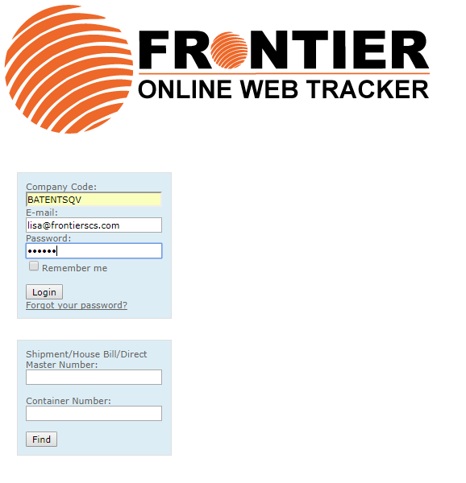

Top of document

# How to Search for Containers

1. Under the “forwarding heading” the third option is containers
2. The 5th row is “last completed milestone” change this to “ETA”
3. The 5th row on the second column is blank, change it to say “next 2 months”
4. Click the “find” button

This search will give the client the Estimated Time of Arrival (ETA) of all incoming containers.

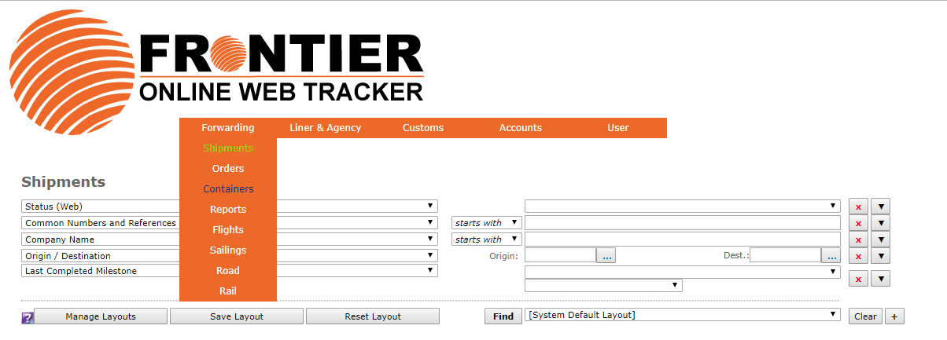

Top of document

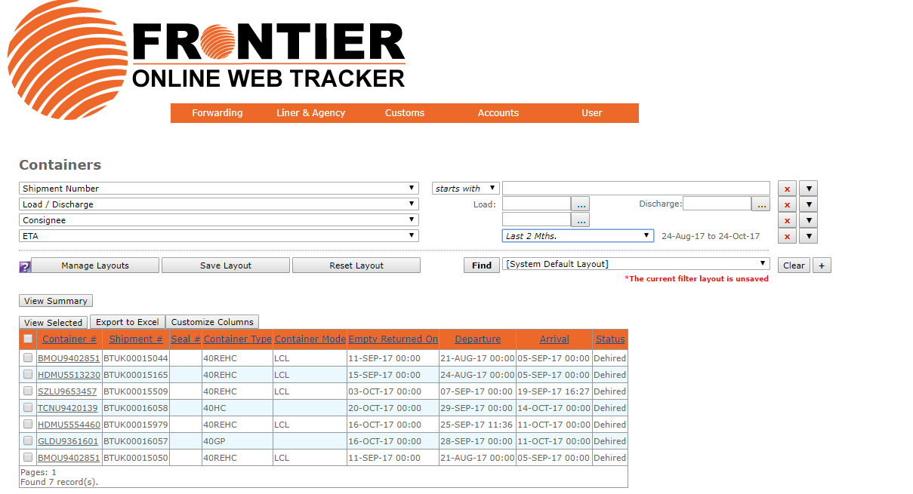

# Customizing Columns

Your client will have the ability to customize the columns of their report.

1. Under the available column select the function you would like the have added to the report.
2. Then click the single arrow pointing right. (>)
3. This will add the function to the selected columns section on the right side.
4. After columns are customized click “save layout”

Popular options are

* Arrival
* 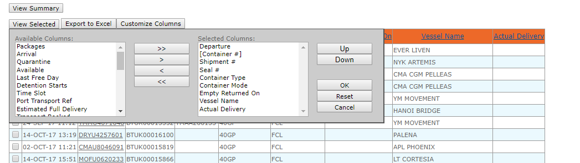Estimated Full Delivery

Top of document

# Exporting the Data

1. Click the “export to excel” button above the data
2. This will download the data
3. 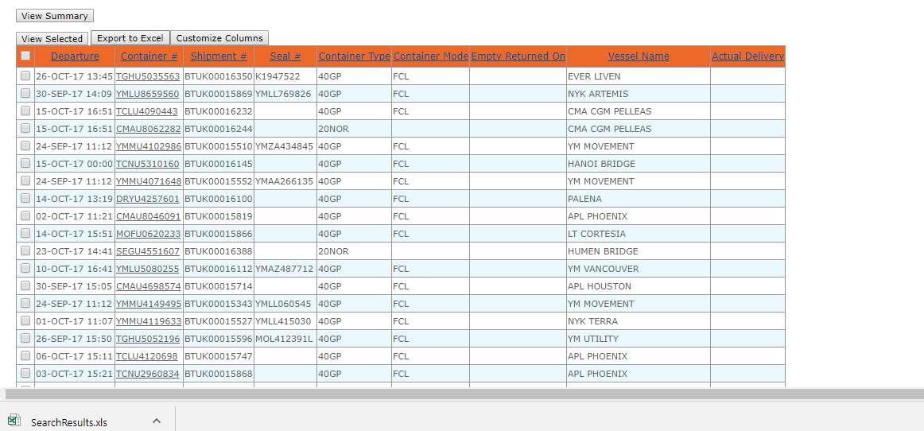Open in an excel file

Top of document

# Container Data

1. Click on the container number

This gives relevant data on the container.

* This will show milestones
* Has departure information

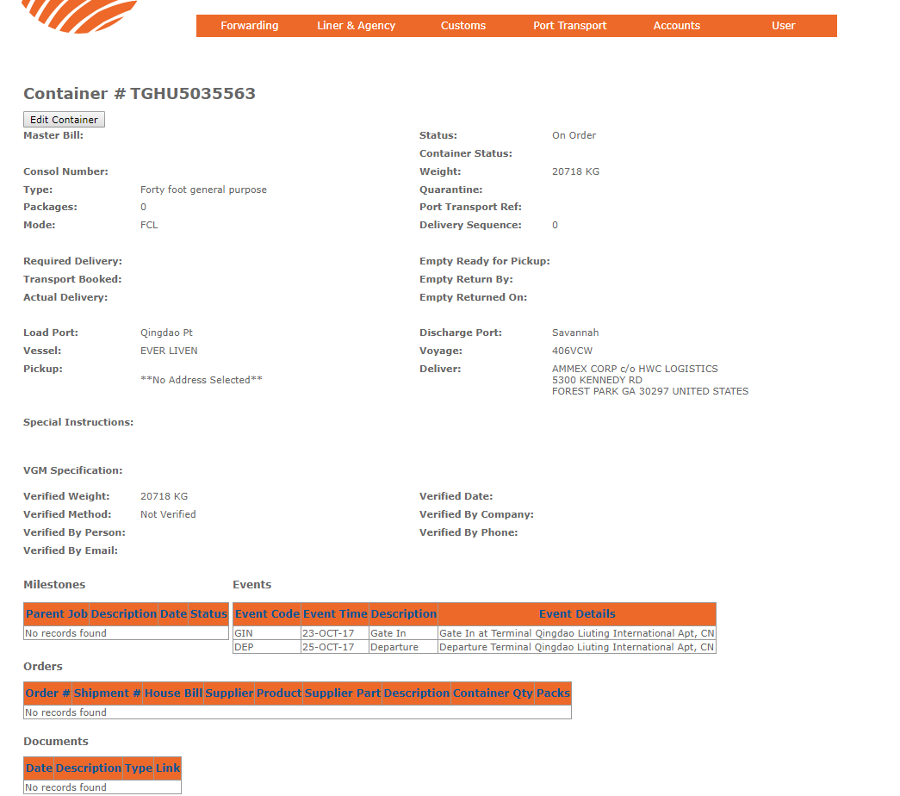

Top of document

# Customs

Declarations

Under Customs click “declarations”

Shows relevant information such as date of arrival

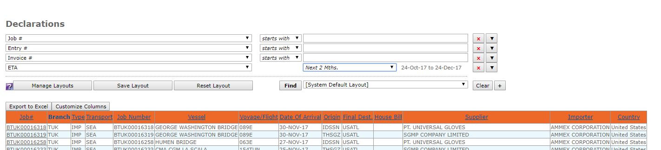

Top of document

# 

# Shipments

The first heading under Forwarding is “shipments”

Select “ETA” in the 5th box in the first column and select “last 6 months” in the 5th row in the second column.

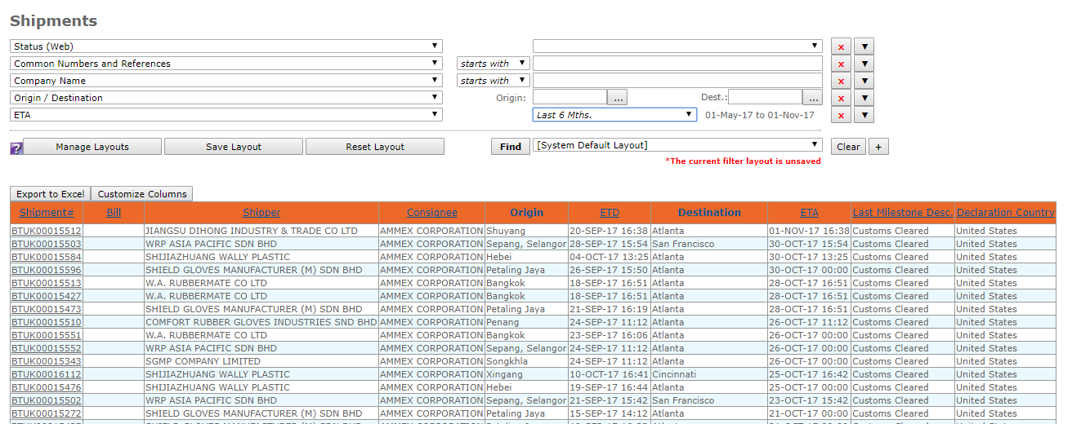

Exporting the Data

1. Click the “export to excel” button above the data
2. This will download the data

Open in an excel file

The client can customize these reports and filter the data to the applicable options. This gives the clients more transparency in their supply chain.

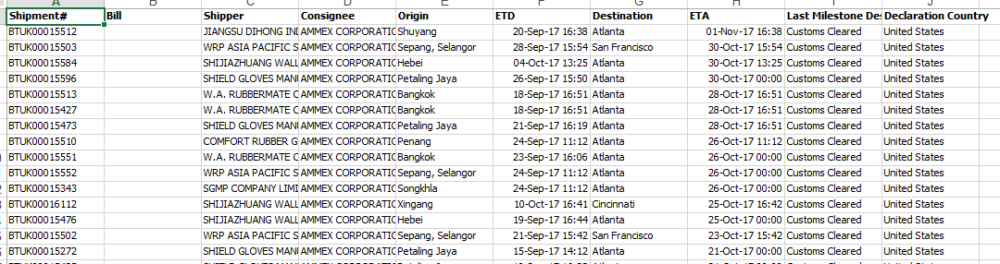

Top of document

# Declarations

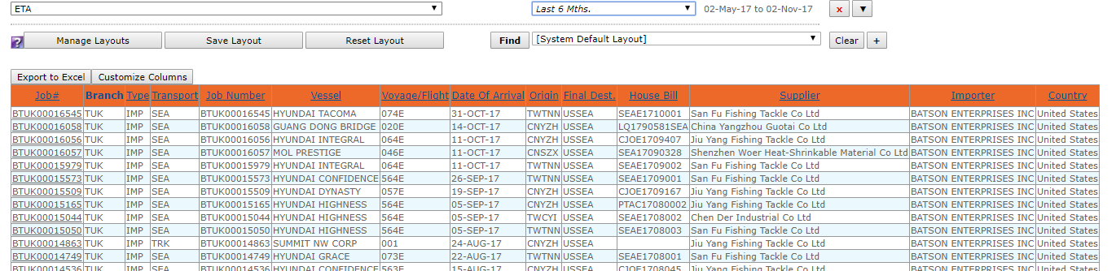

Search by using “ETA” and “next 6 months”

Click on any of the declarations and that declarations information will load.

You can click on the individual declarations for more information.

Top of document

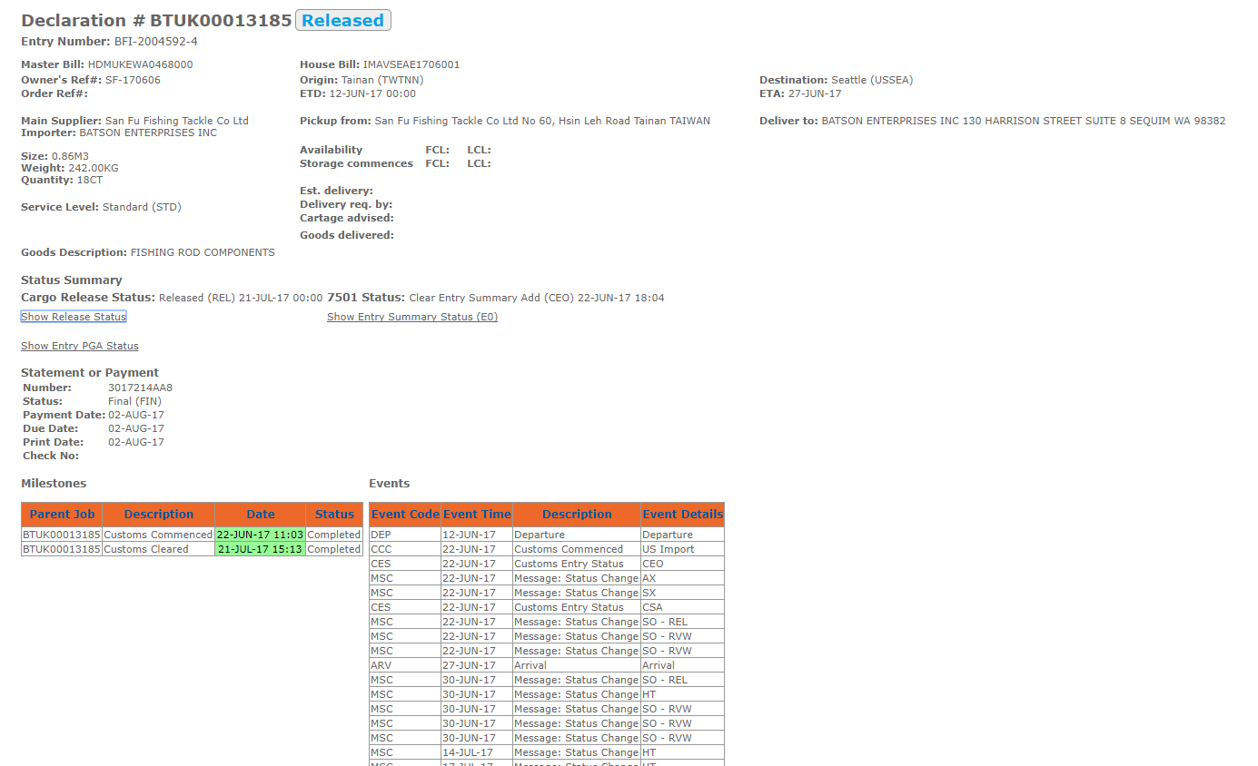

There are buttons for release status, entry summary, and entry PGA status for more information of these topics.

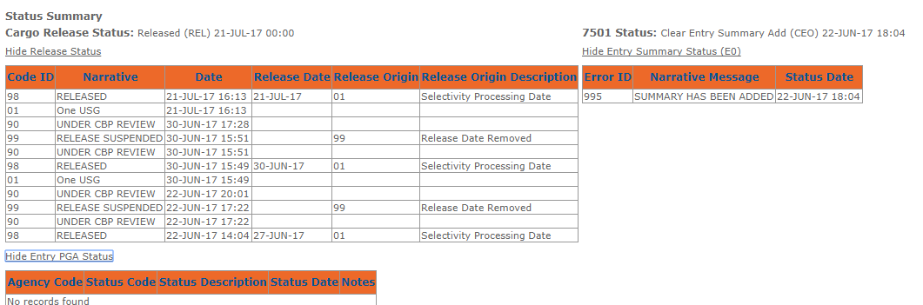

Top of document

# Forwarding Reports

There are 4 main reports are clients generally use from Web Tracker

* Client – Booking Summary
* Client – Current Export Shipments
* Client – Job and Invoiced Charge Summary for Selected Clients
* Client – Shipment Listing Report

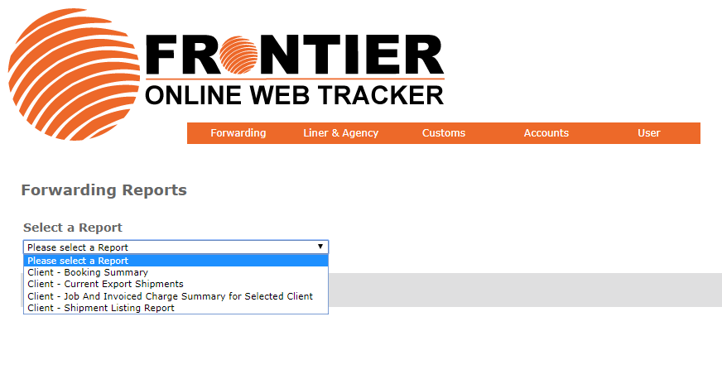

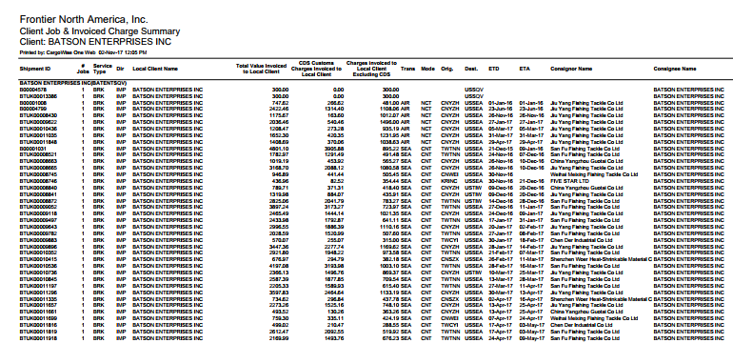Click Job and Invoiced Charge Summary

Enter in the relevant time period for either ETD, ETA, or shipment registered

Click run report at the bottom button

This will create a PDF with relevant data

Top of document

# Customs Reports

To run a customs reports click the heading “customs” then under the drop down select “reports”

An example is “Import Container Reports”

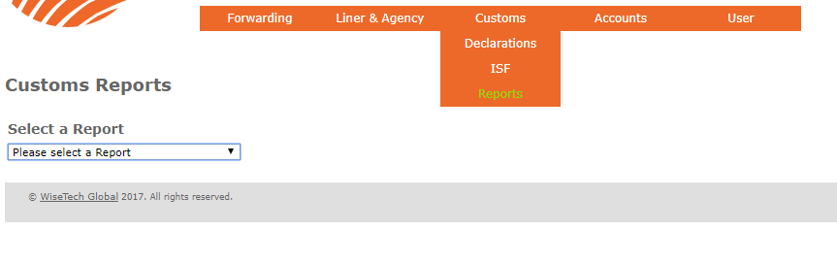

After clicking “Import Container Reports” the client can either choose the applicable date they would like to run the report on.

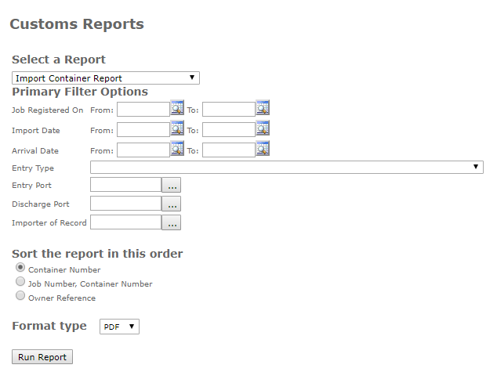

The report will generate as a PDF with the applicable data.

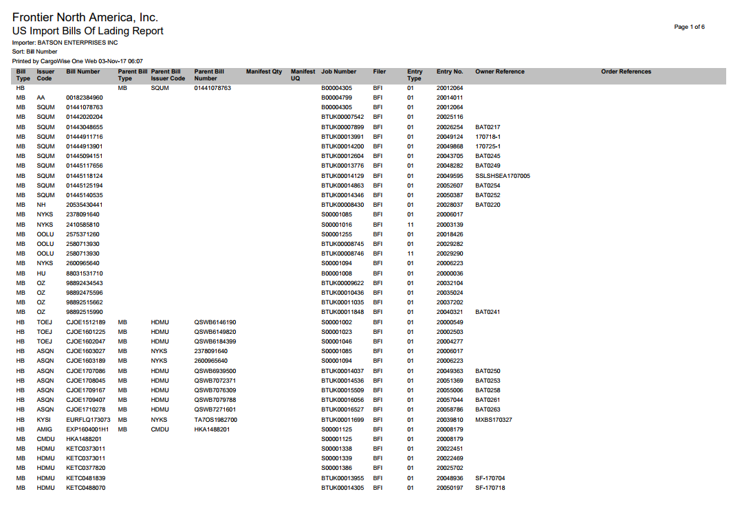

Top of document

# PAPS

# On the bottom of the initial Web Tracker login screen there is another box where you can either input the Shipment/ House Bill/ Direct Master Number or Container number.

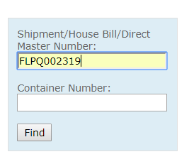For our test input “FLPQ002319” in the Shipment/ House Bill/ Direct Master Number section.

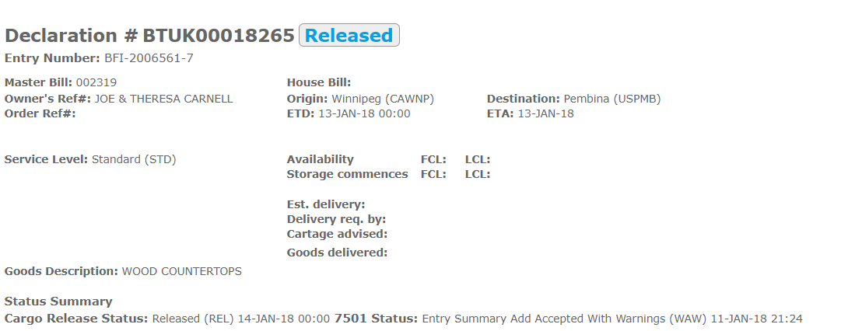Important information such as the declaration # and the goods description is shown

Opening up the fields “release status” “entry summary status” and “entry PGA status” will also give more information on the shipment.

*You must login to get this information*

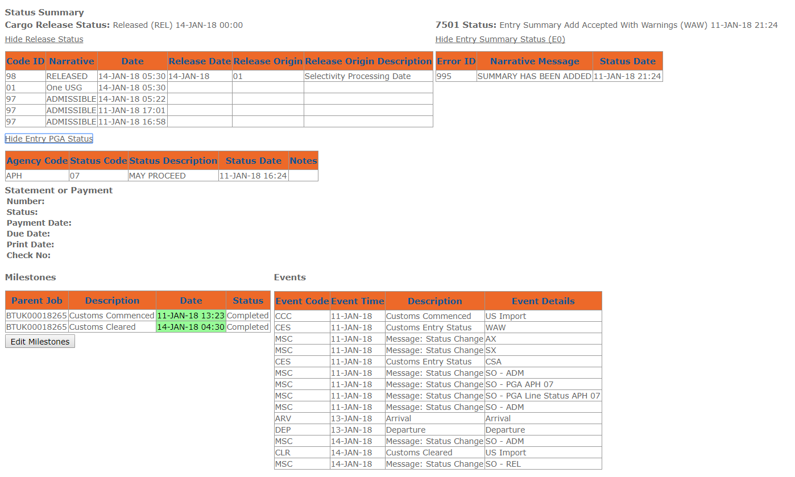

Top of document

# How to Log Off

After every use make sure you are logging off as these are company accounts. Under users simply click “log off”.

Top of document