1. Web Tracker Log in Screen[1]

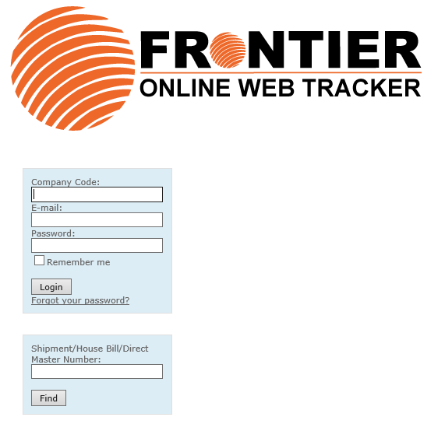

1. Once logged in with assigned information, you will see 6 modules in the orange toolbar

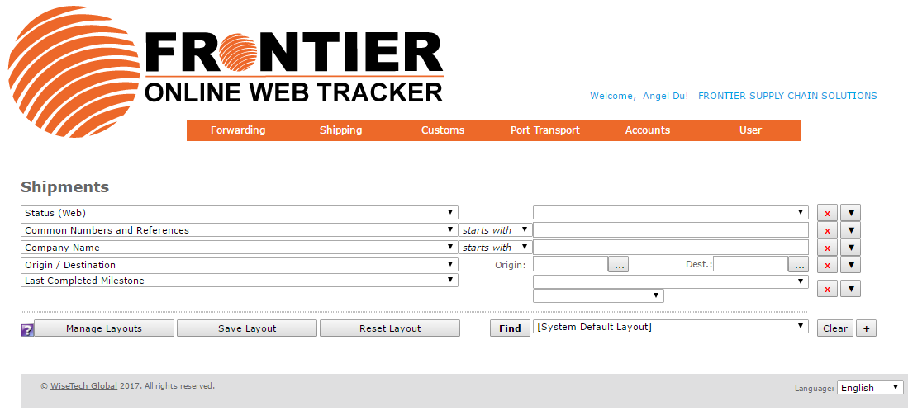

1. History of all shipments[2]

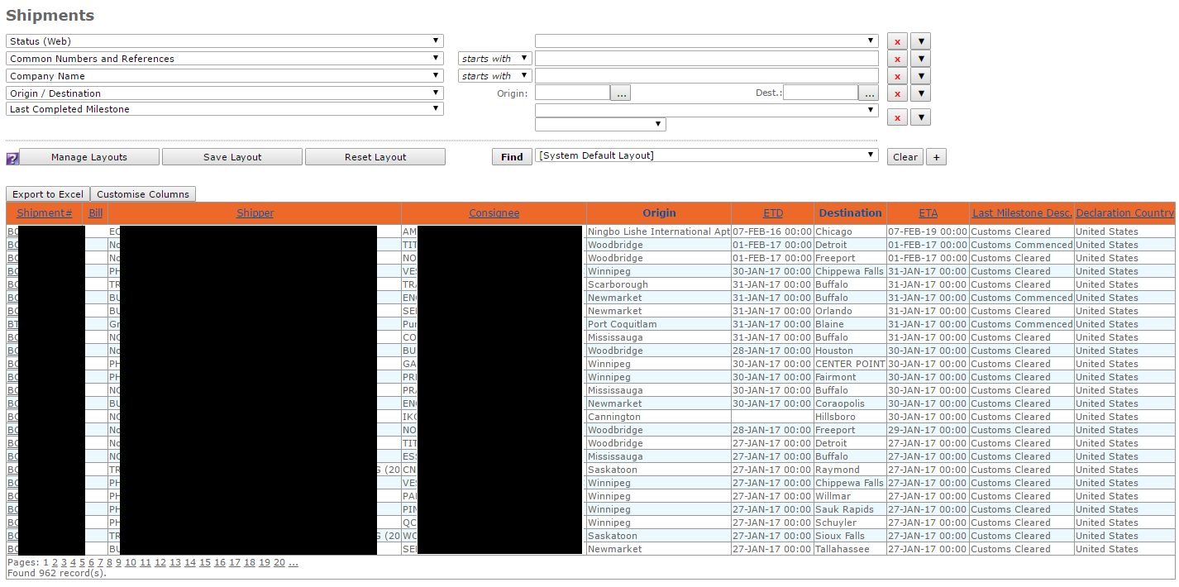

1. Information about a particular shipment

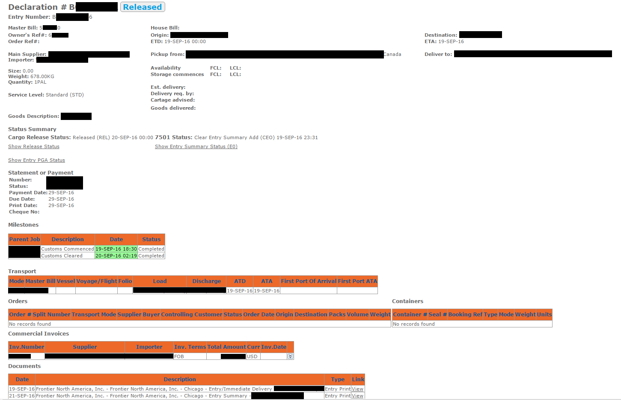

1. Documents associated with shipments[3]

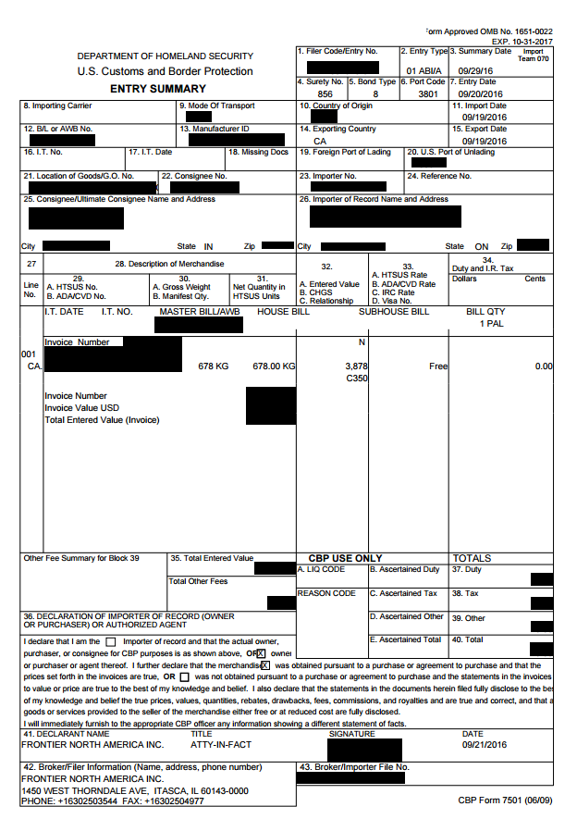

1. List of invoices

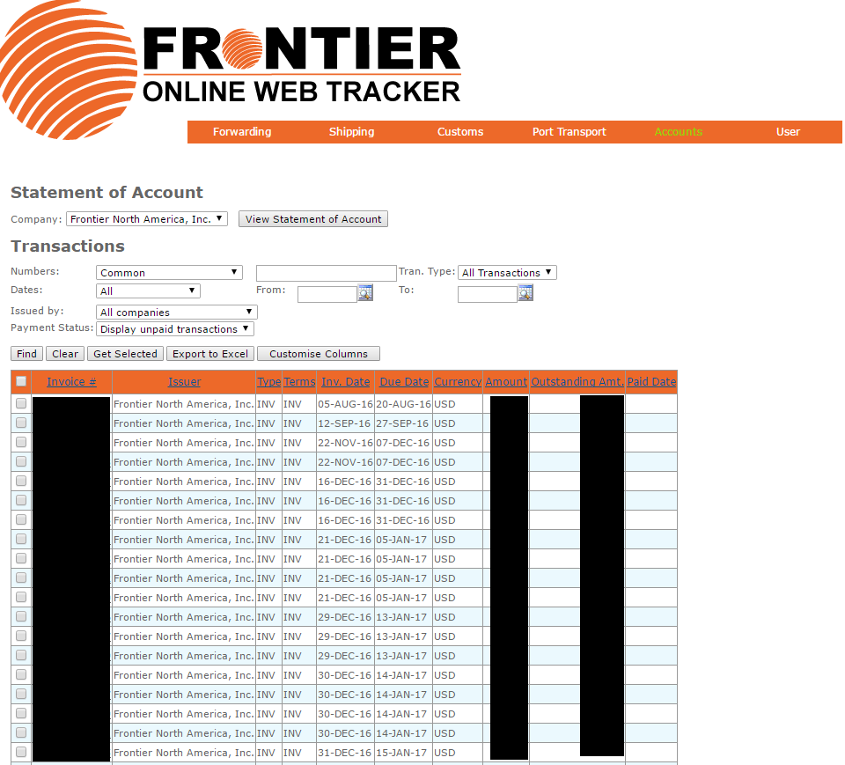

1. An example of a Frontier invoice

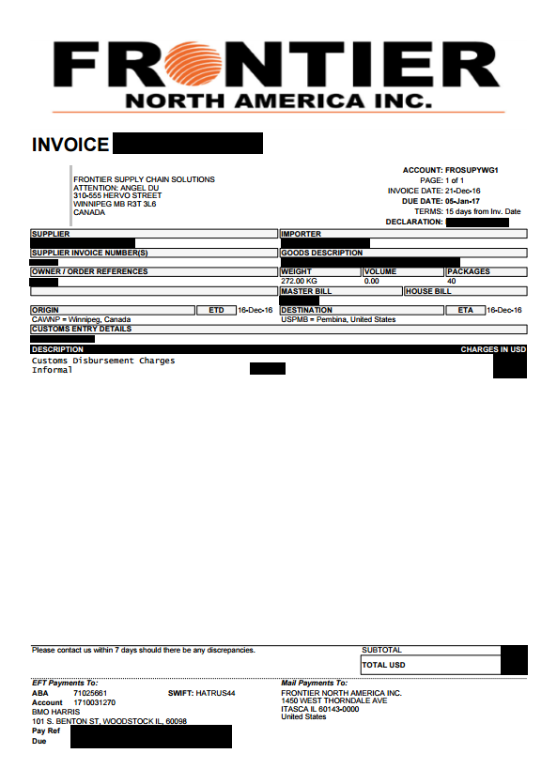

1. For quick access to the log in page, Web Tracker can be also found under the slider on the homepage. Under the “Customs” tool bar, under “U.S. Customs Brokerage”, there is a section called “Web Tracker”, and once you click into it more info will display, and the log in page is also linked. Lastly, you can find the log in page under “Track”, and “Web Tracker” on the left hand side in the toolbox.
2. The top part of the shipment screen allows you to filter and set up predefined layouts to help you find information more efficiently.
3. Whenever applicable, you can also access documents related to your shipment