

Consolidated Logistics & Canadian Customs Brokerage to Serve:

Hal Leonard Corporation



May 2021
Frontier Supply Chain Solutions Inc.
310-555 Hervo St
Winnipeg, MB R3T 3L6
Canada

Tel: 204-784-4800
Fax: 204-784-4803
www.frontierscs.com

May 27th, 2021
Private and confidential

Dave Olsen
Hal Leonard Corporation
1210 Innovation Dr
Winona, MN
55987

Subject: Canadian Distribution and Customs
Frontier Supply Chain Solutions Inc. (Frontier) is a North American logistics company. We create solutions and introduce programs that benefit our clients’ needs because we take the time to understand your business. Our priority is to:
- Reduce the cost of shipping and selling to Canada
- Combine residential and commercial orders to avoid Canada Post
- Utilize an east/west routing split ensuring the fastest delivery times
- Integrate operating systems for efficient transfer of data
- Offer different options suited to Hal Leonard’s needs
In todays environment, consumers are constantly asking for more; quicker delivery times, lower costs, better tracking. Consequently the role of the logistics provider has become increasingly important. At Frontier we understand the importance of meeting the changing demands of your clients. As a matter of fact, it was by comprehending the needs of the consumer that we perfected our Canadian logistic model: Canada Express.

We take pride in our customer service, comprehensive offerings but most importantly developing relationships that build trust, establish communication, and minimize error. Making a decision on a new provider is an important choice that requires an assessment of many things: accessibility, technology, service and performance. The ideal firm will continuously communicate with you, provide valuable insights, and best understand your business needs today and in the future. We believe we are that provider.

Please do not hesitate to contact me at (306) 500-0762 Ext. 1 if you have any questions. On behalf of Frontier, we look forward to working with you.

Sincerely,
John Trumpy
Business Development Manager
Frontier Supply Chain Solutions Inc.

Proposed Solution - Logistics

Overview
Shipping into Canada does not need to be a complicated or costly endeavour. Often a firm believes they are faced with limited options, forcing them to accept a one size fits all approach. Frontier operates in the opposite way; we work with you to formulate the best plan to suite your needs with alternatives and suggestions. This could include shipping on certain days to reduce customs charges, provide customized reporting, and integrate operating systems. By using a combination of company assets and approved carriers, product arrives into Canada on Frontier Equipment and is delivered by local couriers. This method is catered to large, ecommerce based businesses with a high concentration of orders going to places such as Toronto and Montreal. Doing so provides not only cost savings, but other personalised options such as night time delivery in the GTA.

Transportation
Frontier utilizes a consolidation model from our facility in Itasca IL. This method allows us to provide the lowest parcel pricing by combining orders destined for the same geographical area, resulting in reduced line-haul and customs fees. To ensure transit times are as quick as possible, Frontier splits our line-haul into two separate consolidations; Eastern and Western Canada. Each route leaves Itasca daily and is a team service, meaning there are two drivers in each semi trailer. This allows the freight to move non stop while remaining compliant to Federal hours of service rules. Through this system, Hal Leonard’s orders will arrive at the nearest major centre on both sides of the country (Toronto and Winnipeg) in only two days from Winona.

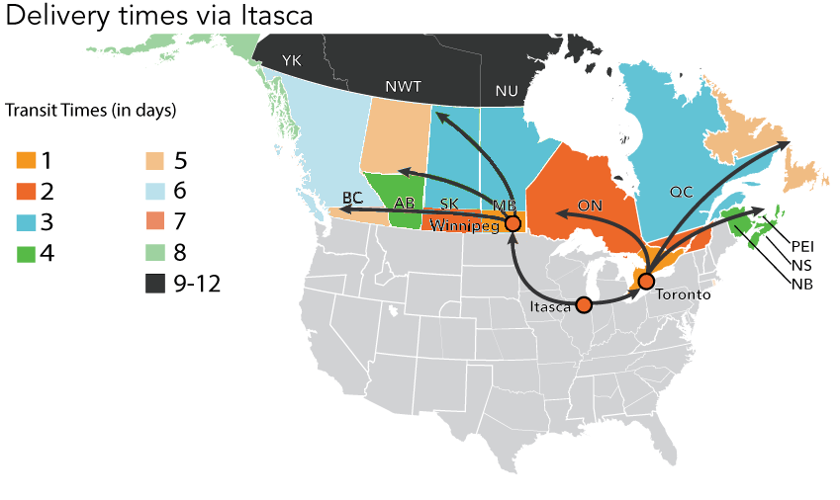

Labels
Through an established API integration, Frontier will receive the shipment data and remit back to Hal Leonard barcoded labels are printed at your facility. Each label will include a “E” or “W”, indicating if the order is sent to Eastern or Western Canada, enabling Hal Leonard to build the skids accordingly. These will be put onto to each piece and have a corresponding PFS number that is used for tracking from origin to destination. An end of day report will be provided which recaps the days’ orders for your records. An example of a label can be found in the separate attachment, Appendix E.

Tracking
Through Frontier’s proprietary web-based tracking system, WebSHIP, Hal Leonard’s customer service team and clients can search and track orders quickly online. This software is the same that is used to create the labels and barcodes generated through the API with Hal Leonard. What this means is the information generated by Hal Leonard can be used to search for each an individual order, for example a reference number or name of consignee. Each order receives a status update once it arrives to Frontier’s facility in Itasca, another at the respective Canadian distribution centre (Winnipeg or Toronto), and at delivery. Proof of Delivery receipts can be accessed the same way. Hal Leonard’s customers can also access live tracking through our website. – show what a status update looks like

Below of WebSHIP
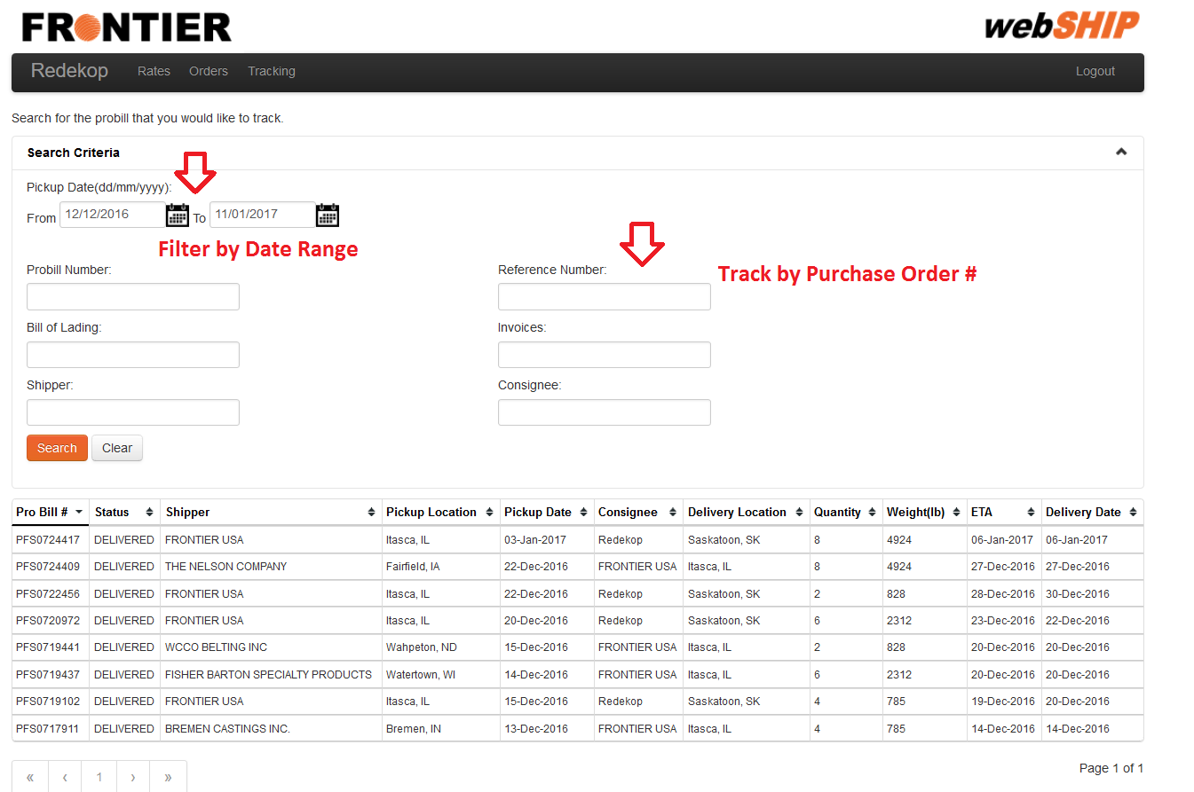

The benefits of working with Frontier as delivery provider are:
- An experienced, asset based delivery provider familiar with high volume clients
- Quick access to Eastern and Western Canada
- Full API integration
- Reduced costs

Proposed Solution – Canadian Customs Brokerage

Dedicated Team
The customs release teams at Frontier have dedicated employees that oversee specific accounts. This enables us to have consistent communication with you. More importantly, we gain an intimate knowledge of your products, needs and expectations.

Your Account Manager will manage the day-to-day review of your customs releases for all imports and exports. They will gain a comprehensive knowledge of your product and the specific needs of your shipments. They manage a team of 3-5 Integrated Service Representatives (ISR) of which one will be your direct contact for all orders and processing.

Hal Leonard’s ISR will create and manage a relationship to ensure they understand the ins and outs of your business. You will receive contact information including email and phone numbers which are directed straight to your team and ISR at Frontier. If your ISR is unavailable and immediate assistance required, the account manager will step in to find a solution. Further, the ISR and team are not only responsible for manage the customs clearance, but the transportation and delivery of the orders as well. This one team, one contact approach makes getting answers quick and easy.

Pricing
In conjunction with the consolidation transportation model, customs clearance is also streamlined resulting in reduced costs. As opposed to clearing each shipment individually, there will be one customs entry per line haul (East and West). When broken down per order, this represents a minimal amount of transportation costs. Additionally, if Hal Leonard would like further their savings, a transportation schedule can be established where shipments are sent into Canada on certain days (e.g. Tuesday and Thursday). This would eliminate three custom entries per week. The customs entry pricing is contingent on receiving customs data through an API which allows us to streamline the entry forms. If Hal Leonard wishes to send certain pieces delivered duty unpaid, this can be accommodated for a flat fee per shipment.

CARM
The CBSA Assessment and Revenue Management project, better known as “CARM” is an initiative by the Government of Canada that will change how firms pay GST and duty on imports. Although delayed by COVID-19, CARM is launching the first phase on May 25th, 2021. At this time, Hal Leonard will need to create an account on the CBSA Client Portal and indicate key contacts, assign customs brokers, and designate authority within Hal Leonard.

For payables owed to the CBSA, all importers will be required to pay applicable duty and GST directly to the receiver general. As opposed to using the bond of the customs broker, the CBSA is mandating all importers have their own Release Prior to Payment Bond. Frontier’s customs brokerage software, Visual Importer, will gather all the import data and serve as an online data base for Hal Leonard.

On the 25th of each month, Hal Leonard will login to Visual Importer and access their Statement of Account(SOA). This statement is a recap of the previous months’ imports, with corresponding duty and GST payable amounts. Hal Leonard can then either then make a payment via online banking to the CBSA, or login to the CBSA Web Portal. To access a running tally of payable amounts throughout the month, Hal Leonard can also download Daily Notices (DN), which are updated every day there is a new import under Hal Leonard’s RM number.

Examples of the Statement of Account and Daily Notice can be found in Appendix C

Canadian Customs Reporting
As mentioned previously, Visual Importer will serve as the primary source of information pertaining to Canadian Customs. The main function of the reporting system is three fold:
- Provide access to Statement of Accounts and Daily Notices
- Act as an online data base of customs entries, downloadable in Excel
- View invoices and download backup documents

Below is an example of one of the main tabs on Visual Importer, showing the monthly account summary broken down by duty and taxes owed to the CBSA

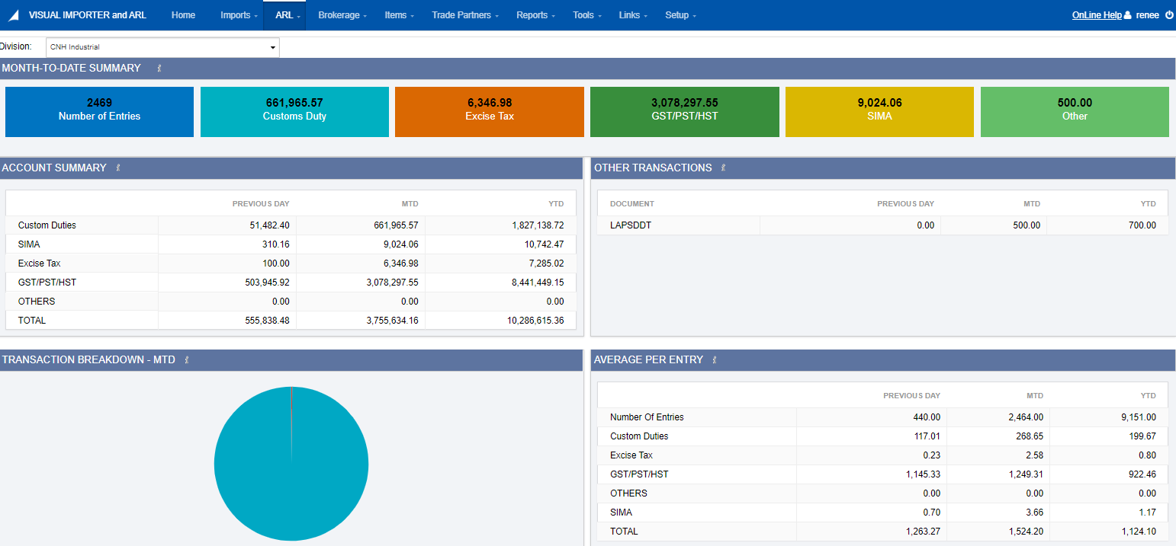

The benefits of working with a mid-sized Customs Broker such as Frontier are:
- Frontier specializes in Non Resident Importers
- Our size allows us to offer exceptional, hands-on customer service
- Reduced customs brokerage fees
- Hands on, step by step compliance with CARM
- Customs Brokerage reporting

Implementation
Task | Responsibility | Time Needed to Complete
Hal Leonard signs/returns required documents | HL | 1 day
API set-up  - Intro call with HC and Frontier IT personnel  - Establish set-up timeline and responsibilities  - Complete Programming  - Test | HL &  Frontier | 2-4 weeks
Establish tariff database  - HL sends database  - HL& FSC service team discuss how to keep it updated  - HL & FSC IT teams determine how push data to FSC | HL & Frontier | 1 day
Develop Standard Operating Procedures  - Pertinent contact information is exchanged  - Processes are outlined and agreed to  - Contingency plans are prepared  - Expectations for both parties are made | HL & Frontier | 2-3 days
Upload USCMA Certificates  - HL provides Frontier with USCMA’s  - Frontier uploads to our operating system | HL & Frontier | 2-3 days
Internal On-boarding meeting  - Frontier meets internally to discuss all matters of the transition  - Key Frontier members involve our customs operation teams  - Questions are gathered which your sales rep will collect and bring forward | Frontier | 1 day
Final questions are prepared & brought forward to HL  - This will be the final specific questions your team will have about your expectations, products, etc. | Frontier & HL | 15-30 minutes
SOP updated and Finalized  - Final changes are made if any | Frontier | 15-30 minutes
Final SOP reviewed between Frontier & Hal Leonard  - At this time you are personally introduced to your team and other key members | Frontier | 15-30 minutes
Hal Leonard alerts vendors of change of broker  - This can be done beforehand or as your send in POs  - Internal communication to the rest of Pampered Chef employees can be made at this time as well | HL | 30-60 minutes

Appendix A – Fees
Small Parcel Rates from Winona, Minnesota*
Rates express in USD, based on an average of 100 orders per day
Origin | Destination | First Lb | Each Additional Lb
Winona, MN | ON - GTA | 6.62 | 0.42
Winona, MN | ON - South | 6.91 | 0.45
Winona, MN | ON - Central | 9.90 | 0.51
Winona, MN | ON - East | 12.27 | 0.62
Winona, MN | ON - North | 15.48 | 0.63
Winona, MN | QC - Montreal | 7.28 | 0.53
Winona, MN | QC - Province | 12.27 | 0.62
Winona, MN | Maritimes | 16.00 | 0.59
Winona, MN | NL - Province | 20.26 | 0.68
Winona, MN | MB - Province | 15.78 | 0.36
Winona, MN | SK - Regina | 11.08 | 0.42
Winona, MN | SK - Province | 13.24 | 0.45
Winona, MN | AB - Calgary | 11.70 | 0.53
Winona, MN | AB - Edmonton | 11.70 | 0.53
Winona, MN | AB - Province | 15.08 | 0.61
Winona, MN | BC - Vancouver | 11.73 | 0.59
Winona, MN | BC - Province | 18.62 | 0.65

Canadian Customs Brokerage – these are in CAD dollars?
Canadian Customs Brokerage Fee
Standard Customs Release : $60.00 CAD per customs clearance*
SWI Fee: $5.00 when Participating Government Agencies are involved**
Statutory Holiday Clearance Fee: $35.00 when required to process a PARS on a statutory holiday in Canada
Send customs docs to another broker, what to call this/how much?
*Assuming customs data is transmitted to Frontier via API
**Frontier can review HS data base to see if this will apply

Release Prior to Payment Bond
Dependant on the monthly average of duty and taxes
Appendix B – Fuel Surcharge

All parcel shipments will be subject to a fuel surcharge based on the weekly average reported by BJ Ervin and Associates, updated after 4:00 PM on Monday of each week. This index price may be obtained at http://charting.kentgroupltd.com If Monday is a holiday, the index will be available on Tuesday. The applicable surcharge will become effective on the Wednesday immediately following.
If the national average price of diesel rises above the following table, the surcharge will increase proportionately. The fuel charge is shown as a separate amount on the freight bill.

From | To | Parcel % |  |  | From | To | Parcel %
$ 0.56 | $0.58 | 1.0% |  |  | $ 1.02 | $1.04 | 12.5%
$ 0.58 | $0.60 | 1.5% |  |  | $ 1.04 | $1.06 | 13.0%
$ 0.60 | $0.62 | 2.0% |  |  | $ 1.06 | $1.08 | 13.5%
$ 0.62 | $0.64 | 2.5% |  |  | $ 1.08 | $1.10 | 14.0%
$ 0.64 | $0.66 | 3.0% |  |  | $ 1.10 | $1.12 | 14.5%
$ 0.66 | $0.68 | 3.5% |  |  | $ 1.12 | $1.14 | 15.0%
$ 0.68 | $0.70 | 4.0% |  |  | $ 1.14 | $1.16 | 15.5%
$ 0.70 | $0.72 | 4.5% |  |  | $ 1.16 | $1.18 | 16.0%
$ 0.72 | $0.74 | 5.0% |  |  | $ 1.18 | $1.20 | 16.5%
$ 0.74 | $0.76 | 5.5% |  |  | $ 1.20 | $1.22 | 17.0%
$ 0.76 | $0.78 | 6.0% |  |  | $ 1.22 | $1.24 | 17.5%
$ 0.78 | $0.80 | 6.5% |  |  | $ 1.24 | $1.26 | 18.0%
$ 0.80 | $0.82 | 7.0% |  |  | $ 1.26 | $1.28 | 18.5%
$ 0.82 | $0.84 | 7.5% |  |  | $ 1.28 | $1.30 | 19.0%
$ 0.84 | $0.86 | 8.0% |  |  | $ 1.30 | $1.32 | 19.5%
$ 0.86 | $0.88 | 8.5% |  |  | $ 1.32 | $1.34 | 20.0%
$ 0.88 | $0.90 | 9.0% |  |  | $ 1.34 | $1.36 | 20.5%
$ 0.90 | $0.92 | 9.5% |  |  | $ 1.36 | $1.38 | 21.0%
$ 0.92 | $0.94 | 10.0% |  |  | $ 1.38 | $1.40 | 21.5%
$ 0.94 | $0.96 | 10.5% |  |  | $ 1.40 | $1.42 | 22.0%
$ 0.96 | $0.98 | 11.0% |  |  | $ 1.42 | $1.44 | 22.5%
$ 0.98 | $1.00 | 11.5% |  |  | $ 1.44 | $1.46 | 23.0%
$ 1.00 | $1.02 | 12.0% |  |  | $ 1.46 | $1.48 | 23.5%
$ 1.02 | $1.04 | 12.5% |  |  | $ 1.48 | $1.50 | 24.0%

Appendix C – Payment Terms and Schedule (2021)

Month | Release Date | Confirmation Date | Invoice Date | Payment Due Date
January | 15 | 25 | 27 | 29
February | 17 | 25 | 24 | 26
March | 17 | 25 | 29 | 31
April | 16 | 26 | 28 | 30
May | 14 | 25 | 7 | 31
June | 17 | 25 | 28 | 30
July | 16 | 26 | 28 | 30
August | 17 | 25 | 27 | 31
September | 17 | 27 | 28 | 30
October | 15 | 25 | 27 | 29
November | 17 | 25 | 26 | 30
December | 17 | 27 | 29 | 31

Frontier provides the same payment terms to our customers that Canada Border Services Agency (CBSA) extends to us as a Customs Broker.
The release date of the shipment triggers the payment due date. All shipments released from the 18th of the previous month to the 17th of the current month are due to Frontier on the 3rd last business day of the current month. The 18th to the 17th cycle may vary by a day during some months depending on how the days in the month fall. See our Production Schedule showing the cycle and due dates for each CBSA accounting month.
Beginning in spring of 2020, the CBSA is introducing an initiative called CARM which mandates that importers must be set up through ARL to pay the receiver general directly online. With Frontier’s software, Hal Leonard will have access to up-to date account balances and amount owing to the receiver general, broken out in to GST, duty etc.
This statement amount must be paid in full at month end.
Frontier reserves the following as part of our credit policy.
Frontier can, at its discretion, opt not to pay a client’s taxes at the month end due date if payment from the client has not been received at month end. Penalties to the client from CBSA will occur as a result of this.
Frontier can, at its discretion, opt to suspend services to the client if payment is not by the due date each month.
Frontier may request payment in advance of the due date if a client exceeds their established credit limit.
Payments are accepted by cheque, wire, or electronic funds transfer (preferred). Any bank wire charges incurred are the responsibility of the client and will be charged back to them.
Appendix D – Sample Documents

Sample CBSA Daily Notice
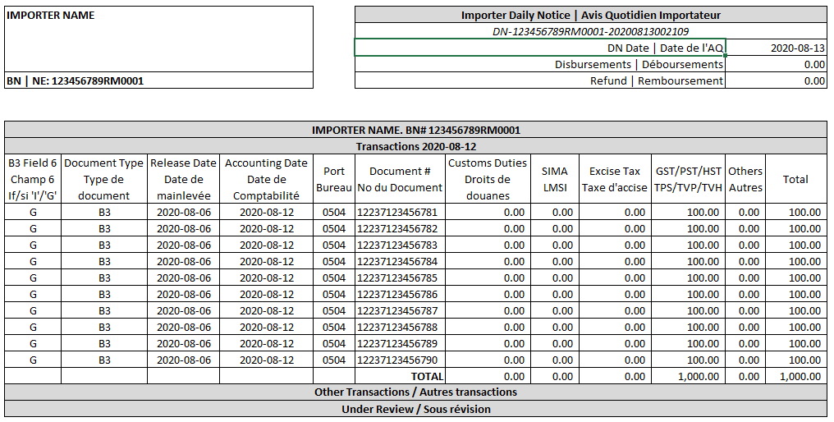

Sample CBSA Statement of Account
