

STEP 1: To begin using Frontier’s shipping features visit www.couttscourier.ca

STEP 2: Click on “Track and Ship”.

# Login

Enter your assigned account number, Web ID, and password. All this information will be provided to you by your account manager.

**Account #: 6486**

**WebID: EMSCO**

**PW: 3599**

**Order Entry**

Pickup/Delivery:

1. The pickup location should default to your main address. If another location is required, either select it from the address book above (in between the two blue arrows), or enter the new location. To save a new address simply click the box located to the right of “Phone”, underneath the green icon.
2. Delivery location – same as instructions above

Service Type:

1. **Frontier Same Day\*** – same day service between Saskatoon, Regina, Moose Jaw and Davidson. eg. A box being shipped from Regina to Moose Jaw, you would select “Frontier Same Day x Regina” – cutoff time is 11am
2. **Overnight** – overnight service to one of our 450+ service points in Saskatchewan. Not every point is overnight, some points will take two days to deliver. Regardless, for normal delivery time select this option. Eg. A box being shipped from Regina to Melville - cutoff time is 3:30pm
3. **Regular** – messenger service in the City of Regina

* the letter “x” in the service type signifies where the shipment originates from. If shipping from Saskatoon, the service selected must be “Frontier ……….. **x Saskatoon**”

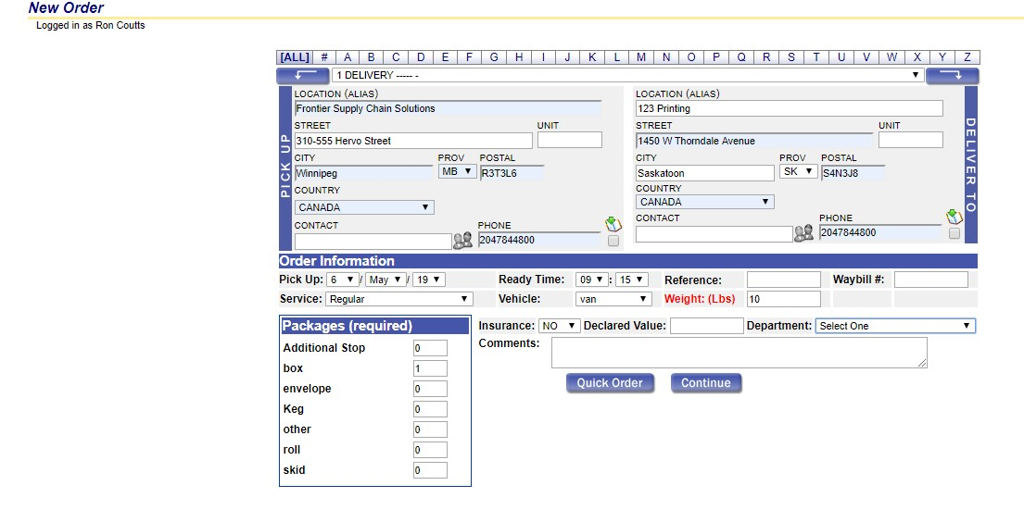

**Rates**

Once you’ve entered the address information, you will be shown our competitive rate for your shipment.

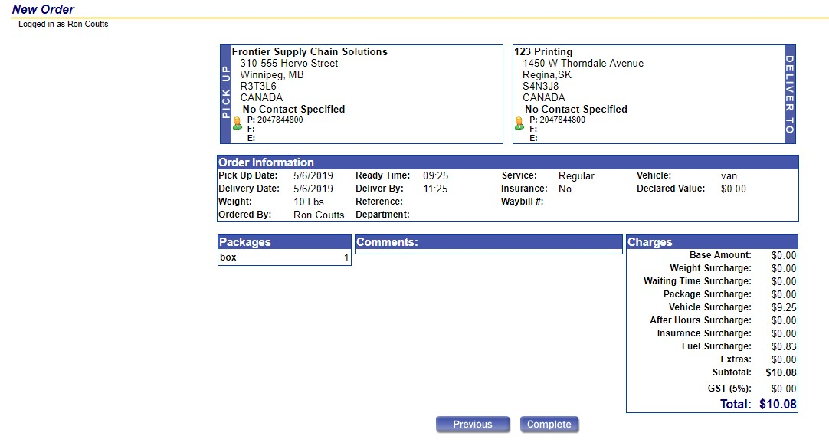

Once you click Complete you will be given a waybill to sign. Please give it to the driver.

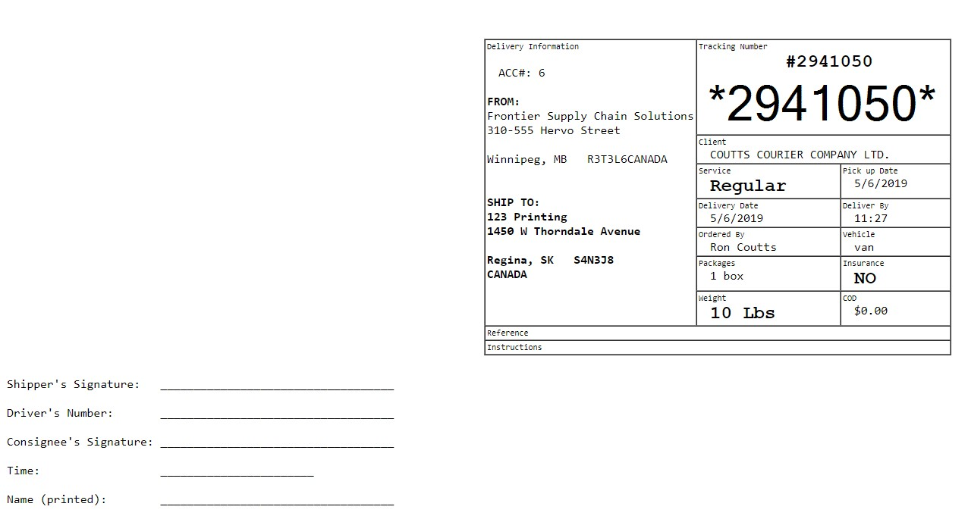

# Tracking

Not only do we accept shipments online, but we also provide our clients with up to date information on past orders. Click on the Order Tracking tab in the tool bar located on the top right hand corner of the screen to access your order history.



You will see the order date, number, pick-up and delivery information, and POD.

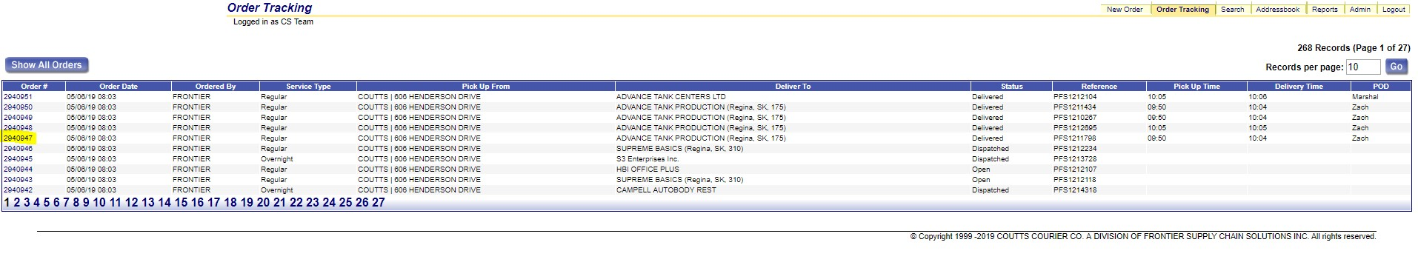

Once you’ve found your invoice, click on it and it will open in a new window. You’ll see the shipping rate, who signed for the delivery, when and where it was delivered, the waybill, and other important information.

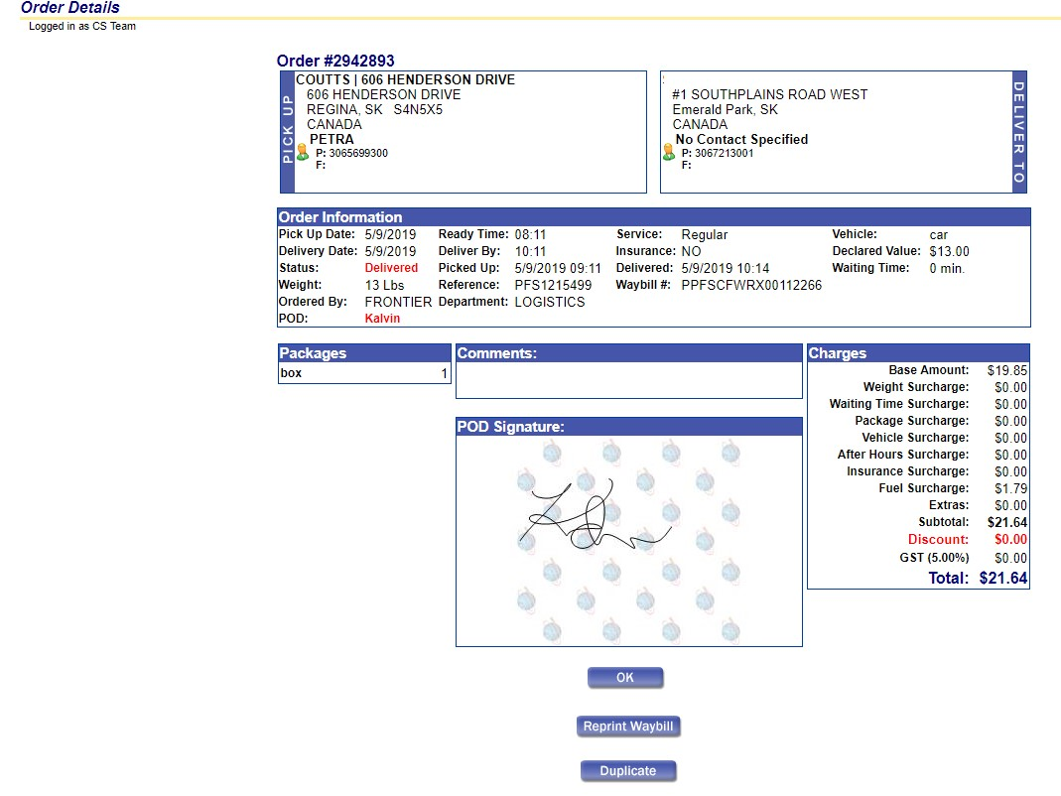

# Searching for an Order

Looking for an order? Frontier/Relay make it easy to find what you’re looking for with our search tool. Click on the Search tab in the tool bar.



A box will pop up where you can enter the order number, dates, delivery information, POD, and waybill number to find the order you are searching for.

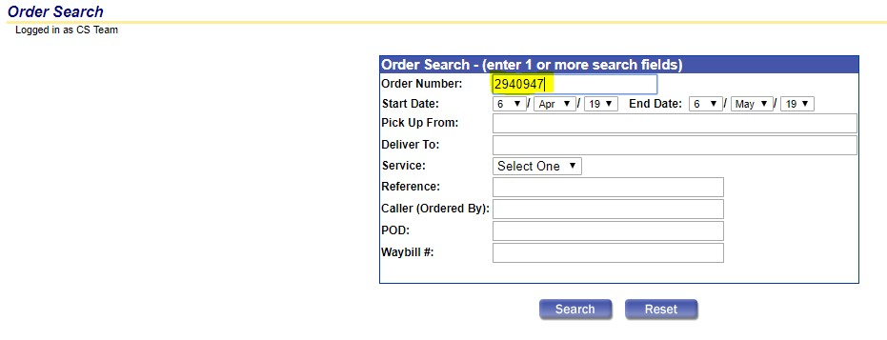

The software will bring up the invoice.

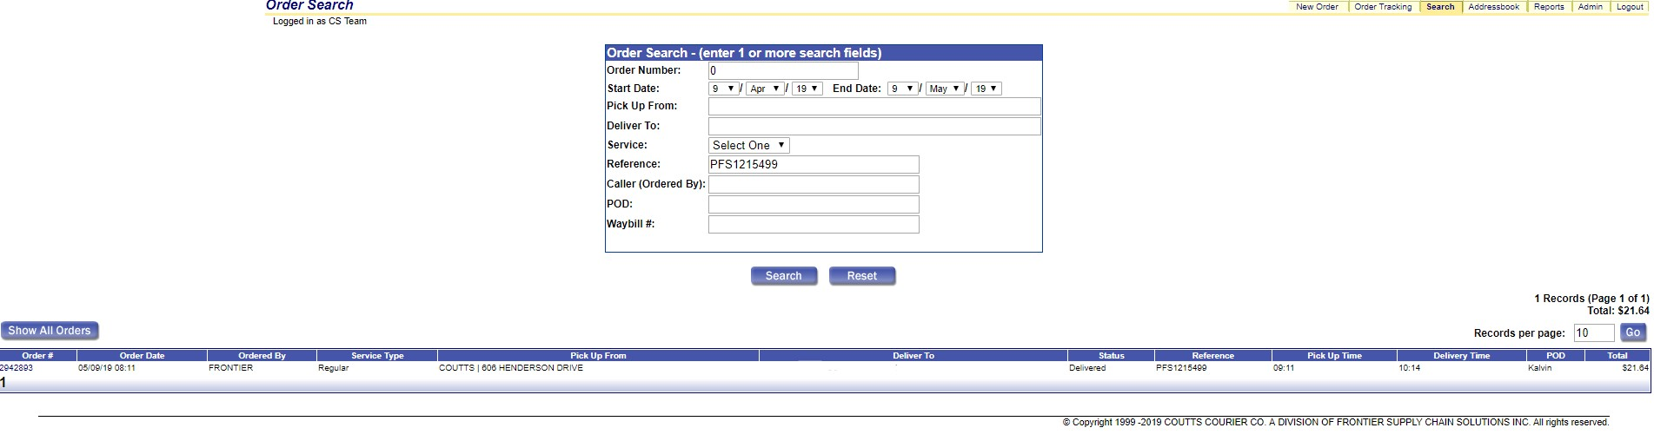

**Invoices**

If you need a record of your invoices, Frontier/Relay makes that easy by clicking on the Report tab in the tool bar.



A box will open with the invoice number, date, and the amount.

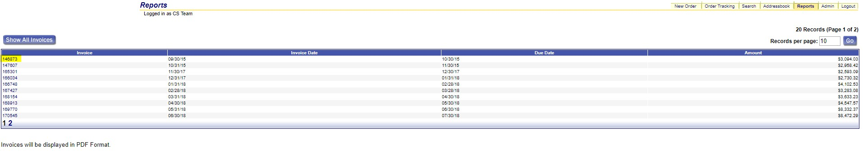

The report will open in a PDF window when clicked.

