**Tracking Shipment Manager SOP**

* Located at <http://invoiceserver/>

Mass PFS Update Feature Instructions

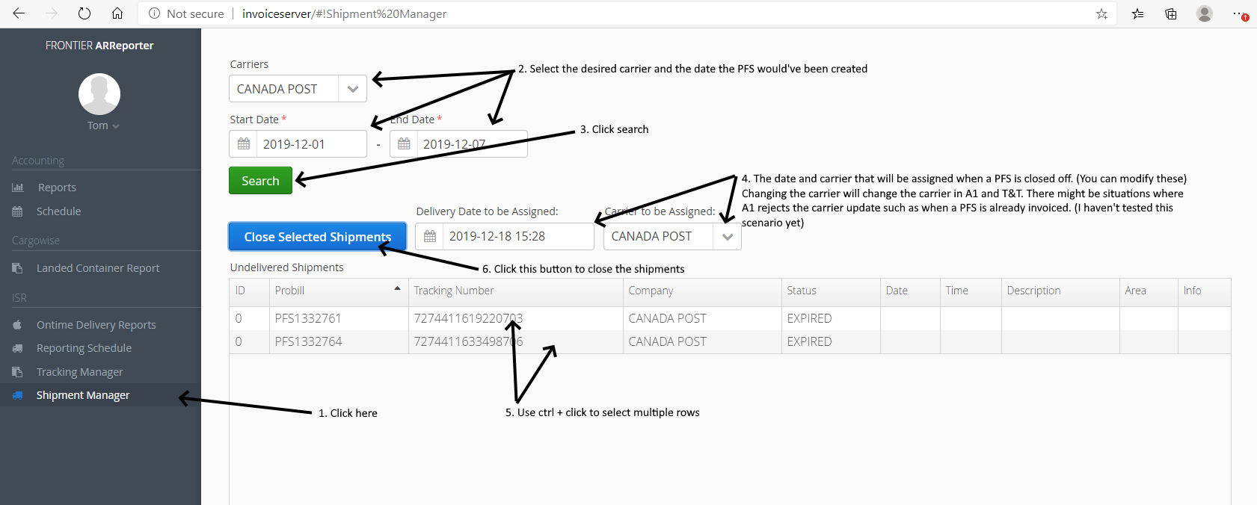

Upload a POD

