1. **PURPOSE**

To detail the process for:

Tracking orders with the delivery variance report, correctly brokering and progressing orders on A1 and the Invoice server.

1. **RESPONSIBILITY**
   1. It is the responsibility of all Associates to follow this procedure
   2. The Logistics Manager is responsible for ensuring that this procedure is adhered to.
2. **PROCEDURE**

* 1. A notification email is sent from [itreports@noreply.frontierscs.com](mailto:itreports@noreply.frontierscs.com). It will have an excel spreadsheet that contains all the orders that are open past the estimated delivery date.

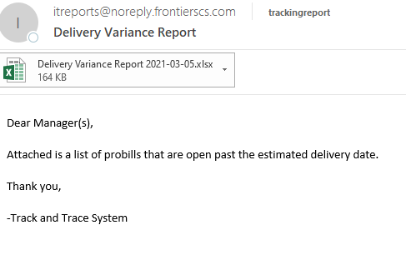

You click on the excel spreadsheet, and enable editing.

1. On the spreadsheet you select all the date, Ctrl + A
2. Click on the “**Insert**” tab then select “**Pivot Table**”

Make sure – **Select a table or range**, **New Worksheet** and **Add this date to the Data Model** are all selected. Then click **ok**.

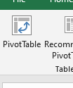

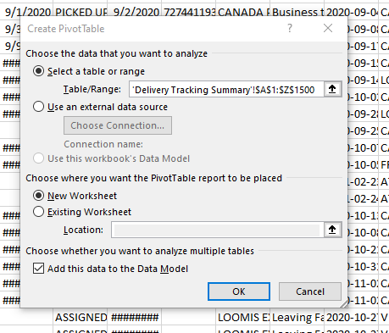

1. On the right-hand side of the under the **Pivot Table Fields**,
   1. Under the **Active tab** you select;

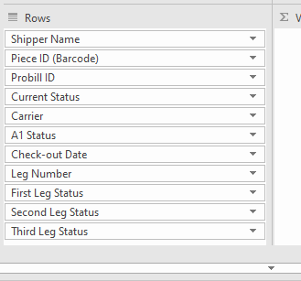

* 1. Under the **Design tab** at the top you select;
* **Report Layout** – Show in tabular form
* **Subtotals** – Do not show subtotals

1. Once the pivot table is created, you can filter the **Current Status** and **Carrier** by clicking on the drop-down button.



** For now, you may be tracking every carrier except **IDS**.

** You may choose to track each Probill by each individual carrier or by the Current status of the order.

1. Next you open up A1, and enter in your assigned user name and password

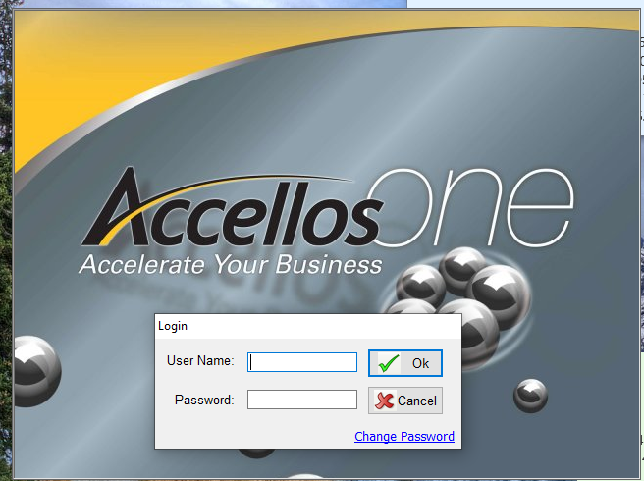

1. You will also open up the links below on your preferred web browser
   1. <http://192.168.1.211/WebTrackDEV/views/Frontier/FrontierDetails.xhtml;jsessionid=b74abb1c1968d7212f8334f10afc>
   2. The website above is used to provide tracking information for a probill

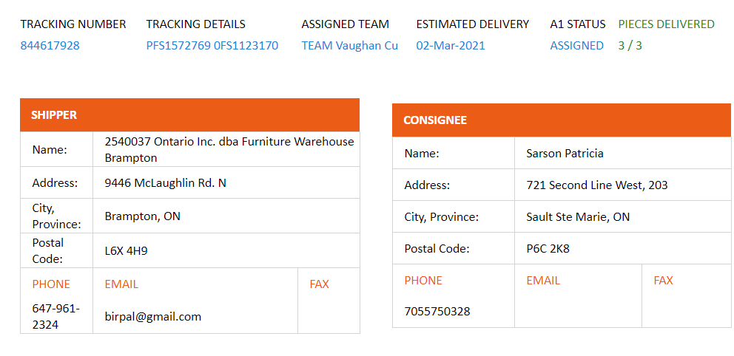

This includes the tracking number and carrier

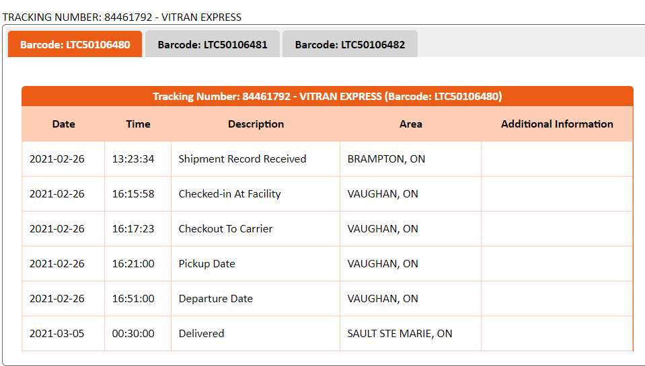

* 1. <http://invoiceserver/>

This will allow us to finish tracking by using the application within Track & Trace and A1.

