FILING ISF (IMPORTER SECURITY FILING) IN CARGOWISE
The Importer Security Filing (ISF) is a rule that requires importers, customs brokers and other authorized agents to submit additional information to CBP electronically before the shipment arrives in the U.S. The ISF rule became mandatory in January 2009 and applies specifically to ocean shipments.
Importer Security Filing (ISF) information is important because it is used for risk assessment and trade control. CBP use ISF data to identify high risk shipments, prevent illegal activities like smuggling, and ensure that inbound marine shipments are not a threat to the health, safety and security of citizens. Failure to transmit accurate, complete and timely ocean cargo and ISF data to CBP may result in cargo holds, exams and monetary penalties of $5,000 per violation, up to $10,000.
It is the responsibility of the importer of record to submit the ISF to CBP. The importer is typically the owner/buyer of the imported merchandise or the party causing the goods to enter the limits of a port in the United States. An authorized agent such as a licensed customs broker may also submit the ISF on behalf of the importer.
The following data elements must be provided in order for us to file ISF:
- Importer of Record name (must already have a 5106 on file with CBP)
- Consignee name and address; local phone number if available
- Seller name and address
- Buyer name and address
- Ship-to party name and address
- Manufacturer/supplier name and address
- Country of origin
- Precise description of Commodity and, if possible, Harmonized Tariff Code to the 6-digit level
- Container Stuffing Location
- Freight Consolidator
- Bill of lading number – ISFs must contain the lowest bill of lading number (i.e. master or house/AMS bill of lading.

Documents needed:
The importer is responsible for supplying an ISF form containing all of the above data, as well as, ideally, a copy of the bill of lading.
Filing an ISF in CargoWise (video starts at 3:13:00
Details tab
Operate -> Customs -> US Importer Security Filing
Click ‘NEW’ to start a new ISF filing
Entry type
- 99% of our ISF filings are ISF 10
Shipment type
- Most will fall under -01 Standard/Regular Filing. Other types that you may encounter include:
- -03 Household goods/Personal Effects
- -11 Informal (Includes Section 321 shipments under $800 USD value)
- -07 US Return Goods
Transport mode
- Leave as ’11 – Containerized’.
- ‘Break Bulk’ (non-containerized) and Ro-Ro (Roll-on, Roll-off) shipments require ISF so if this is the case the Transport mode can be changed to ’10 – Break Bulk’
- Bulk cargo (i.e. grain, coal, oil, etc) does not require ISF.
Enter ocean carrier SCAC (Standard Carrier Alpha) code
Enter the Importer of Record’s code. To find the code, click on the Search button next to the field to go to the Organization search screen.
Skip to Bond Activity Code. Choose from the following:
1 = Importer or Broker. The importer must have a Continuous Bond with US Customs on file.
16 = ISF Bond. Importers who do not have a Continuous Bond with US Customs import infrequently. They are required to file an ISF bond to cover any potential penalties that can result from late or inaccurate ISF filing.
Bond Type
8 = Continuous. Select and skip to References section.
9 = Single Transaction #
Surety Code – enter 054, which is the code for Avalon Risk Management, the company through which we file all of our ISF bonds.
The Bond Reference Number is generated on the Customs bond processing site. This is required for an ISF bond, UNLESS it is a Household Goods/Personal Effects shipment or an Informal/Section 321 shipment. That process will be explained in a separate lesson.
References section
- If you’ve only received one bill of lading/AMS number, enter it in the Ocean Bill field.
- If you’ve been provided with both a Master bill and a house/AMS bill, enter into the Master and House bill fields respectively.
Enter Ship to, Buying Party, Container Stuffing, Selling Party and Consolidator as shown on the ISF instructions provided by the importer.
SAVE and proceed to Lines tab.
Lines tab
In the far-right corner, enter the Manufacturer code. If you have more than one code, you can list them one by one in the grid.
Lines section – enter the following:
- Product name (s)
- Country of origin
- US HTS (tariff) number to the 6th digit
SAVE and proceed to Containers tab
Containers tab
Under Equipment –
Desc Code = CL
Cntr# = enter container number (AAAANNNNNNN)
- If this is an Informal or Household Goods/Personal Effects shipment, you will need to complete all 4 fields under Low Value Details.
- If this is a Standard Filing, SAVE and proceed to the Routing tab
Routing tab
- Click the ‘Is Linked’ box in the upper right-hand part of the screen.
- Complete Vessel and Voyage/Flight fields.
  - If you receive a red ‘stop sign’ message, you will need to Create a Vessel by clicking on the Search box next to the vessel name and adding ‘NEW’.
  - In the pop-up screen:
    - Enter vessel name
    - Google vessel name to find the Lloyd’s/IMO# and enter that number in the field, SAVE and CLOSE.
      - Ocean carrier sites, VesselFinder.com and MarineTraffic.com are reputable sites from which to gain this information.
  - Search Carrier and select the appropriate carrier with customer service office located in the U.S. if you have a red ‘stop sign’ warning in that field.
- Enter Load and Discharge ports (UNLOC code is required).
- Enter ETD, ETA.
SAVE.
- If you’ve generated an ISF bond, you will enter the Bond Reference Number in the appropriate field on the Details tab before transmitting.
Transmitting the ISF
Go to FILE – VALIDATE ALL to check if there are any remaining errors.
Go to Messaging -> Send. Video ends at 13:21; follow with screenshots of 2 ISF messages and Disposition code screenshot
ISF filing results
- You will receive two separate messages via ABI.
  - The Importer Security Filing Response will be an ‘ISF accepted’ message (or a ‘Failure’ which will need to be addressed and retransmitted)
  - The Importer Security Filing Status Advisory Response provides the ISF Transaction Number (our filer code BFI followed by 11 digits), the Disposition code, and remarks.
    - If you’ve generated an ISF bond, send the ISF Transaction Number to the surety from within that site’s bond generation screen.
- Check to see if there is a Bill Match (Disposition code S1 Bill On File) message.
  - If there is no Bill Match, you will need to monitor the file every so often until you receive a Bill on File/Bill Match.
    - Make amendments and request additional information if necessary, depending on the disposition code that you receive in your Importer Security Filing Status Advisory Response message.
Refer to the chart below. The aim is to receive an S1 Bill on File within 2 days of mother vessel departure to the 1st U.S. Port. Once you have that, the ISF filing is complete and you may create a Declaration.
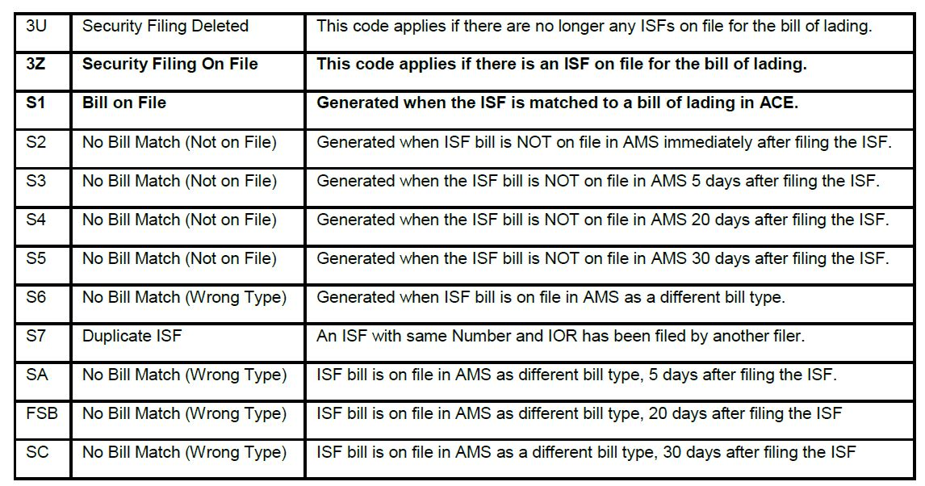
Pick up video again at 14:44 to end
Finally, Create a Declaration to activate shipment tracking and make this searchable in the Customs Declaration Dashboard
- Enter the ISF file # in the Job Number field of the US Importer Security Filing Search Screen. Click ‘Find’.
- Highlight the selection and right click, drop down to Actions, and over to ‘Create New Declaration’.
- To get the Declaration (‘B’) number, SAVE and take note of the file number that has been generated, it will show at the top of the screen.

